


General Information

TCAC is an area chapter of the National Church Library Association, a non-profit support organization serving church librarians of all backgrounds. Membership is open to individuals or churches of all Christian denominations that desire assistance with church library development. Contact the national office or any TCAC board member if you are interested in joining or have questions.

Twin Cities Area
Chapter Board

Sandra Johnson, President
952-544-8117
sjj24@msn.com
Paula Erickson, Vice President
763-427-5128
pl.rcksn@gmail.com

Laura Dirks, Secretary
612-378-3026
Laura.Dirks@securian.com

Colleen Stieg, Treasurer
763-533-1702
cmks30@msn.com

National Office
National Church Library Association

275 South Third Street
Suite 101A
Stillwater, MN 55082
651-430-0770
info@churchlibraries.org
www.churchlibraries.org

Mission Statement: To energize church library ministry through education, resource
sharing, spiritual encouragement and fellowship.
Mission Statement: To energize church library ministry through education, resource
sharing, spiritual encouragement, and fellowship.

Fall 2022
Inside This Issue
Treasurer’s Report  Co-Presidents’ Letter | 2
What Churches Are Reading | 3-4
Fall Meeting Information | 5
Directions to Gustavus Adolphus | 6
Meeting Schedule  Registration Form | 7

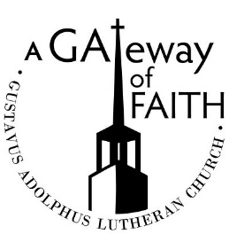

1669 Arcade Street North
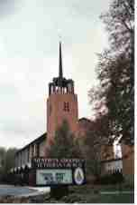
St. Paul

TCACLA Fall Meeting
Gustavus Adolphus Lutheran Church
October 29, 2022
8:30 – 12:30

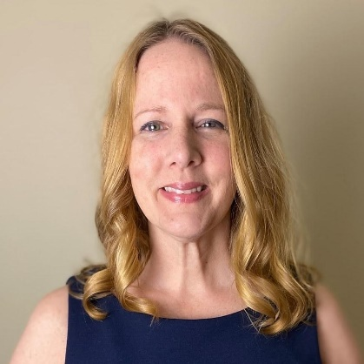
Our keynote speaker is Dawn Rundman. She holds a PhD in Developmental Psychology and is Director of Resource Devel-opment at 1517 Media, the publishing ministry of the ELCA. For 20 years Dawn has devel-oped faith formation resources for children, youth, and families, including curriculum, Bibles, and children's books. She loves talking about the thrilling inter-sections of faith and neuroscience, especially when that means talking with book lovers about the ways that church libraries can support print literacy, biblical literacy, and healthy child development. Dawn lives in Edina with her prom date/newly ordained husband and their daughter. Their son lives 45 minutes away in Northfield where he's a first-year student at St. Olaf.

Session Description: “Let's talk brains, books, and faith development! Consider how churches can be rich contexts for healthy development, with lively music, intergenerational social interactions, and engaging stories and symbols that surround children right from the start. We'll explore how experiences shape brain pathways starting in infancy and throughout the first years of life. And we'll affirm the ways that church libraries can support healthy development throughout childhood with an array of books for kids and families to discover.”


General Information
The Twin Cities Area Church Library Association (TCACLA) is a non-profit support organization serving church librarians. Member-ship is open to individuals and churches of all denominations that desire to network with others on church library development and enrichment.

TCACLA BOARD

Grace Kurtz, Co-President 651-631-3726
gkurtz61@gmail.com
Jeanne Schleh, Co-President
612-729-6041
jerebob@aol.com
Emily Hoch, Vice-President
612-508-4934 ejhoch@gmail.com
Leslie Kallas, Secretary 612-978-9572 ljkallas@gmail.com
Roberta Shaw, Treasurer
651-206-6334 roberta.shaw@yahoo.com
Historian
Vacant
Off the Shelf Editor
Laura Dirks
otseditor@gmail.com

Website
www.tcacla.comwww.tcacla.com
Members: | 25 churches, 1 individual
01/01/2022 | $2,695.93 |  | Beginning Balance
 | $40.00 |  | Off the Shelf Subscriptions
 | -$195.48 |  | Off the Shelf Printing & Postage
 | -164.60 |  | Spring Meeting Expenses
 | -$13.00 |  | Website Fee
 | -$27.97 |  | Bank Expense – New Checks
09/30/2022 | $2,334.88 |  | Ending Balance

***********************************************************************
Letter from Our Departing Co-Presidents

Our October 29 meeting includes the election of a new president
and secretary. As Grace and I wind up our two terms (plus an extra
Covid year!) as co-presidents, and Leslie finishes two terms as secretary, we’d like you to know how much we enjoyed serving on
the board—and we hope to inspire you to step up. The continued
vitality of TCACLA depends on the willingness of members to serve
on the board!

I can assure you, based on my own history, that NO experience is
required. What is needed is a love of libraries and enjoyment of
brainstorming with other board members to come up with two pro-
grams a year that will intrigue church librarians. We meet (very
efficiently) by Zoom and email, so this is not a time-consuming job.

Our fall speaker is a perfect example of the board’s work. We are
so excited to present Dawn Rundman. Her book, LITTLE STEPS,
BIG FAITH, is one every church library will want to acquire. Her
personal stories and expertise on faith formation and children’s brain
development—from toddlers to teens—will inspire parents, grand-
parents and teachers. Please consider inviting others in your congre-
gation to join you for this unique opportunity to hear her and ask
questions.

And thank you for the privilege of serving TCACLA.

Jeanne Schleh

WHAT CHURCHES ARE READING

General Information

TCAC is an area chapter of the National Church Library Association, a non-profit support organization serving church librarians of all backgrounds. Membership is open to individuals or churches of all Christian denominations that desire assistance with church library development. Contact the national office or any TCAC board member if you are interested in joining or have questions.

Twin Cities Area
Chapter Board

Sandra Johnson, President
952-544-8117
sjj24@msn.com
Paula Erickson, Vice President
763-427-5128
pl.rcksn@gmail.com

Laura Dirks, Secretary
612-378-3026
Laura.Dirks@securian.com

Colleen Stieg, Treasurer
763-533-1702
cmks30@msn.com

National Office
National Church Library Association

275 South Third Street
Suite 101A
Stillwater, MN 55082
651-430-0770
info@churchlibraries.org
www.churchlibraries.org

Everyone is encouraged to contribute to this section. Please send book titles and authors to otseditor@gmail.com.

“In the case of good books, the point is not to see how many of them you can get through, but rather how many can get through to you.” – Mortimer J. Adler

GRACE CAN LEAD US HOME; A Christian Call to End Homelessness by Kevin Nye, Herald Press, 2022.
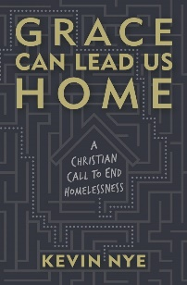

THE SANDBOX REVOLUTION; Raising Kids for a Just World edited Lydia Wylie-Kellermann, Broad-leaf Books, 2021.
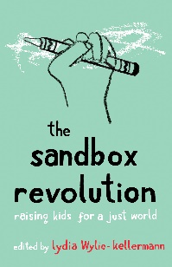

SACRED NATURE; Restoring Our Ancient Bond with the Natural World by Karen Armstrong,

Knopf, 2022.

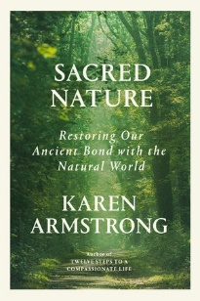

p. 3

Reporting back from his work in homeless services, minister and advocate Kevin Nye introduces readers to the Christ he’s met in tents, shelters, and drop-in centers. He demystifies homelessness by journey-ing into complex issues like affordable housing, mental illness, addiction, and more, while reimag-ining our theological approach to these matters and educating us on how they intersect with homeless-ness.

It is a complex time to be a parent. Our climate is in crisis, and economic inequality is deepening. Racial-ized violence is spreading, and school shootings are escalating. The authors of the essays in this anthology include pastors, teachers, activists, artists, and gardeners who are also parents. They offer a diversity of voices and experiences on topics that include education, money, anti-racism, resist-ance, spirituality, disability justice, and earth care.

The natural world has always inspired everything from fear, to awe, to tranquil contemplation. Yet today, we rarely see nature as sacred. Drawing on her vast knowledge of the world’s religious traditions, Armstrong vividly describes nature’s central place in spirituality across the centuries. In bringing this age-old wisdom to life, she shows modern readers how to rediscover nature’s potency and form a connection to something greater than themselves.

COURAGE FOR CAREGIVERS; Sustenance for the Journey in Company with Henri J. M. Nouwen by Marjorie J. Thompson, InterVarsity Press, 2022.
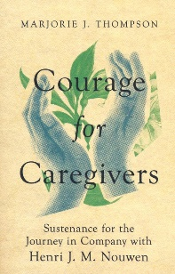

ORDINARY BLESSINGS FOR PARENTS; Prayers, Poems and Meditations for Family Life by Meta Herrick Carlson, Broadleaf Books, 2022.

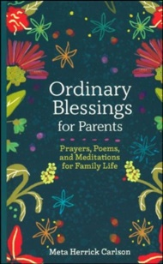
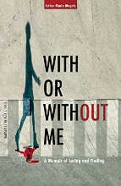
WITH OR WITHOUT ME; A Memoir of Losing and Finding by Esther Maria Manis, Plough, 2022.

YOU CAN SHINE SO BRIGHT by Jinger & Jeremy Vuolo, Worthy Kids, 2022.

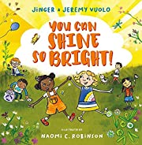

p. 4

Thompson offers an exploration of caregiving intertwined with both her own many years of intimate caregiving of family members and collected stories of caregivers in various stages of life. While not shying away from the demanding physical, emotional, and spiritual challenges of caregiving, she also celebrates the gifts of caregiving grounded in the belovedness that both caregiver and care receiver share in God's eyes. Includes a leader guide and resources for a group ministry.

When we're caught up in the day-to-day challenges of raising children, from teething to teen relation-ships, we can easily miss the sanctity of these moments. Carlson, a poet, pastor, and mom, has created a “spiritual high-five” for parents in every stage of raising kids. Her blessings call out the simple struggles that remind us we are in good company and that we are loved in the midst of loving children.

One woman’s unsparing and eloquent memoir about the inadequacy of religion and philosophy to answer her emotional pain after her father’s cancer diagnosis when she was 15. While she initially rejected her faith, she eventually took a tortuous journey back – one punctuated by several personal losses, retold with bluntness and immediacy. “Es-sential reading for anyone who has ever doubted God’s goodness in the midst of personal loss.” —Christian Century

A beautifully illustrated book that encourages children to let their light shine as they move about the world. As they read along, little readers will be introduced to the fruits of the Spirit from Galatians 5:22–23. Written in lighthearted verse, the story follows a diverse group of children - including some wearing glasses and one in a wheelchair - as they model love, joy, patience, peace, kindness, and more in everyday, relatable scenarios. Ages 4-7.

MORE ABOUT THE OCTOBER 29 MEETING

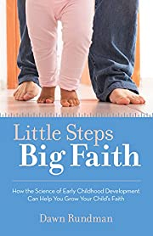

Copies of Dawn Rundman’s book, LITTLE STEPS, BIG FAITH: How the Science of Early Childhood Development Can Help You Grow Your Child's Faith will be available for purchase. She’s also bringing some books for review along with some giveaways! Fun fact: Dawn has written two books under the name Lucy Bell, her company’s pseudonym for in-house authors: URI AND THE BUSY DAY: A Book about Feeling Overwhelmed and JO AND THE NOT-SO-LITTLE LIE: A Book about Telling the Truth.

******************************************************************************************************************************

WORKSHOP ON DONATIONS

Most of us have found a mysterious bag, box, or pile of books outside of the library door or on the library desk. There may be a note indicating that the books are a donation from a specific person, but often, they just appear. While these donations can be perfect additions to your collection, it’s more likely that they are well-loved books, yellow with age and/or heavily underlined.

Per the National Church Library Association’s handbook for church librarians: Donations of new or used books “present church librarians with one of the thorniest issues they may face….If the book doesn’t meet your needs established in the selection policy, it is not a gift, it’s a burden.”

Without a written policy, it can be difficult, delicate, and often arbitrary to deal with donations. Some of us don’t accept donations at all; others rely heavily on them. Does your library have a written policy on donations? A form that should be completed by donors? A box for donated materials in the library? Come prepared for a lively interactive discussion and bring a sample of your form(s).


*******************************************************************************************************************
BOOK SWAP Your library may have a duplicate copy of a book or a gently used book that you no longer need. If so, consider bringing it to the meeting to share with others. Despite the word “swap,” there is no requirement that you bring a book to take a book. If you bring a book that hasn’t been taken by the end of the meeting, please take it home with you.


*****************************************************************************************************************************
HELP WANTED - PHOTOGRAPHER

Jan Bolstad is relocating and no longer available to serve as our historian. I am looking for someone to take pictures at the Fall meeting. If you can help, please contact otseditor@gmail.com. Many of the pictures will appear be in the Winter newsletter.

p. 5
GUSTAVUS ADOLPHUS LUTHERAN CHURCH
1669 ARCADE ST N, ST. PAUL

HOW TO GET THERE
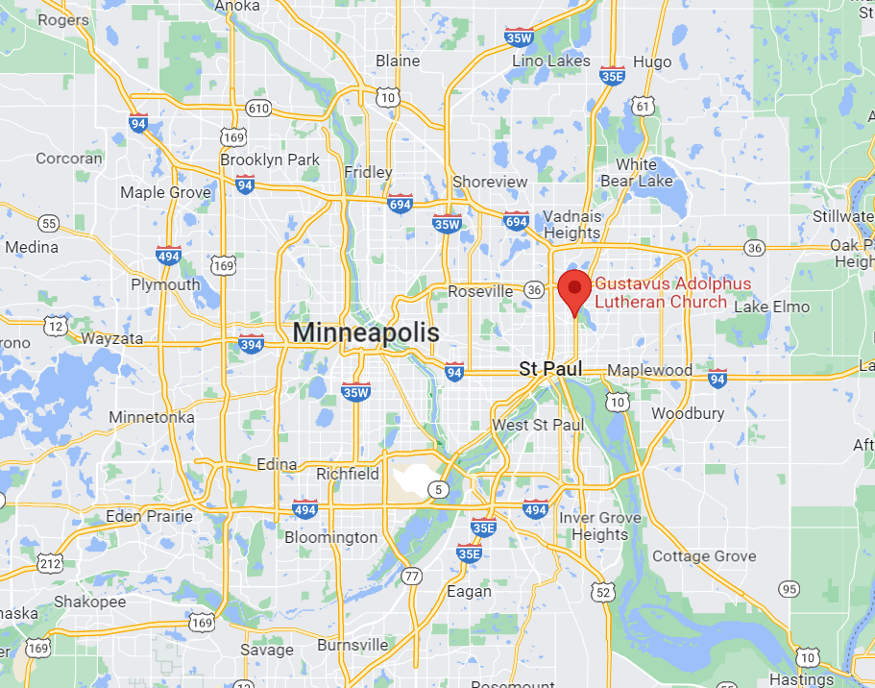

NOTE:
ARCADE ST IS ALSO HWY 61

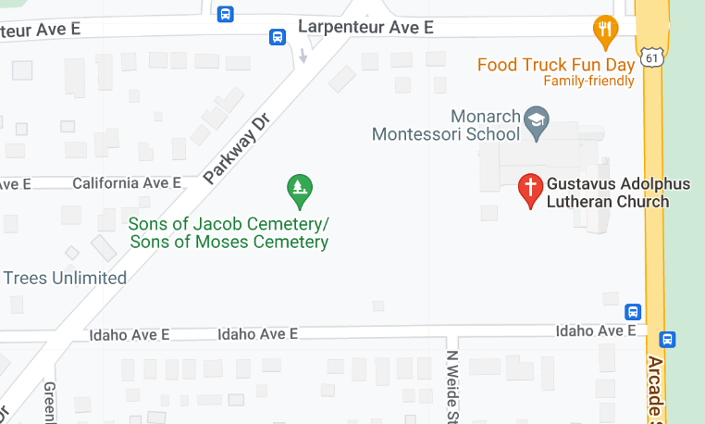
There are multiple entrances to the church parking lot on the surrounding streets. On the day of the meeting, enter the church either through Door #4 (north side, off Larpenteur Ave) or Door #1 (south side, off Idaho Ave).

p. 6

Twin Cities Area Church Library Association Meeting
Saturday, October 29, 2022

Currently masking is optional at Gustavus Adolphus.

8:30 Registration, Social Time, Book Swap Table Browsing
9:00 Welcome, Devotions, Business Meeting
9:30 Workshop on Book Donations
10:15 Break, Tours of the Library, Chapel and Sanctuary
10:30 Dawn Rundman Presentation
11:30 Break, Book Sales, Tours and Book Swap Continue
11:45 Lunch

If you can’t be with us in person that day, you can join us via Zoom.

---------------------------------------------------------------------------------------------------------------------------------------------------

TCACLA Fall Meeting
October 29, 2022
MEETING REGISTRATION FORM

Registration Deadline: October 24.

Your church name: ________________________________________________________________

Name(s) of person(s) attending in person: _______________________________________________

________________________________________________________________________________

Name(s) and e-mail address(es) of person(s) attending via Zoom:

Number of in-person registrants and their guests: _______ x $12.00 = $ ________.

Make checks payable to TCACLA. Mail the completed form and check(s) to:

Roberta Shaw
940 Franklin Ter Apt 404
Minneapolis MN 55406-1136
p. 7
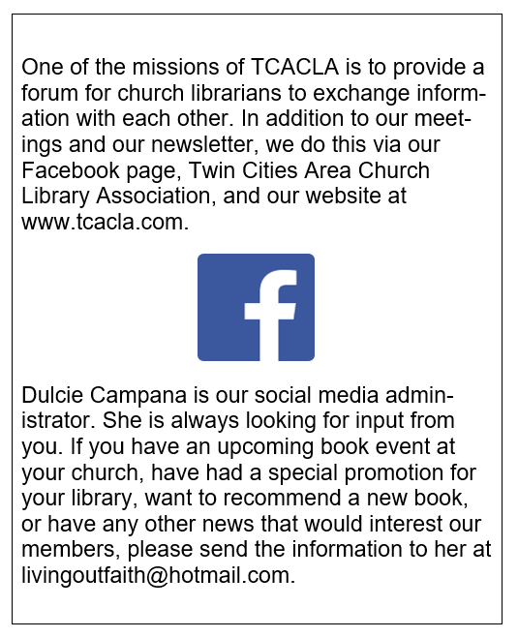


TCACLA Fall Meeting
October 29, 2022

OFF THE SHELF
c/o Laura Dirks
333 8th St SE Apt 206
Minneapolis, MN 55414-1246

