General Information
The Twin Cities Area Church Library Association (TCACLA) is a non-profit support organization serving church librarians. Member-ship is open to individuals and churches of all denominations that desire to network with others on church library development and enrichment.
TCACLA BOARD
Grace Kurtz, Co-President 651-631-3726 gkurtz61@gmail.com
Jeanne Schleh, Co-President 612-729-6041 jerebob@aol.com
Jan Nordin, Vice-President & Treasurer
612-590-7884 jan.lacher@hotmail.com
Leslie Kallas, Secretary 612-978-9572 ljkallas@gmail.com
Historian
Jan Bolstad bolstadje@yahoo.com
Off the Shelf Editor
Laura Dirks otseditor@gmail.com
Website
www.tcacla.com

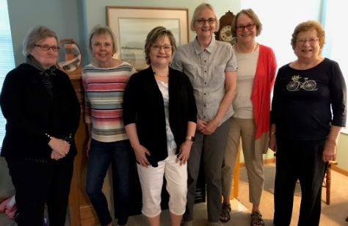
 |  |  | CON
Members: | 23 churches, 2 individuals
01/01/2020 | $3,240.38 |  | Beginning Balance
 | $310.00 |  | Membership Dues
 | -$400.00 |  | Fall 19 Meeting Expenses
 | -$52.65 |  | Off the Shelf Printing & Postage
 | -$18.17 |  | Website Expenses
06/30/2020 | $3,079.56 |  | Ending Balance

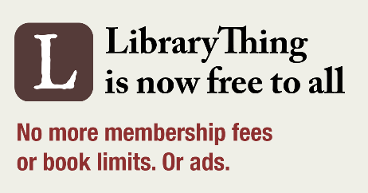  **************************************************************************  Thanks to the success of its other product lines, LibraryThing’s online catalog is now available to everyone without charge and for any number of books. They intended to announce this in conjunction with the roll out a new design of the site but decided to do it now when so many people are stranded at home and may be ex-periencing financial difficulty.  **************************************************************************  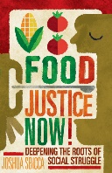  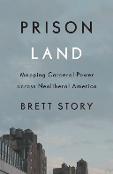  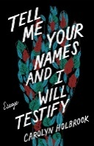  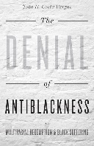  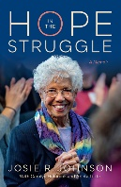  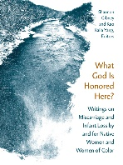  The University of MN Press is providing free online access to 22 books  in its “Reading for Racial Justice” collection through August 31. (upress.umn.edu)  **************************************************************************  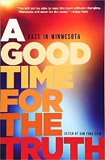  A digital version of the 2016 book, A GOOD TIME  FOR THE TRUTH: Race in Minnesota, published  by the Minnesota Historical Society Press, is avail-  able free on Ebooks Minnesota until August 23. (mndigital.org/projects/ebooks-minnesota) | )

p. 2
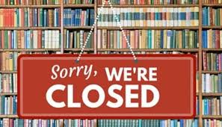
Lynn Tvedt, Faith Lutheran Church:
Our church library is not open. I can get in there to check on things periodically, but no normal activity. We have no book checkout but have received a few returns. I have put together a list of books to order but that has not happened yet because deliveries to the church have been limited. We have not had the opportunity to do any of our computer entries or other basic library tasks. So far we have not discussed any plans for when the library is made accessible again. The only communication with church members has been through our church newsletter and other computer-related communication. My communication with other committee members is either by email or phone conversations.
Hazel Lutz, Plymouth Congregational Church:
I am new at chairing the library committee and the committee members are all new too. We're taking this time to go through out library catalogue to identify books that are likely to be culled when we open the library. We are also working on organizing a book buying event for the library in the future.
Janet Brownell, House of Hope Presbyterian Church:
Our church has not reopened, so the library has not reopened. I have asked for, but as of yet, have not received permission to go in to check up on things. I haven’t been ordering new books; under the circumstances I can’t do anything with them as to processing, etc. anyway.
Sally Onstad, Prince of Peace Lutheran Church:
Both the church and the library are closed. However, I have worked there a few times weeding the collection before doing an inventory. I have also purchased some new titles and have received some donated ones. All are now cataloged, processed, and ready to be checked out as soon as the church is opened. They are on display now in anticipation of the library opening.
Judy Simko, St. Philip’s Lutheran Church:
Our library is not open at this time, as our church is not fully open. The library committee has not met since March. We will most likely be meeting the end of August. We have been thinking of some materials we would like to purchase. We have purchased several children’s books on the topic of racism and would like some adult books to be added.
Pat Loehlein, Maternity of Mary Church:
Our church library is closed. Unfortunately patrons can not have access to our collection to take out any of our resources even though they can find them in our ResourceMate catalog online. Our business administrator allows purchases of new books and other materials even when the library is closed. Our church is open for 50% capacity at Masses but we will have to publicize the reopening of the library widely. We will certainly have bulletin articles/inserts, pulpit announcements. I think that Mary Ksiazek will creatively come up with something fun as well.
Laura Dirks, Hennepin Avenue United Methodist Church:
Our building is officially closed but I have gone into the library by appointment. Our team has been able to continue purchasing and processing new books but are frustrated that we don’t have a way to make them available to the congregation. We meet periodically via Zoom. A proposal has been made to offer curbside pickup service, but it hasn’t been approved yet. We’ve publicized the library via occasional announcements in the church newsletter about free online materials from various sources. Recently we started working on a big project to finally eliminate our old paper card catalog that is still being used for books purchased prior to 2009.
Jeanne Schleh, St. Peder’s Evangelical Lutheran Church:
Our church is closed down with very limited office hours, but we are instituting curbside pickup of books from the library during those hours (with alternative arrangements available for those who can't make it then). Our July newsletter encourages members to use the library and, in particular, to consider our racial justice books. This initiative is supported by our Racial Justice Team, part of an ELCA initiative since 2016.

p. 3
OFF THE SHELF

Mission Statement: To energize church library ministry through education, resource sharing, spiritual encouragement and fellowship.

General Information

TCAC is an area chapter of the National Church Library Association, a non-profit support organization serving church librarians of all backgrounds. Membership is open to individuals or churches of all Christian denominations that desire assistance with church library development. Contact the national office or any TCAC board member if you are interested in joining or have questions.

Twin Cities Area
Chapter Board

Sandra Johnson, President
952-544-8117
sjj24@msn.com
Paula Erickson, Vice President
763-427-5128
pl.rcksn@gmail.com

Laura Dirks, Secretary
612-378-3026
Laura.Dirks@securian.com

Colleen Stieg, Treasurer
763-533-1702
cmks30@msn.com

National Office
National Church Library Association

275 South Third Street
Suite 101A
Stillwater, MN 55082
651-430-0770
info@churchlibraries.org
www.churchlibraries.org

Spring/Summer 2020
A Letter from Our TCACLA Co-Presidents

Dear Fellow Members of TCACLA,

With great regret, the TCACLA Board has concluded that it would be unsafe to plan our usual fall meeting this year. It appears highly unlikely that the Covid 19 pandemic will have run its course or that a vaccine will be available by October. In light of these circumstances, we have decided that 2020 will be a pause year for TCACLA.

Dues paid for 2020 will be applied to 2021. We look forward to seeing you all at our spring 2021 meeting.

In the meantime, the TCACLA newsletter will continue. At this time when we continue to shelter in place, we are given great new opportunities for reading and reflection, especially on social justice issues highlighted by the pandemic and the death of George Floyd and its aftermath. We would like the newsletter to provide a forum for sharing ideas on books and how we can continue to engage our congregations in reading and discussing the issues of the day—and what new methods of communication can be employed to do so while face-to-face communication continues to be restricted.

For starters, this issue of Off the Shelf contains ideas and timely books many of you have already contributed in response to editor Laura Dirks’ email. As your congregation adjusts to this new reality, and particularly as new books are read and discussed, please continue to share your experiences so that they can be shared in upcoming newsletters with other TCACLA members.

Stay safe and well—and keep on reading!

Sincerely,

Grace Kurtz and Jeanne Schleh
Co-Presidents

What’s been happening in our church libraries? See p. 3 for an edited version of the responses I received to my recent e-mail. As our co-presidents noted, we hope that this is the beginning of an ongoing dialogue as we begin to re-open our churches and libraries in the coming months – and hopefully a short-lived new section of the newsletter. Keep us posted!.....Laura Dirks

WHAT CHURCHES ARE READING

The books on the following pages were suggested by TCACLA members and/or have been featured on websites of publishers, bookstores, and publications. Priority was given to newer titles and those that have not been featured in an earlier edition of Off the Shelf. Please continue to e-mail book titles and authors to otseditor@gmail.com.

“No one is born hating another person because of the color of his skin, or his background, or his religion. People must learn to hate, and if they can learn to hate, they can be taught to love.” — Nelson Mandela

HOW TO BE AN ANTIRACIST by Ibram X. Kendi, Random House, 2019.

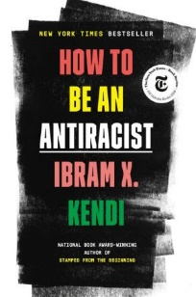

SO YOU WANT TO TALK ABOUT RACE by Ijeoma Oluo, Seal Press, 2019.

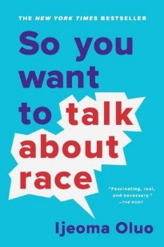

WHITE FRAGILITY: Why It's So Hard for White People to Talk about Racism by Robin DiAngelo, Beacon Press, 2018.

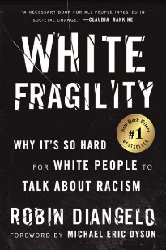

p. 4

Kendi takes readers through a widening circle of antiracist ideas--from the most basic concepts to visionary possibilities—to help them see all forms of racism clearly, understand their poisonous conse-quences, and work to oppose them in our systems and in ourselves. He weaves an electrifying com-bination of ethics, history, law, and science with his own personal story of awakening to antiracism. At its core, racism is a powerful system that creates false hierarchies of human value

How do you tell your roommate her jokes are racist? Why did your sister-in-law take umbrage when you asked to touch her hair--and how do you make it right? How do you explain white privilege to your white, privileged friend? Oluo guides readers of all races through subjects ranging from intersectionality and affirmative action to "model minorities" in an attempt to make the seemingly impossible possible: honest conversations about race and racism, and how they infect almost every aspect of American life.

DiAngelo explores counterproductive reactions white people have when their assumptions about race are challenged and how these reactions maintain racial inequality. White fragility is characterized by emotions such as anger, fear, and guilt, and by behaviors including argumentation and silence. These behaviors, in turn, function to reinstate white racial equilibrium and prevent any meaningful cross-racial dialogue. In this in-depth exploration, DiAngelo suggests what we can do to engage more con-structively.

BE THE BRIDGE; Pursuing God's Heart for Racial Reconciliation by Latasha Morrison, Waterbrook Press, 2019.

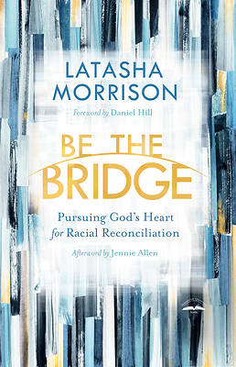

RAISING WHITE KIDS; Bringing Up Children in a Racially Unjust America by Jennifer Harvey, Abingdon Press, 2019.

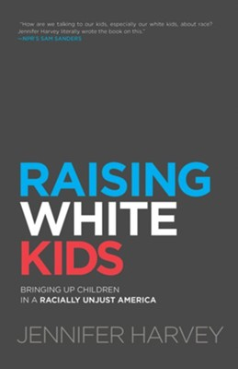

AMERICA’S ORIGINAL SIN; Racism, White Privilege, and the Bridge to a New America
by Jim Wallis, Baker Publishing, 2017.

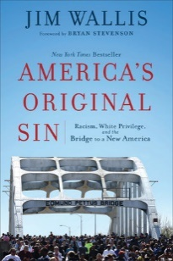

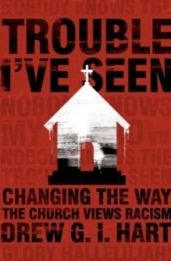
TROUBLE I'VE SEEN THE END; Changing the Way the Church Views Racism by Drew Hart, Herald Press, 2016.

p. 5
Morrison, a leading advocate for racial reconciliation, offers a clarion call for Christians to move toward relationship and deeper understanding in a divisive culture. She applies biblical principles, such as lamentation, confession, and forgiveness, to lay the framework for restoration. Along with prayers, discussion questions, and other resources to en-hance group engagement, Be the Bridge presents a vision of what it means for every follower of Jesus to become a bridge builder—committed to pursuing justice and racial unity in light of the gospel. Christianity Today Book Award Winner

Raising White Kids is for families, churches, educa-tors, and communities who want to equip their children to be active and able participants in a soci-ety that is becoming one of the most racially diverse in the world while remaining full of racial tensions. What can we do? Should we teach our children to be “color-blind” or to notice race? What roles do we want to equip them to play in addressing racism when they encounter it? What strategies will help our children learn to function well in a diverse nation?

Fifty years ago, Wallis was driven away from his faith by a white church that considered dealing with rac-ism to be taboo. His participation in the civil rights movement brought him back when he discovered a faith that commands racial justice. Yet as recent tra-gedies confirm, we continue to suffer from the legacy of racism. Probing yet positive, biblically rooted yet practical, this book shows people of faith how they can work together to overcome the embedded rac-ism in America, galvanizing a movement to cross the bridge to a multiracial church and a new America.

What if all Christians listened to the stories of those on the racialized margins? How might the church be changed by the trouble we’ve seen? Hart, a theo-logian and blogger, places police brutality, mass incarceration, antiblack stereotypes, poverty, and everyday acts of racism within the larger framework of white supremacy. Leading readers toward Jesus, he offers concrete practices for churches that seek solidarity with the oppressed and are committed to racial justice.

SOMETHING HAPPENED IN OUR TOWN: A Child's Story About Racial Injustice by Marianne Celano, Magination Press, 2018.
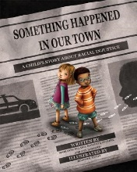

ANTIRACIST BABY by Ibram X. Kendi, Penguin, 2020.

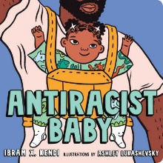

NEW KID by Jerry Craft, HarperCollins, 2019.
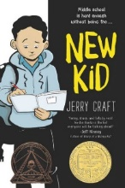

GENESIS BEGINS AGAIN by Alicia D. Williams, Atheneum, 2019.
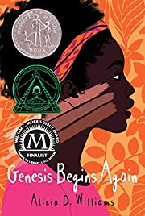

DEAR MARTIN by Nic Stone, Random House, 2018.
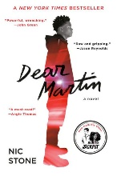

The book follows 2 families -- one white, one black -- as they discuss a police shooting of a black man itheir community. The story aims to answer children's questions about such traumatic events and to help children identify and counter racial injustice in their own lives. Written by 3 psychologists, the book is a National Parenting Product Award Winner and in-cludes an extensive note to parents and caregivers.

Take your first steps with Antiracist Baby! Or rather, follow this board book’s 9 easy steps for building a more equitable world. With bold art and thoughtful yet playful text, it introduces the youngest readers and the grown-ups in their lives to the concept and power of antiracism while providing the language necessary to begin critical conversations at the earliest age.

Multiple award-winning graphic novel. Instead of sending him to the art school of his dreams, Jordan’s parents enroll him in a private school known for its academics, where he is one of the few kids of color. As Jordan makes the daily trip from his Washington Heights apartment to the upscale Riverdale Acad-emy Day School, he finds himself torn between two worlds and not really fitting into either one.

There are 96 things Genesis hates about herself. She knows the exact number because she keeps a list. Like #95: Because her skin is so dark, people call her charcoal and eggplant—even her own family. A deeply sensitive and powerful novel that tells the story of a 13-year-old who must overcome internal-ized racism and a verbally abusive family to finally learn to love herself. Another multiple award winner.

Justyce McAllister is a good kid, an honor student, and always there to help a friend. Then comes the day Justyce goes driving with his best friend, Manny, windows rolled down, music turned up—way up, sparking the fury of a white off-duty cop. Words fly. Shots are fired. Justyce and Manny are caught in the crosshairs. In the media fallout, it's Justyce who is reckoning with the ugly, persistent violence of social injustice.” Publishers Weekly
p. 6

DEADLIEST ENEMY: Our War Against Killer Germs by Michael T. Osterholm and Mark Olshaker, Little Brown, 2020.

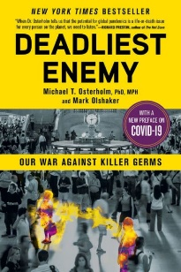

GOD AND THE PANDEMIC: A Christian Reflection on the Coronavirus and Its Aftermath
by N. T. Wright, Zondervan, 2020.

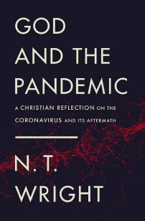

Drawing on the latest medical science, case studies, policy research, and hard-earned epi-demiological lessons, Deadliest Enemy explores the resources and programs we need to develop if we are to keep ourselves safe from infectious disease. The authors show how we could wake up to a reality in which many antibiotics no longer cure, bioterror is a certainty, and the threat of a disas-trous influenza or coronavirus pandemic looms ever larger. Only by understanding the challenges we face can we prevent the unthinkable from becoming the inevitable.

Wright, a New Testament scholar, has just written a guide to seeing the events of the day through the light of Jesus’ death and resurrection. He shows that a careful reading of the Bible and Christian history offers simple though profound answers to our many questions, including: What should be the Christian response? How should be think about God? How do we live in the present? What should we lament? What should we learn about ourselves? How do we recover?

TRUTH AND HOPE; Essays for a Perilous Age
by Walter Brueggemann, Westminster John Knox, 2020.
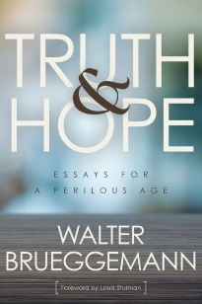

THE SPIRIT OF HOPE: Theology for a World in Peril by Jürgen Moltmann, Westminster John Knox, 2019.
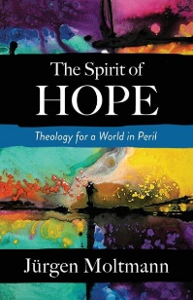

p. 7

In this collection of essays, Brueggemann provides a lens into biblical teachings concerning the present age of fake news, lies, and alternate realities. The prophetic tradition of Jeremiah, for instance, is preoccupied with truth-telling that exposes false-ness. That same prophetic tradition, like many others, turns eventually to the work of hope-telling. Such hope does not doubt that the faithful God can create futures, a way out of no way. Our temptation is to do the work of hope without the prior work of truth.

In the 21st century, Moltmann tells us, hope is challenged by ideologies and global trends that would deny hope and even life itself. Terrorist violence, social and economic inequality, and most especially the looming crisis of climate change all contribute to a cultural moment of profound despair. Here, he reminds us that Christian faith has much to say in response to a despairing world. In “the eternal yes of the living God,” we affirm the goodness and ongoing purpose of our fragile humanity. Likewise, God’s love empowers us to love life and resist a culture of death.

WHEN KIDS ASK HARD QUESTIONS: Faith-Filled Responses for Tough Topics edited by Bromleigh McCleneghan, APG Trade West, 2019.

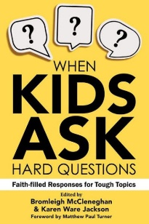

HOW TO HELP YOUR ANXIOUS TEEN: Discovering the Surprising Sources of Their Worries and Fears by Jessica Thompson, Harvest House, 2019.
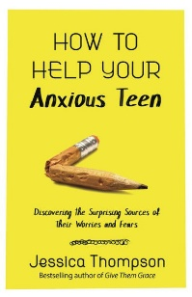

Learn to craft faithful conversations and be better prepared to talk about the tough stuff with children. More than 30 essays from a diverse group of young parents and pastors (multiple faiths) address today’s toughest topics, including gender, race, bullying, mental illness, death, divorce, money, technology, and generosity. When Kids Ask Hard Questions invites readers to take a deep breath, create safe spaces for the hard conversations, and speak the truth in love. Each chapter includes a resource list for further exploration.

Thompson, the mother of 3 teens, has seen kids struggle with anxiousness. With a gospel centered perspective, she wants readers to understand the issues surrounding teenage anxiety and how our culture (social media, it’s not OK to be normal), the church (“be the best Christian you can be”), and perhaps even parents (inadvertently over-correcting their teens’ behavior and trying to control it) are contributing to the problem.

