OFF THE SHELF

Mission Statement: To energize church library ministry through education, resource sharing, spiritual encouragement and fellowship.
Winter 2020

General Information

TCAC is an area chapter of the National Church Library Association, a non-profit support organization serving church librarians of all backgrounds. Membership is open to individuals or churches of all Christian denominations that desire assistance with church library development. Contact the national office or any TCAC board member if you are interested in joining or have questions.

Twin Cities Area
Chapter Board

Sandra Johnson, President
952-544-8117
sjj24@msn.com
Paula Erickson, Vice President
763-427-5128
pl.rcksn@gmail.com

Laura Dirks, Secretary
612-378-3026
Laura.Dirks@securian.com

Colleen Stieg, Treasurer
763-533-1702
cmks30@msn.com

National Office
National Church Library Association

275 South Third Street
Suite 101A
Stillwater, MN 55082
651-430-0770
info@churchlibraries.org
www.churchlibraries.org

Inside This Issue
Treasurer’s Report  2020 Membership Renewal  Circulation Question | 2
What Churches Are Reading | 3-4
Fall Meeting Highlights | 5-6
Odds ‘n’ Ends | 7
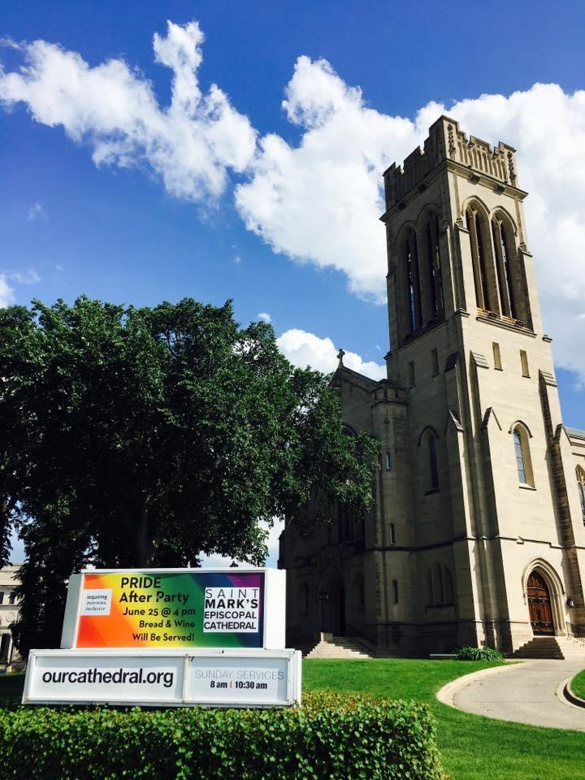


519 Oak Grove Street
Minneapolis



Spring Meeting
May 2, 2020

The spring meeting will be at Saint Mark’s Episcopal Cathedral. The Cathedral is known for its unique bell tower which chimes throughout the day and is lighted with seasonal colors during the year.
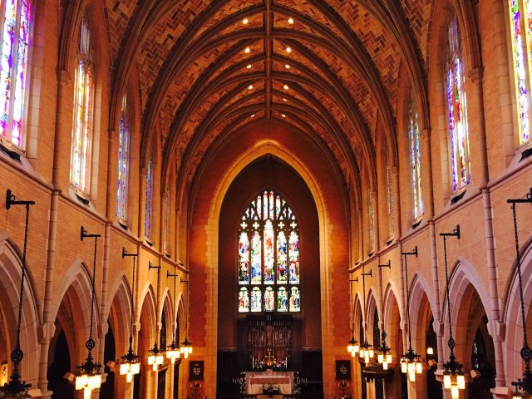
Saint Mark’s life began in 1858 as a north Minneapo-
lis mission of Gethsemane Church. Over time, the congregation grew and moved to other locations. When a parishioner offered to sell a portion of her Loring Park estate to the church at a very generous price, the dream of Bishop Samuel Cook Edsall to build a new cathedral for the Diocese of Minnesota was realized. Within 5 years of its opening in 1910, the church had over 1,000 members. Its designation as Cathedral came in 1941.
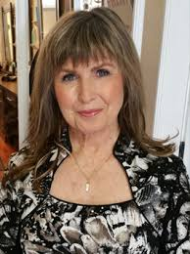
The morning’s keynote speaker is Dr. Janis Amatuzio, an expert in forensic pathology and author of 2 books that explore the mys-tery of death. The title of her presentation is “Forensic Secrets of a Good Strong Life: Messages from Within."

The Spring issue of Off the Shelf will include detailed information on the full program, a registration form, and directions to the church.

General Information
The Twin Cities Area Church Library Association (TCACLA) is a non-profit support organization serving church librarians. Member-ship is open to individuals and churches of all denominations that desire to network with others on church library development and enrichment.
TCACLA BOARD
Grace Kurtz, Co-President 651-631-3726 gkurtz61@gmail.com
Jeanne Schleh, Co-President 612-729-6041 jerebob@aol.com
Jan Nordin, Vice-President & Treasurer
612-590-7884 jan.lacher@hotmail.com
Leslie Kallas, Secretary 612-978-9572 ljkallas@gmail.com
Historian
Jan Bolstad bolstadje@yahoo.com
Off the Shelf Editor
Laura Dirks otseditor@gmail.com
Website
www.tcacla.com

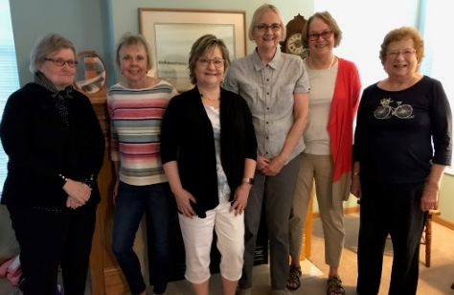

 |  |  | CON
Members: | 25 churches, 1 individual
01/01/2019 | $2,128.51 |  | Beginning Balance
 | $1,203.00 |  | Meeting Registration
 | $510.00 |  | Membership Dues
 | $1,713.00 |  | Income
 | -$432.05 |  | Meeting Costs
 | -$137.91 |  | Off the Shelf Printing & Postage
 | -$31.17 |  | Website Fees
 | -$601.13 |  | Expenses
12/31/2019 | $3,240.38 |  | Ending Balance

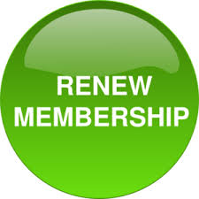
**************************************************************************
2020 MEMBERSHIP FORM

If your church hasn’t renewed its membership
for 2020 yet, you’ve received a renewal form
with this issue of Off the Shelf. For just $20.00,
any number of people from your church can
register for meetings at the member rate.

Please complete both sides of the form, then mail it to the
Treasurer with your check by no later than March 31, 2020.

**************************************************************************
The New York Public Library recently released a list of the 10 most borrowed titles during its 125-year history. The most wanted book during this time was The Snowy Day by Ezra Jack Keats. The most wanted book in 2019 was Becoming by Michelle Obama.
What are the most borrowed titles in your library? How do you
track this? Send your replies to otseditor@gmail.com.

WHAT CHURCHES ARE READING

The following books were recently added to the libraries of TCACLA member churches. You are encouraged to share what your church is reading on a regular basis. Please e-mail book titles and authors to otseditor@gmail.com.

“Read. Read anything. Read the things they say are good for you and the things they claim are junk. You’ll find what you need to find. Just read.” – Neil Gaiman
CHILD OF THE RIVER; a Novel by Irma Joubert, Gale Group, 2017.

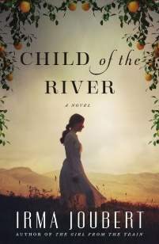

EXACTLY AS YOU ARE; The Life and Faith of Mister Rogers by Shea Tuttle, Wm. Eerdmans, 2019.

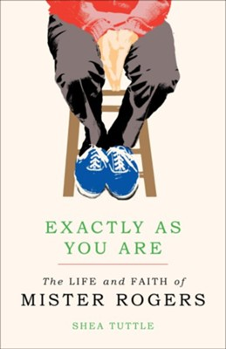

BECOMING MRS. LEWIS; The Improbable Love Story of Joy Davidman and C. S. Lewis by Patti Callahan, Thomas Nelson, 2018.

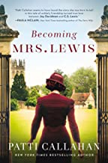

p. 3

A compelling coming of age story of heartbreak and triumph set in South Africa at the dawn of apartheid. Persomi is young, white, and poor, born the middle child of illiterate sharecroppers. When her very small world falls apart and she must navigate the tragedies of war and racial strife in her homeland, bigger dreams become open to her - an education, a profession, a native country that values justice and equality, and love. Ultimately, she discovers who she truly is, where she belongs, and why her life and every life matters.

An exploration of the kind, influential, and sometimes surprising Fred Rogers: the neighborhood he came from, the neighborhood he built, and the kind of neighbor he, by his example, calls all of us to be. Tuttle pays particular attention to Rogers’ Christian faith. He was a deeply spiritual person, ordained by his church with a one-of-a-kind charge to minister to children and families through television. He was guided by his core belief: God loves children, and everyone else, exactly as they are.

A historical novel about the woman C. S. Lewis called “my whole world.” When poet and writer Joy Davidman began writing letters to C. S. Lewis, she was looking for spiritual answers, not love. Every-thing about New Yorker Joy seemed ill-matched for an Oxford don and the beloved writer of Narnia, yet their minds bonded over their letters. Joy traveled from America to England and back again, struggling to become her own person at a time when women had few options. She faced heartbreak and poverty, dis-covered friendship and faith, and against all odds, found a love that even the threat of death couldn’t destroy. 2019 Christy Award for Book of the Year.

THE WARRIOR MAIDEN by Melanie Dickerson, Thomas Nelson, 2019.
. 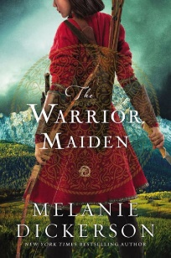

THERE THERE by Tommy Orange, Knopf, 2018.

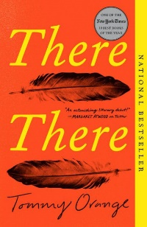

WHY RELIGION?; a Personal Story by Elaine Pagels, Harper Collins, 2018.

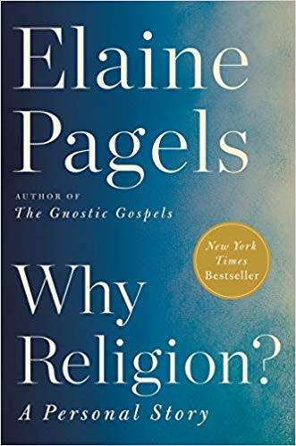

THE BAGGAGE HANDLER; a Novel by David Rawlings, Thomas Nelson, 2019.

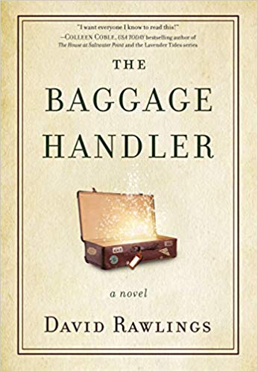

p. 4

A reimagining of the classic Mulan tale in medieval Europe, where both love and war challenge even the strongest of hearts. When Mulan takes her father’s place in battle against the besieging Teutonic Knights, she realizes she has been preparing for this journey her whole life—and that her life, and her mother’s, depends on her success. As the adopted daughter of poor parents, Mulan has little power in the world. If she can’t prove herself on the battlefield, she could face death—or, perhaps worse, marriage to the village butcher. 2019 Christy Award for Young Adult Novel.

This multiple-award winning novel follows 12 characters from Native communities - all traveling to the Big Oakland Powwow, all connected to one another in ways they may not yet realize. Together, their chorus of voices tells of the plight of today’s urban Native American. With themes of violence, identity and despair, There There is at once poignant and unflinching. The unexpected ending may disturb some readers but others feel it is powerful and appropriate.

A memoir from a best-selling author and professor of religion at Princeton University that echoes the book of Job. After her husband died in a hiking accident less than a year after her young son died of a heart problem, Pagels’ body became covered with boils. While sharing her personal story, she illuminates how, for better and worse, religious traditions have shaped how we understand ourselves, how we relate to one another, and how to get through the most difficult challenges we face.

When Gillian, David, and Michael each take the wrong suitcase from baggage claim, the airline directs them to retrieve their bags at a mysterious facility in a deserted part of the city. There they meet the enigmatic Baggage Handler, who shows them there is more in their baggage than what they have packed and carrying it with them is slowing them down in ways they can’t imagine. And they must deal with it before they can leave. A modern-day parable about the burdens that weigh us down and an inspiring invitation to lighten the load. 2019 Christy Award for First Novel.
.

TCACLA FALL MEETING HIGHLIGHTS

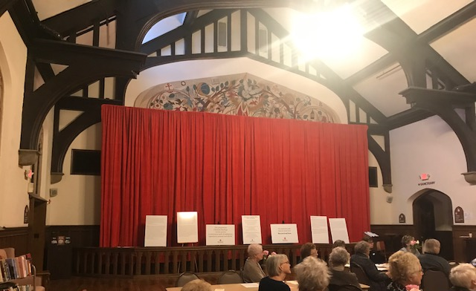
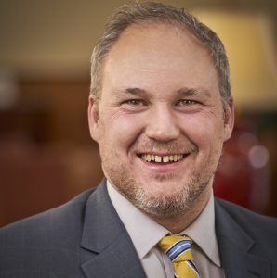
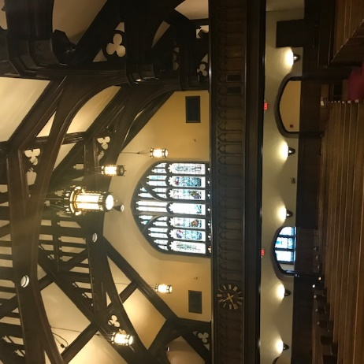
The 2019 fall meeting was hosted by Plymouth Congregational Church in Minneapolis on October 12. Seth Patterson, Director of Spiritual Formation and Theater, welcomed us and provided a brief history of the Guild Hall, the original sanctuary and our meeting site. As a prelude to the focus of our meeting, he also reflected on the church’s recent conversations about imagery and symbolism in the church artwork.
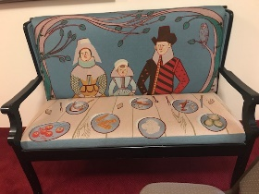

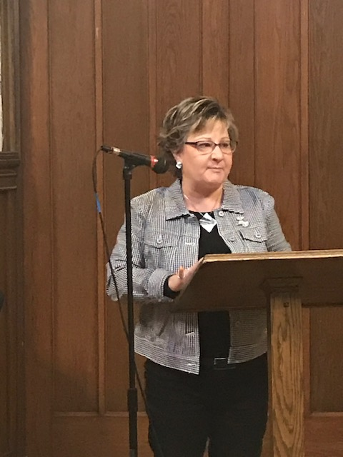
Vice-President Jan Nordin called the Business Meeting to order. The minutes of the 2018 meeting were distributed and approved.
There being no nominations for officers from the floor, Co-Presidents Grace Kurtz and Jeanne Schleh and Secretary Leslie Kallas were re-elected for their second two-year terms by acclimation.
New member Emily Hoch offered to host the spring meeting at Saint Mark’s Episcopal Cathedral.
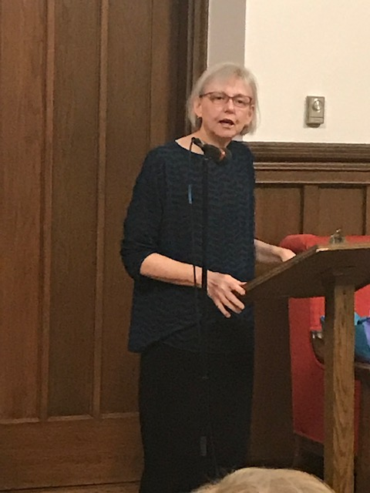

Susan Marie Swanson, an award-winning author of children’s books, poet and educator, made a spirited and insightful presentation which she titled “Picture Book Joy: Recent Picture Books by Minnesota Authors and Artists.”
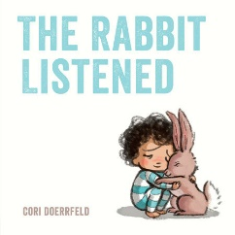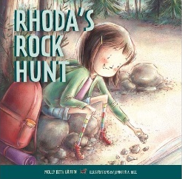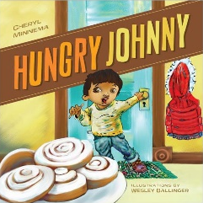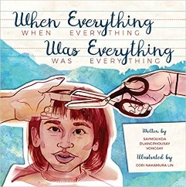
p. 5
Per Susan Marie, there are 4 principles of good picture books: (1) They are either mirrors in which children see themselves or windows to see other cultures. (2) They embody values. (3) They are communal literature. (4) They are complex works of art. Resources for learning about new picture books by Minnesota authors and artists include public libraries, independent booksellers, the Minnesota Writers Directory, the Minnesota Book Awards, and the Minnesota Children’s Book Festival at Anderson Center in Red Wing.
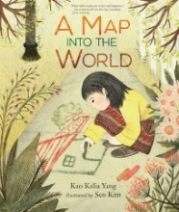
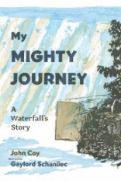
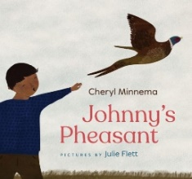
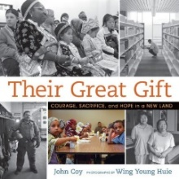
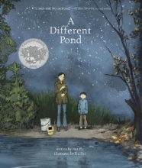
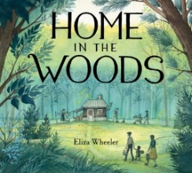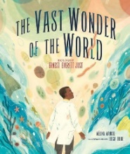

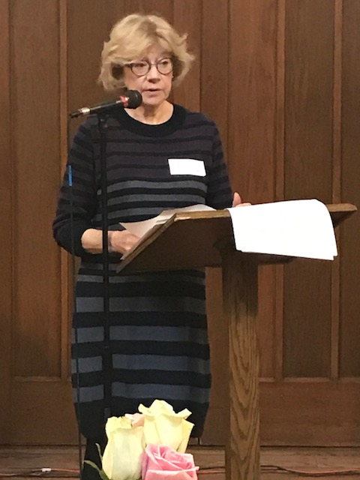
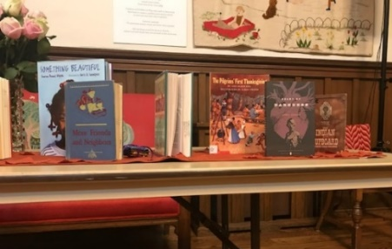
Meg Gisslen led a workshop entitled “Identifying Racism and Sexism in Your Library.” In conjunction with this, she distributed an 8-page document, “Social Justice in the Church Library,” which suggests several criteria for evaluating children’s books. Attendees were invited into the library for a scavenger hunt to find books that were being removed from the church library as a result of going through this evaluation process. There was a lively discussion afterward, particularly over the challenge of classic, well-loved older books such as The Adventures of Huckleberry Finn that look very different to us in 2020.
Copies of Susan Marie’s book list and Meg’s document were distributed to TCACLA members by e-mail after the meeting. If you didn’t receive them, please contact otseditor@gmail.com for copies.
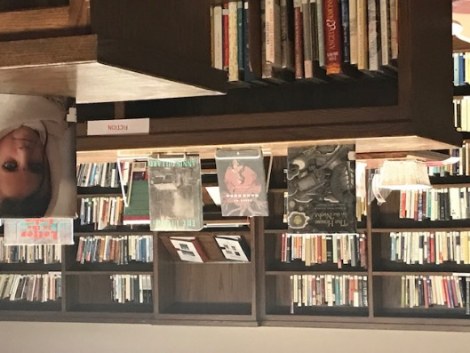
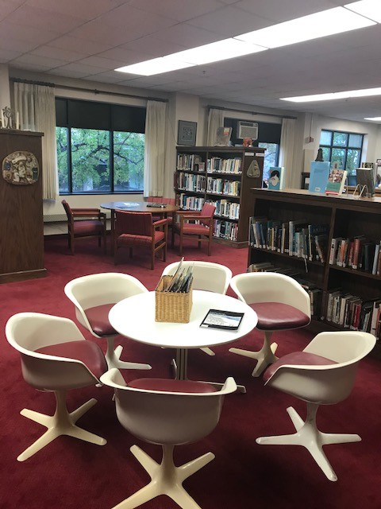
The Elaine Marsh Library supports the spiritual journey of members and friends and the mission of Plymouth Church.
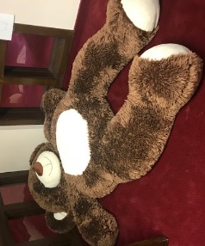

Secretary Leslie Kallas and Historian & Photographer Jan Bolstad made significant contributions to this section.
p. 6
Now that we’ve been inspired to include more diversity in the children’s books in our libraries, the challenge will be to find them. Meg Gisslen provided this interesting graphic.

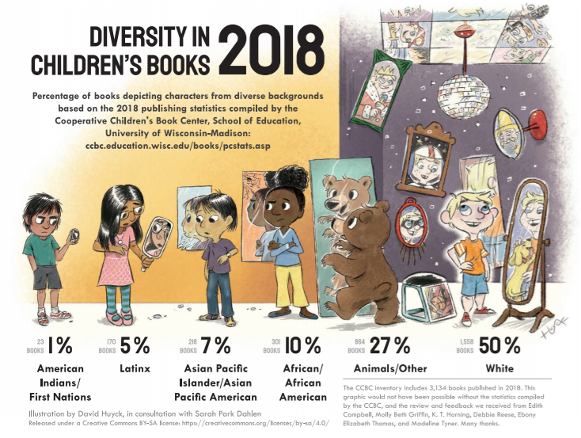

******************************************************************************************
On November 10, 2019, members of Plymouth Congregational Church voted to uphold the church leadership’s decision to stop displaying a massive fall embroidery that was first hung in1974. This decision was based on a “commitment to racial justice” and a “desire to be inclusive of all people’s history.” Churchmen in the New World shows Pilgrims and Native Americans gathered at a table — part of the harmful Thanksgiving myth, some said — as well as a slave ship with people being led away. It was draped with a large red cloth on the day of our meeting.
******************************************************************************************
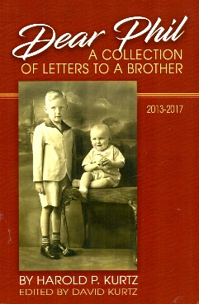
In Dear Phil; a Collection of Letters to a Brother, author Harold Kurtz captures a more innocent age in the letters he wrote for his older brother, Phil, after Phil suffered a stroke. This compilation of family stories highlights small town parsonage life in Brandon, WI in the 1940’s where family, school, and church were the primary poles in which life was anchored. For ordering information, contact kurtzfamilypublications@gmail.com or talk to Grace (Mrs. Harold) Kurtz, one of our Co-Presidents.
p. 7
One of the missions of TCACLA is to provide a forum for church librarians to exchange information with each other. In addition to our meetings and our newsletter, we do this via our website at www.tcacla.com and our Facebook page, Twin Cities Area Church Library Association.



Dulcie Campana, our social media adminis-trator, is always looking for input from you. If you have an upcoming book event at your church, have had a special promotion for your library, want to recommend a new book, or have any other news that would interest our members, please send the information to her at livingoutfaith@hotmail.com.

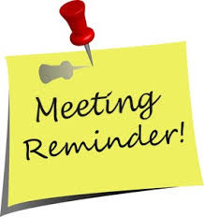
TCACLA Spring Meeting
May 2, 2020

OFF THE SHELF
c/o Laura Dirks
333 8th St SE Apt 206
Minneapolis MN 55414-1246

