
Mission Statement: To energize church library ministry through education, resource sharing, spiritual encouragement and fellowship.
OFF THE SHELF

General Information

TCAC is an area chapter of the National Church Library Association, a non-profit support organization serving church librarians of all backgrounds. Membership is open to individuals or churches of all Christian denominations that desire assistance with church library development. Contact the national office or any TCAC board member if you are interested in joining or have questions.

Twin Cities Area
Chapter Board

Sandra Johnson, President
952-544-8117
sjj24@msn.com
Paula Erickson, Vice President
763-427-5128
pl.rcksn@gmail.com

Laura Dirks, Secretary
612-378-3026
Laura.Dirks@securian.com

Colleen Stieg, Treasurer
763-533-1702
cmks30@msn.com

National Office
National Church Library Association

275 South Third Street
Suite 101A
Stillwater, MN 55082
651-430-0770
info@churchlibraries.org
www.churchlibraries.org

Summer 2019
Inside This Issue
Treasurer’s Report  Election of Officers | 2
What Churches Are Reading | 3-4
Spring Meeting Highlights | 5-6
Library Odds ‘n’ Ends | 7
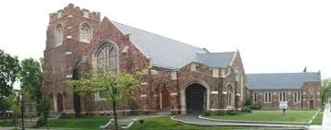

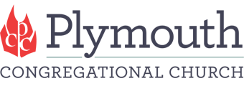

1900 Nicollet Ave S Minneapolis

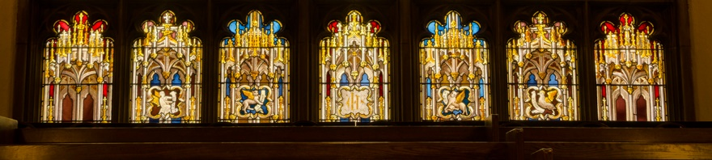



TCACLA Fall Meeting
October 12, 2019

The fall meeting will be at Plymouth Congregational Church, which is located at the southern edge of downtown Minneapolis. Founded in 1857, today Plymouth is a progressive faith community of 1,600 people. Per its web site, the church is “grounded in the Christian tradition. In mutual care and respect for our diverse understandings of God, we seek to embody the radical love and justice found in the life, teachings and spirit of Jesus…We are committed to creating sanctuary for the soul and seeking the sacred in all ways. We engage the ancient teachings to bring them alive today, nourishing and expanding hearts and minds to become the change we want to see in the world.”
Plymouth’s Elaine Marsh Library’s collection includes over 3,000 books on current thinking on social justice issues, personal growth, and religion, as well as meaningful fiction for children, young adult, and adult readers. It is open 8:30 a.m.-12:30 p.m. Sundays and 6:00-9:00 p.m. Wednesdays during the program year. Go to www.librarycat.org/lib/PlymouthCC to see the library catalog.
The Fall issue of Off the Shelf will include detailed information on the program, a registration form and directions to the church.

General Information
The Twin Cities Area Church Library Association (TCACLA) is a non-profit support organization serving church librarians. Member-ship is open to individuals and churches of all denominations that desire to network with others on church library development and enrichment.
TCACLA BOARD
Grace Kurtz, Co-President 651-631-3726 gkurtz61@gmail.com
Jeanne Schleh, Co-President 612-729-6041 jerebob@aol.com
Jan Nordin, Vice-President & Treasurer
612-590-7884 jan.lacher@hotmail.com
Leslie Kallas, Secretary 612-978-9572 ljkallas@gmail.com
Historian
Jan Bolstad bolstadje@yahoo.com
Off the Shelf Editor
Laura Dirks otseditor@gmail.com
Website
www.tcacla.com

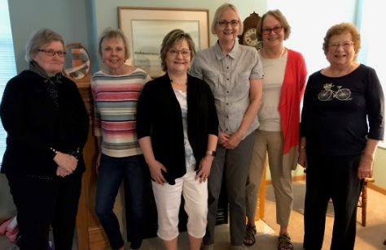
 |  |  | CON
Members: | 25 churches, 1 individual
01/01/2019 | $2,128.51 |  | Beginning Balance
 | $648.00 |  | Meeting Registration
 | $265.00 |  | Membership Dues
 | $913.00 |  | Income
 | -$332.05 |  | Meeting Costs
 | -90.17 |  | Off the Shelf Printing & Postage
 | -$18.17 |  | Website Fee
 | -$440.39 |  | Expenses
06/30/2019 | $2,601.12 |  | Ending Balance


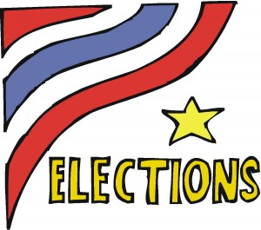
**************************************************************************

During the annual business meeting on October 12, we will be
electing a President and a Secretary for the 2020-2021 term. If
you, perhaps along with a friend, are interested in filling one of
these positions, please contact any of the board members listed
on this page.

p. 2
WHAT CHURCHES ARE READING

The following books were recently added to the libraries of TCACLA member churches. You are encouraged to share what your church is reading on a regular basis. Please e-mail book titles and authors to otseditor@gmail.com.

“Reading is a form of prayer, a guided meditation that briefly makes us believe we’re someone else, disrupting the delusion that we’re permanent and at the center of the universe. Suddenly (we’re saved!) other people are real again, and we’re fond of them.” —George Saunders
THE SAME SKY; a Novel by Amanda Eyre Ward, Ballantine Books, 2015.

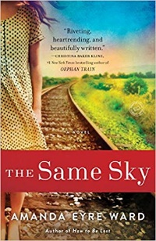

THE LIFE OF FREDERICK DOUGLASS; A Graphic Narrative of a Slave's Journey from Bondage to Freedom by David F. Walker, Potter/Ten Speed, 2019.

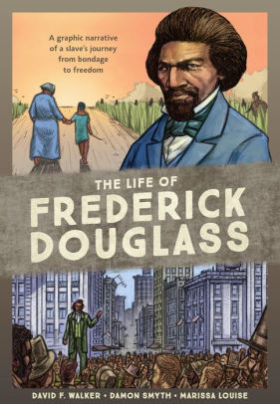

WHERE WE BELONG by Lynn Austin, Bethany House, 2017.
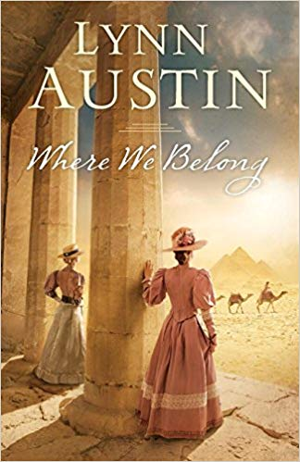

p. 3
Alice and her husband own a barbecue restaurant in Austin, TX. Carla is a strong-willed young girl in Honduras. When her grandmother dies and violence in the city escalates, she and her brother join the thousands of children making their way across Mexico to America, facing great peril for the chance at a better life. The lives of Alice and Carla intersect in a profound and surprising way. “Sure to provoke conversations about immigration and adoption.”—The New York Times Book Review
Comic book writer and filmmaker David F. Walker joins with the art team of Damon Smyth and Marissa Louise to bring Frederick Douglass to life. Told from Douglass’s point of view and based on his own autobiographical writings and speeches, the book takes readers from his life as a young slave through his forbidden education to his escape and prominence as a speaker, abolitionist, and influential cultural figure. Along the way, special features provide additional background on the history of slavery in the US, the development of photography, and the Civil War.

In 1892 Chicago, the rules for Victorian women are strict, their roles are limited. But sisters Rebecca and Flora Hawes are not typical Victorian ladies. Their love of adventure and their desire to use their God-given talents have taken them out of society ball-rooms and delivered them to the Sinai Desert. Ac-companied by their somber young butler and a street urchin who is learning to be their ladies' maid, the two women are on a quest to find an important biblical manuscript. Based on the true story of remarkable Scottish twins who discovered a copy of the “hidden Gospels.”

LOOKING INTO YOU by Chris Fabry, Tyndale House, 2018.
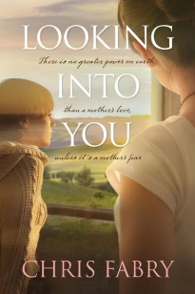

CATCHING THE WIND by Melanie Dobson, Tyndale House, 2017.
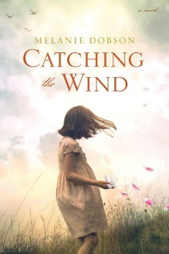

THE FASHION DESIGNER by Nancy Moser, Barbour Publishing, 2018.
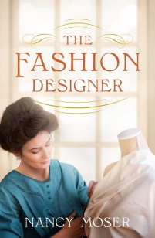

REMARKABLY YOU by Pat Zietlow Miller, HarperCollins, 2019.
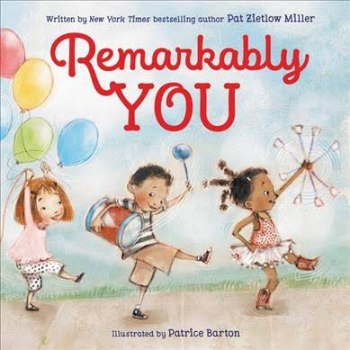

p. 4
In this follow up to Every Waking Moment, Fabry explores the concept of being so ashamed of some-thing that you’ve done that you lie to cover it up. Paige Redwine is haunted by a choice she made when she was 17. Now, just past 40 and still single, she lives a tidy, controlled life as a well-respected English professor. Nothing could prepare her for the day Treha Langsam, the daughter she secretly placed for adoption, walks into her classroom as a student, unknowingly confronting Paige with both her greatest longing and her greatest fear.
When Daniel Knight was 13, he and 10-year-old Brigitte Berthold escaped the Gestapo agents who arrested their parents. They survived a harrowing journey from Germany to England, only to be separated upon their arrival. Daniel vowed to find Brigitte after the war, a promise he has fought to fulfill for more than 70 years. Now a wealthy old man, Daniel’s final hope in finding Brigitte rests with Quenby Vaughn, an American journalist working in London. Together, they delve deep into the past, following a trail of deception, sacrifice, and healing that could change all of their futures. Winner of several awards for historical Christian fiction.

Annie Wood, a housemaid-turned-pattern designer, jumps at the chance to design her own clothing line when a wealthy New York couple offers to finance her endeavor. Personal and financial setbacks test old relationships and new romances while threatening to keep the business from ever selling a single dress. No one said it would be easy. But the promise of the American Dream holds a deep hope for those who work hard, trust God, and never give up. #2 in The Pattern Artist series.

A rhyming picture book about all the things - little or small, loud or quiet – that make us who we are. It encourages children to find what they’re good at and stick with their gifts, even if they’re different from those around them. Racially diverse with an under-lying theme of treating others with dignity and respect. Age range: 4-8.

TCACLA SPRING MEETING HIGHLIGHTS

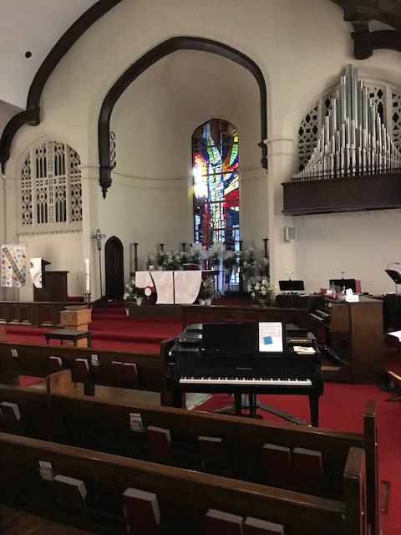
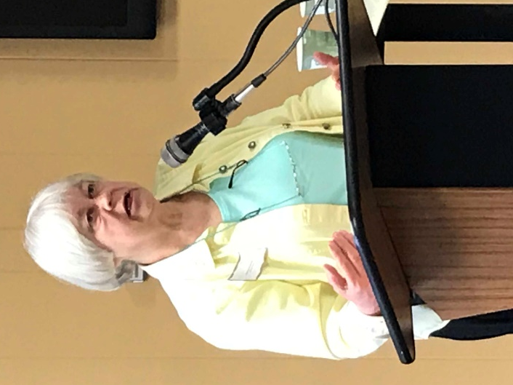
The spring meeting was hosted by Holy Trinity Lutheran Church. Librarian Roberta Shaw welcomed us to the church, offered a brief history of the congregation, and outlined their goals for the next 2 years. Her devotions, “O Spring Rising Out of Winter’s Arms,” came from The Circle of Life by Joyce Rupp and Macrina Wiederkehr.

Stephanie Landsem, author of The Living Water series, spoke about her interest in bringing the women in the Gospels (both named and unnamed) to life. She considers whether the lives of these women are similar or different to ours, demonstrates how the treatment of women by Jesus was radical in the context of his time, and examines how the encounters with Jesus changed the women. Stephanie is very concerned that her books, although fiction, be historically accurate and she never makes up dialogue for Jesus.
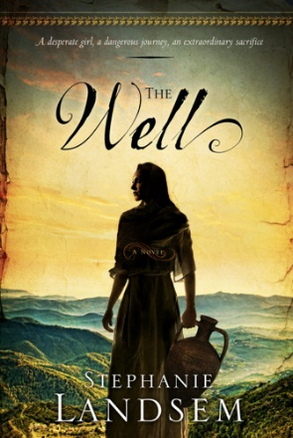
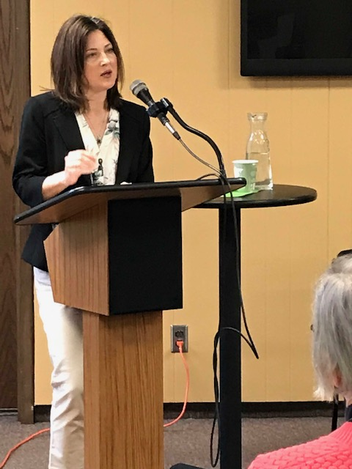
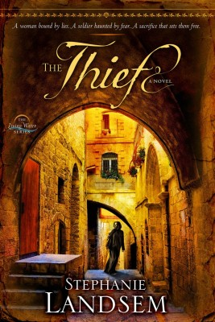

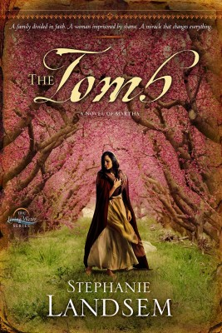

Per her website, the 4th novel, In a Far Off Land, is 45.5% completed.
p. 5
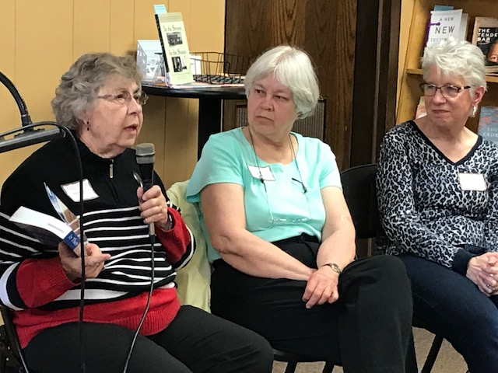
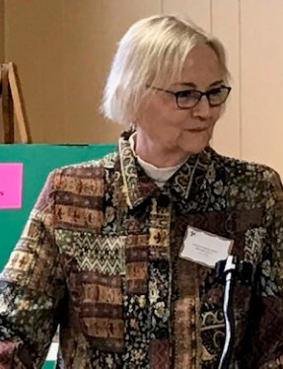
Laura Dirks moderated a workshop on book selection. The panelists were Deanna Gordon, Roberta Shaw, and Joyce Haase. Laura asked the panelists who decides which books to buy for their library, if their library has a written collection development policy (see below), and how they learn about potential new books for their collections. The conversation was lively, both among the panelists and the audience. Topics included ways to highlight new books in the collection, examining the church’s mission statement for guidance, paying attention to book reviews in recent publications, weeding and updating older materials, asking for advice from pastors and library volunteers, providing a suggestion box, and using the church website and newsletters to maintain a presence in your church. Discussions continued during the delicious lunch of assorted salads from Lunds & Byerlys.

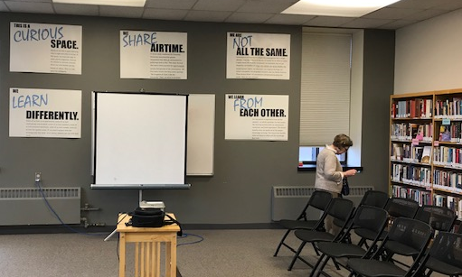
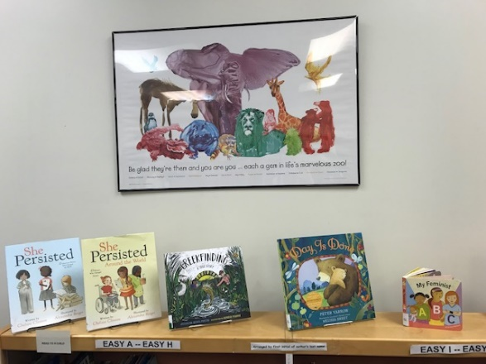
Shots of the Holy Trinity Church library. Caption under the animal picture over a display of children’s books: “Be glad they’re them and you are you – each a gem in life’s marvelous zoo!”
Secretary Leslie Kallas and Historian & Photographer Jan Bolstad made significant contributions to this section.
******************************************************************************************
Collection Development Policies: While most of our members have a written mission statement for our church libraries, few, if any, also have a written collection development policy. A Handbook for Church Librarians by the National Church Library Association suggests these selection criteria:
- Does the item help fulfill the mission of your congregation?
- Does it promote or at least not detract from the specific theology of your denomination?
- Does it fill a need in your congregation? Which groups within your congregation are likely to use it?
- It is repetitive? Do you already have something else like it?
- Is any violence appropriate to the material and balanced by a positive resolution?
- Are the author and the publisher credible and reputable?
- Is it well written and produced? The quality of the illustrations is especially crucial for children’s books.
- Is the cost comparable to similar items?
Your policy should also include sections on donated materials and on how challenges on materials are handled.
p. 6
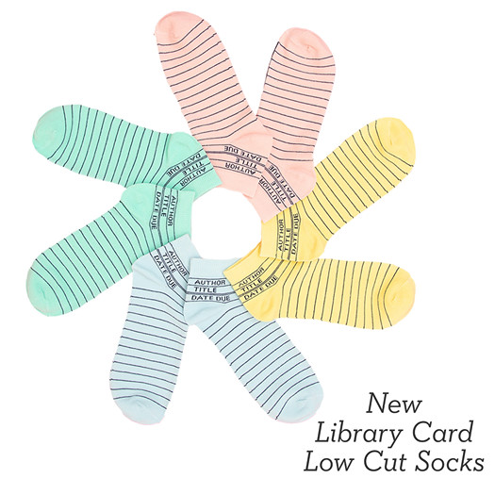
LIBRARY ODDS ‘N’ ENDS

Wedding announcement received by Laura Dirks. David is her nephew.

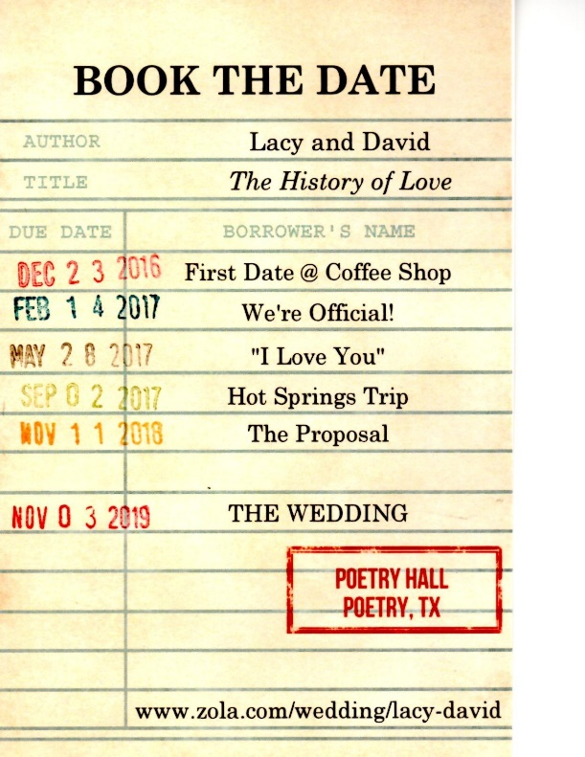

Advertised on Facebook

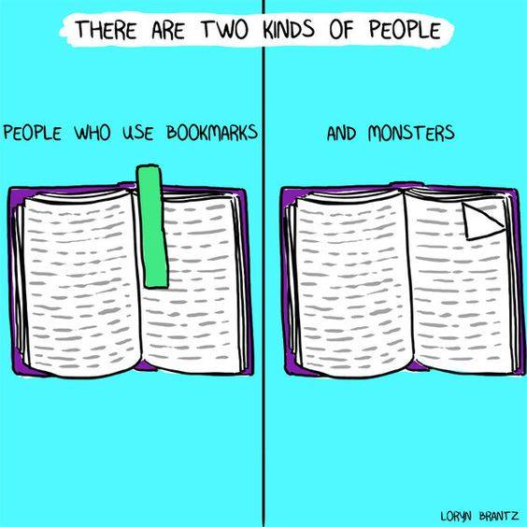

Awesome Librarian
*************************************************************************************************************************************

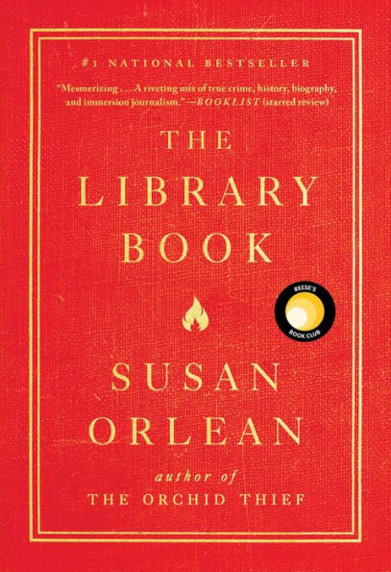
On the morning of April 29, 1986, a fire alarm sounded in the Los Angeles Public Library. By the time the fire was extinguished, it had consumed 400,000 books and damaged 700,000 more. In The Library Book, award-winning journalist Susan Orlean chronicles the fire and its aftermath to showcase the larger, crucial role that libraries play in our lives; delves into the evolution of libraries from their beginnings as a metropolitan charitable initiative to their current status as a cornerstone of national identity; brings each department of the library to life through on-the-ground reporting; studies arson and attempts to burn a copy of a book herself; reflects on her own experiences in libraries; and re-examines the case of Harry Peak, the actor long suspected of setting the fire. Along the way, Orlean introduces readers to an unforgettable cast of characters from libraries past and present. The Library Book is a reminder that, perhaps especially in the digital era, libraries are more necessary than ever. Simon & Schuster, 2019. Recommended by members of the TCACLA board.

p. 7


One of the missions of TCACLA is to provide a forum for church librarians to exchange information with each other. In addition to our meetings and our newsletter, we do this via our website at www.tcacla.com and our Facebook page, Twin Cities Area Church Library Association.



Dulcie Campana, our social media adminis-trator, is always looking for input from you. If you have an upcoming book event at your church, have had a special promotion for your library, want to recommend a new book, or have any other news that would interest our members, please send the information to her at livingoutfaith@hotmail.com.

TCACLA Fall Meeting
October 12, 2019

OFF THE SHELF
c/o Laura Dirks
333 8th St SE, Apt 206
Minneapolis, MN 55414-1246

