
Mission Statement: To energize church library ministry through education, resource sharing, spiritual encouragement and fellowship.
OFF THE SHELF

General Information

TCAC is an area chapter of the National Church Library Association, a non-profit support organization serving church librarians of all backgrounds. Membership is open to individuals or churches of all Christian denominations that desire assistance with church library development. Contact the national office or any TCAC board member if you are interested in joining or have questions.

Twin Cities Area
Chapter Board

Sandra Johnson, President
952-544-8117
sjj24@msn.com
Paula Erickson, Vice President
763-427-5128
pl.rcksn@gmail.com

Laura Dirks, Secretary
612-378-3026
Laura.Dirks@securian.com

Colleen Stieg, Treasurer
763-533-1702
cmks30@msn.com

National Office
National Church Library Association

275 South Third Street
Suite 101A
Stillwater, MN 55082
651-430-0770
info@churchlibraries.org
www.churchlibraries.org

Spring 2019

Inside This Issue
Treasurer’s Report  Meeting Invitation | 2
What Churches Are Reading | 3-4
Fall Meeting Information | 5
Directions to Holy Trinity  Lutheran Church | 6
Meeting Schedule  Registration Form | 7
TCACLA on Social Media | 8

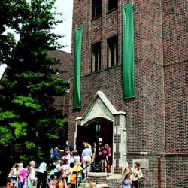

The program also includes an inter-active discussion on book selection, a book swap, time to visit the church library, and an opportunity to network with other church librarians. See pages 5-7 for more information.

TCACLA Spring Meeting
Holy Trinity Lutheran Church
April 27, 2019
9:00 a.m. – 12:30 p.m.
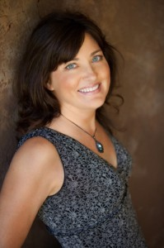

The featured speaker is Minnesota author Stephanie Landsem. She will talk about how she came to write biblical fiction, provide a bit of histor-ical background on first century Israel, and describe the method she uses to bring to life the stories of the women who encounter Jesus.

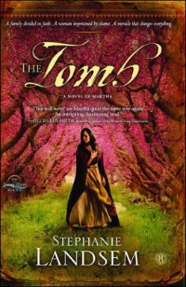
The novels in Stephanie’s Living Water series—The Well, The Thief, and The Tomb, a Novel of Martha—are biblically authentic stories. In Walk in Her Sandals, Experiencing Christ’s Passion Through the Eyes of Women, she brings to life the days of Holy Week, Easter, and Pentecost for individual prayer or book clubs. Stephanie is also one of the collaborators in Gaze Upon Jesus, Experienc-ing Christ’s Childhood Through the Eyes of Women, a scripture study of the joyful mysteries surrounding Advent and the Christmas season. She is currently working on a new book, In a Far Off Land.

The Living Water novels will be available for purchase at the meeting for $15.00 including tax. Stephanie can accept cash, checks and credit cards.

To read more about her books or subscribe to her blog, go to www.stephanielandsem.com.

General Information

The Twin Cities Area Church Library Association (TCACLA) is a non-profit support organization serving church librarians. Member-ship is open to individuals and churches of all denominations that desire to network with others on church library development and enrichment.
TCACLA BOARD
Grace Kurtz, Co-President 651-631-3726 gkurtz61@gmail.com

Jeanne Schleh, Co-President 612-729-6041 jerebob@aol.com

Jan Nordin, Vice-President & Treasurer
612-590-7884 jan.lacher@hotmail.com

Leslie Kallas, Secretary 612-978-9572 ljkallas@gmail.com

Historian
Jan Bolstad bolstadje@yahoo.com

Off the Shelf Editor
Laura Dirks otseditor@gmail.com
Website
www.tcacla.com

 |  | CON
Members: | 21 churches
01/01/2019 | $2128.51 |  | Beginning Balance
 | $165.00 |  | 2019 Membership Dues
 | -$18.17 |  | Website Renewal
- | -$49.12 |  | Off the Shelf Printing & Postage
03/31/2019 | $2226.22 |  | Ending Balance

NOTE: We have a new Treasurer. If your church office mails
checks and completed registration and/or membership forms to
TCACLA, please confirm that they are mailed to Jan Nordin’s
name and address. Even though Jan’s information appears on
the forms, some churches have Deanna Gordon’s name and ad-
dress automatically linked to TCACLA in their accounting systems.
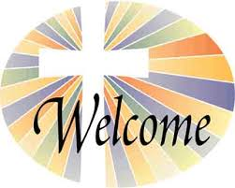

Many of us have friends who attend churches that have libraries
but aren’t members of TCACLA. Why not share this issue of
Off the Shelf with them and invite their church library teams to
come to the Spring meeting? Your guests may come at the
$15.00 member rate.

p. 2
WHAT CHURCHES ARE READING
The following nonfiction books were recently added to the libraries of TCACLA member churches. Memoirs seem to be especially popular. I hope that all of you will share what your church is reading on a regular basis. All I need are the titles and authors of the books. Please e-mail this information to otseditor@gmail.com.

“Books are the quietest and most constant of friends. They are the most accessible and wisest of counsellors and the most patient of teachers.” - Charles William Eliot

BARKING TO THE CHOIR; The Power of Radical Kinship by Gregory Boyle, Simon & Shuster, 2018.

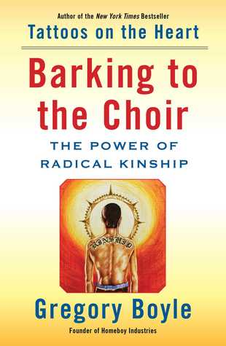

EDUCATED; a Memoir by Tara Westover, Random House, 2018.
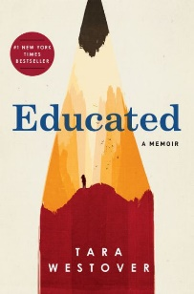

IT'S NOT SUPPOSED TO BE THIS WAY: Finding Unexpected Strength When Disappointments Leave You Shattered by Lysa TerKeurst, Nelson Thomas, 2018.

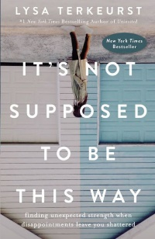

p. 3
Boyle, a Jesuit priest and founder of the largest gang intervention program in the world, invites readers to find kinship with one another. Sergio, arrested at 9, in a gang by 12, and serving time shortly thereafter, now works with a substance-abuse team. Jamal, aban-doned by his family when he tried to attend school at age 7, gradually finds forgiveness for his schizo-phrenic mother. New father Cuco, who never knew his own dad, shares daily adventures with his son. These former gang members uplift the soul and re-veal how bright life can be when filled with uncon-ditional love and kindness.

Born to survivalists in the mountains of Idaho, Westover was 17 the first time she set foot in a classroom. Her family was so isolated from main-stream society that there was no one to ensure the children received an education and no one to inter-vene when one of her older brothers became violent. When another brother got into college, Tara decided to try a new kind of life. Her quest for knowledge transformed her, taking her to Harvard and to Cam-bridge University. Only then would she wonder if she’d traveled too far, if there was still a way home.

Life often looks very different from what we hoped for or expected. What do you do when God’s timing seems questionable, His lack of intervention hurtful, and His promises doubtful? We may feel disappointed and disillusioned, and even quietly start to wonder about the reality of God’s goodness. TerKeurst, a best-selling author, understands this deeply, having experienced heart shattering circumstances on her journey of faith. She feels that our disappointments can be the divine appointments our souls need to radically encounter God.

THE PENGUIN LESSONS: What I Learned from a Remarkable Bird by Tom Michell, Random House, 2015.
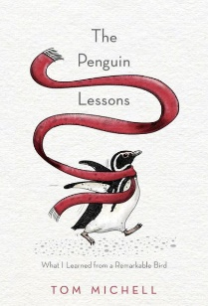

I'M STILL HERE: Black Dignity in a World Made for Whiteness by Austin Channing Brown, Crown Publishing, 2018.

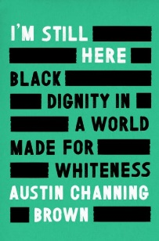

I CAN ONLY IMAGINE; a Memoir by Bart Millard, Nelson Thomas, 2018.
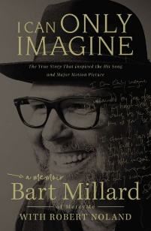

HIGHER IS WAITING by Tyler Perry, Random House, 2017.
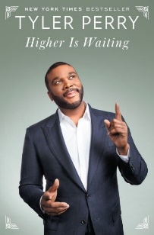
p. 4

In 1975, 23-year-old Englishman Michell becomes assistant master at a prestigious boarding school in Argentina. On a weekend trip to Uruguay, after he rescues a penguin covered in oil from an ocean spill, the penguin refuses to leave Michell’s side. “Juan Salvador” becomes the mascot of the rugby team, confidant to the dorm housekeeper, co-host of Michell’s parties, and an unprecedented swimming coach to a shy boy. As it turns out, it is the penguin who saved Michell. Described as “charming,” “heart-warming” and “delightful” by reviewers.

An illuminating look at how the white middle-class has participated in an era of rising racial hostility, inviting the reader to confront apathy and recognize God's ongoing work in the world. As a child of 7, Brown learned that her parents named her Austin to deceive future employers into thinking she is a white man. In this book, she writes in detail about her journey to self-worth and the pitfalls that kill our attempts at racial justice. Her stories bear witness to the complexity of America's social fabric--from Black Cleveland neighborhoods to private schools in the middle-class suburbs, from prison walls to the boardrooms at majority-white organizations.

The story behind the best-selling single in the history of Christian music and the man who wrote it. Millard shares how his father’s transformation from abusive dad to man of God sparked a divine moment in music history. Whether falling in love with his childhood sweetheart or mourning his father’s death, founding MercyMe or flailing in the midst of its success, Millard continues to place his trust in God’s plans.

This spiritual guidebook is meant to inspire readers to climb higher in their own lives and pull themselves up to a better, more fulfilling place. Perry writes of how his faith has sustained him in hard times, centered him in good times, and enriched his life. He recalls moments of grace and beauty in a childhood marked by brutality, deprivation, and fear. Through tender portraits of the people who sustained him, Perry describes his growing awareness of God’s presence in his life, how he learned to tune in to His voice, to persevere through hard times, and to choose faith over fear.

MORE ABOUT THE APRIL 27 MEETING

WORKSHOP ON BOOK SELECTION: Most of us are familiar with the expression “so many books, so little time.” In the case of church libraries, “so little money” may also apply. New books are being published every day. Now that self-publishing is readily available, there are even more possibilities.

Given this large universe, how do you decide which books to buy for your church library? What sources do you use to find out about new books? Who makes the final decision on what to buy? Do you have a written selection policy?
These questions and more will be posed during an interactive panel discussion. Three TCACLA members will start the conversation but the success of the work-shop depends on participation by all of you! If you have specific questions or topics that you’d like to see covered in this workshop, please send them to otseditor@gmail.com by April 20.

******************************************************************************************

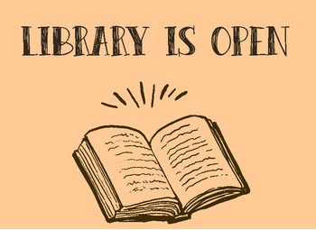
VISIT THE CHURCH LIBRARY: If you attended the Fall 2018 meeting and participated in the workshop that Roberta Shaw led on promoting the church library – and even if you didn’t – you’ll want to visit the library to see some of her creative ideas in action. Per Roberta: "Holy Trinity's library focuses on featuring and acquiring books related to the congregation's three current goals: continue to grow in competency and commitment to racial justice, moving from awareness to action within our local community; grow in competency and commitment to issues of gender and sexuality in our congregation; and nurture faith and attend to our spiritual lives through education and faith practices."

******************************************************************************************

BOOK SWAP: Your library may have a duplicate copy of a book or a gently used book that you no longer need. If so, consider bringing it to a TCACLA meeting to share with others. Despite the “swap” name, there is no requirement that you bring a book in order to take a book. If you bring a book that’s still there at the end of the meeting, please check with a member of the host church before leaving the book with them to dispose of.

p. 5
HOLY TRINITY LUTHERAN CHURCH
2730 E 31st ST, MINNEAPOLIS

How do I get there?
From the west: Take I-94 east to the Hiawatha Avenue (MN Hwy 55) exit (234A). Follow Hiawatha to the Lake Street exit. Turn left on Lake Street. Stay on Lake Street until 28th Avenue.
From the east (I-94): Take I-94 west to the Riverside/25th Avenue exit (235A). Turn left on 25th Avenue, which quickly becomes 26th Avenue. Turn left on Lake Street. Stay on Lake Street until 28th Avenue.
From the east (Marshall Avenue): Take Marshall Avenue across the Mississippi River bridge to Lake Street. Stay on Lake Street until 29th Avenue.
From the north: Take I-35W south to the Hiawatha Avenue (MN Hwy 55) exit. Follow Hiawatha until the Lake Street exit. Turn left on Lake Street. Stay on Lake Street until 28th Avenue.
From the south (I-35W): Take I-35W north to I-94 east (exit 16B), and then take the Riverside/25th Avenue exit (exit 235A). Make a right turn onto 25th Avenue, which quickly becomes 26th Avenue. Turn left on Lake Street. Stay on Lake Street until 28th Avenue.
From the south (Hiawatha Avenue/Hwy 55): Take Hiawatha Avenue (MN Hwy 55) north to the Lake Street exit. Turn right on Lake Street. Stay on Lake Street until 28th Avenue.
Where do I park?
The entrance to the parking lot is located on Lake Street between 28th and 29th Avenues, just across from U.S. Bank. The church building is about 1/2 block southwest of the lot. A sidewalk leads from the parking lot through a rain garden to the church. Parking is also available on the surrounding streets.
For handicap access, use the cul-de-sac entrance, located on 31st Street across from 28th Avenue.
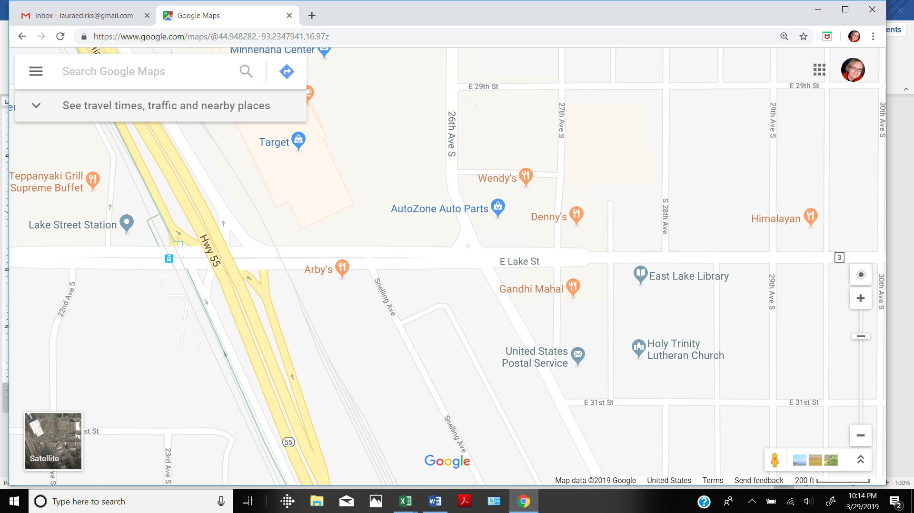

p. 6

Twin Cities Area Church Library Association Meeting
Saturday, April 27, 2019

The book swap and church library will be open all morning. In addition, the speaker will have copies of her books available for sale.

9:00 Registration
9:15 Welcome and Devotions
9:25 Stephanie Landsem – Bringing Women of the Gospels to Life
10:15 Break
10:30 Workshop: Tools and Strategies for Selection of New Books
11:20 Break
11:30 Lunch

---------------------------------------------------------------------------------------------------------------------------------------------------

TCACLA Spring Meeting
April 27, 2019
MEETING REGISTRATION FORM

Note: Please pre-register by April 22, 2019

Your church name: ________________________________________________________________

City: ___________________________Future Workshop Suggestions: ______________________

Name(s) of person(s) attending: ______________________________________________________

________________________________________________________________________________

Number of TCACLA member church registrants and their guests: _____ x $15.00 = ____________

Number of non-member church registrants: _____ x $18.00 = ____________

Make checks payable to TCACLA.

Mail to: Jan Nordin
3101 202nd Ln NW
Oak Grove MN 55011-5012

Questions: Call Jan at 612.590.7884 or e-mail jan.lacher@hotmail.com.

p. 7


One of the missions of TCACLA is to provide a forum for church librarians to exchange information with each other. In addition to our meetings and our newsletter, we also do this via our website at www.tcacla.com and our Face-book page, Twin Cities Area Church Library Association.

Dulcie Campana, our social media administrator, is always looking for input from you. If you have an upcoming book event at your church, have had a special promotion for your library, want to recommend a new book, or have any other news that other members would be interested in, please send the information to her at livingoutfaith@hotmail.com.

TCACLA Spring Meeting
April 27, 2019

OFF THE SHELF
c/o Laura Dirks
333 8th St SE, Apt 206
Minneapolis, MN 55414-1246

