
Mission Statement: To energize church library ministry through education, resource sharing, spiritual encouragement and fellowship.
OFF THE SHELF

General Information

TCAC is an area chapter of the National Church Library Association, a non-profit support organization serving church librarians of all backgrounds. Membership is open to individuals or churches of all Christian denominations that desire assistance with church library development. Contact the national office or any TCAC board member if you are interested in joining or have questions.

Twin Cities Area
Chapter Board

Sandra Johnson, President
952-544-8117
sjj24@msn.com
Paula Erickson, Vice President
763-427-5128
pl.rcksn@gmail.com

Laura Dirks, Secretary
612-378-3026
Laura.Dirks@securian.com

Colleen Stieg, Treasurer
763-533-1702
cmks30@msn.com

National Office
National Church Library Association

275 South Third Street
Suite 101A
Stillwater, MN 55082
651-430-0770
info@churchlibraries.org
www.churchlibraries.org

Fall 2019
Inside This Issue
Treasurer’s Report  Host Churches Needed  2020 Membership Renewal | 2
What Churches Are Reading | 3-4
More Information on the Fall Meeting | 5
Directions to Plymouth Congregational Church | 6
Meeting Schedule  Registration Form | 7

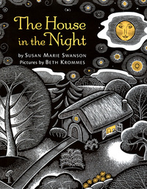

A spare, patterned text and glowing pictures explore the origins of light that make a house a home in this bedtime book for young children. Naming nighttime things that are both comforting and intriguing to preschoolers—a key, a bed, the moon—this timeless book illuminates a reassuring order to the universe.

TCACLA Fall Meeting
Plymouth Congregational Church
October 12, 2019
8:45 a.m. – 12:30 p.m.

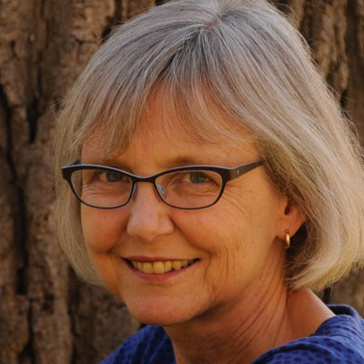
The featured speaker is Susan Marie Swanson, the author of several books for young readers, including Getting Used to the Dark: 26 Night Poems, Letter to the Lake, The First Thing My Mama Told Me, and To Be Like the Sun. She is best known for The House in the Night, which won both the Minnesota Book Award and the Caldecott Medal in 2009. One of her poems for children, “Trouble, Fly,” has appeared in a choral setting for treble voices and in an art installation in a children’s hospital.
As a visiting writer, Susan Marie has written poems and stories with children for many years, teaching in literary arts programs sponsored by COMPAS, the American Swedish Institute, the Loft Literary Center, and other organizations. She also writes and speaks about children’s literature, most recently in an essay on writing poetry with children for a parenting book, a presentation on books by Native authors for an elementary school faculty, and a talk on international children’s books for a local writers’ group.
At the TCACLA Fall Meeting, Susan Marie will be talking about picture books by Minnesota authors and illustrators, both her own and titles by a diverse group of others. She’ll share resources, suggest criteria for book selection—and offer general good cheer about church libraries. She is a long-time member of Plymouth Congregational Church.

General Information
The Twin Cities Area Church Library Association (TCACLA) is a non-profit support organization serving church librarians. Member-ship is open to individuals and churches of all denominations that desire to network with others on church library development and enrichment.
TCACLA BOARD
Grace Kurtz, Co-President 651-631-3726 gkurtz61@gmail.com
Jeanne Schleh, Co-President 612-729-6041 jerebob@aol.com
Jan Nordin, Vice-President & Treasurer
612-590-7884 jan.lacher@hotmail.com
Leslie Kallas, Secretary 612-978-9572 ljkallas@gmail.com
Historian
Jan Bolstad bolstadje@yahoo.com
Off the Shelf Editor
Laura Dirks otseditor@gmail.com
Website
www.tcacla.com

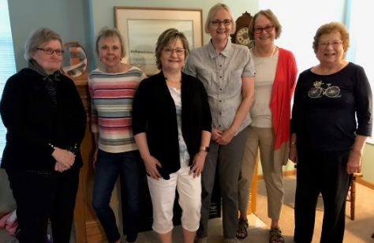

 |  |  | CON
Members: | 25 churches, 1 individual
01/01/2019 | $2,128.51 |  | Beginning Balance
 | $648.00 |  | Meeting Registration
 | $265.00 |  | Membership Dues
 | $913.00 |  | Income
 | -$432.05 |  | Meeting Costs
 | -90.17 |  | Off the Shelf Printing & Postage
 | -$18.17 |  | Website Fee
 | -$540.39 |  | Expenses
08/31/2019 | $2,501.12 |  | Ending Balance

**************************************************************************
HOST CHURCHES NEEDED

If it’s been a while since your church hosted a TCACLA meeting
or you’ve never hosted one, the board encourages you to consider doing so in 2020. Whether your library has 200 books or 2,000,
we’d love to see it. TCACLA pays all expenses and the board
plans the program. Here’s an endorsement from Meg Gisslen:
“I have to say that hosting this Fall Meeting is so well supported
by this board.”


**************************************************************************
2020 MEMBERSHIP FORM
Even though your current TCACLA membership doesn’t expire until March 31, 2020, a 2020 new/renewal membership form is included in this issue for two reasons:
- Some of our members want to pay their 2020 dues with funds still available in their 2019 budget.
- If your church isn’t currently a member of TCACLA and you join now, you may attend the Fall 2019 Meeting, along with all 2020 meetings, at the member rate.

p. 2
WHAT CHURCHES ARE READING

The following nonfiction books were recently added to the libraries of TCACLA member churches. You are encouraged to share what your church is reading on a regular basis. Please e-mail book titles and authors to otseditor@gmail.com.

“I have always imagined that Paradise will be a kind of library.” — Jorge Luis Borges
I WAS HUNGRY: Cultivating Common Ground to End an American Crisis by Jeremy K. Everett, Brazos Press, 2019.

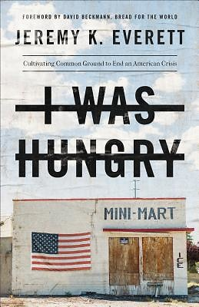

'TIL FAITH DO US PART; The Rise of Interfaith Marriage and the Future of American Religion, Family, and Society by Naomi Schaefer Riley, Oxford University Press, 2013.

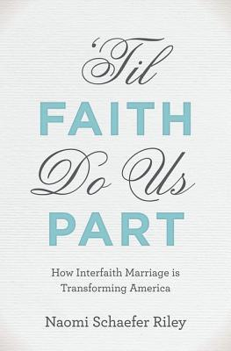

DINNER WITH THE SMILEYS; One Military Family, One Year of Heroes, and Lessons for a Lifetime by Sarah Smiley, Hachette Books, 2013.
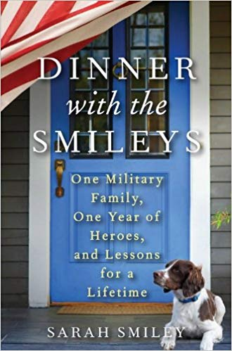

p. 3

Christians are called to address the suffering of the hungry and poor. However, the problems of hunger and poverty are too large and too complex for any one of us to resolve individually. Everett, a respected advocate for the hungry and poor, connects faith to public policy. He offers not only an assessment of the current crisis but also a strategy for addressing it. Part prophetic call to action and part how-to manual; a blueprint for a more inclusive, prosperous and compassionate America.

The rapidly growing number of mixed-faith families has become a source of hope, encouraging openness and tolerance among religious communities that historically have been insular and suspicious of other faiths. Yet as Riley demonstrates, what is good for society often proves difficult for individual families. Even when couples recognize their deeply held differences, believing that love conquers all, they fail to ask the necessary questions about how they will raise their children, celebrate holidays, donate to their faith communities and more. The book is based on a national survey of 2,500 Americans and extensive interviews with couples, religious leaders, and marriage counselors.

An uplifting true story of a mother's yearlong experience inviting one new guest (from senators to teachers, artists to professional athletes) to dinner for each week that her husband was deployed overseas. But it’s not really about dinner or the military. It's about 250 strangers who came together to help raise three boys in the absence of their father. Inside this personal story are the universal issues of loss, grief, loneliness, regrets, sacrifice, and, ultimately, unexpected joy and finding one's own strength.

BRAIDING SWEETGRASS; Indigenous Wisdom, Scientific Knowledge and the Teachings of Plants by Robin Wall Kimmerer, Milkweed Editions, 2015.

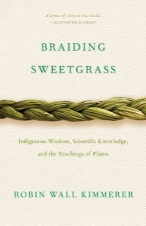

HOPE IN THE DARK; Believing God is Good When Life Is Not by Craig Groeschel, Zondervan, 2018.
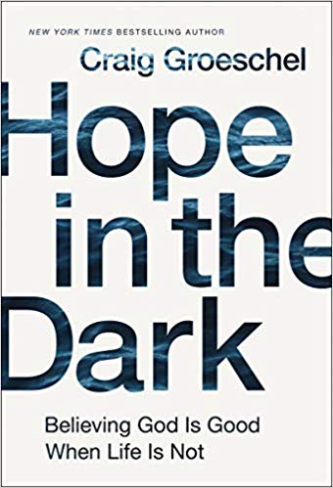
BEATING GUNS; Hope for People Who Are Weary of Violence by Shane Claiborne and Michael Martin, Baker Publishing, 2019.


SENSING THE RHYTHM; Finding My Voice in a World Without Sound by Mandy Harvey, Howard Books, 2017.
.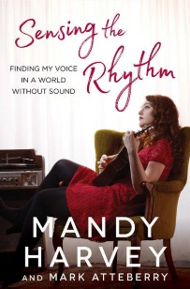
p. 4

Drawing on her life as an indigenous woman and as a botanist, Kimmerer shows how plants and animals offer us gifts and lessons, even if we've forgotten how to hear their voices. In reflections that range from the creation of Turtle Island to the forces that threaten its flourishing today, she argues that the awakening of ecological consciousness requires the acknowledgment and celebration of our reciprocal relationship with the rest of the living world. For only when we can hear the languages of other beings will we be capable of understanding the generosity of the earth and learn to give our own gifts in return.

Can God be good when life is not? As Groeschel, Senior Pastor of Life Church, shares his pain surrounding the current health challenges of his daughter, he acknowledges the questions we may ask in our own deepest pain: "Where was God when I was being abused?" "Why was my child born with a disability?" "Why did the cancer come back?" "Why are all my friends married and I’m alone?" Using biblical examples (Habakuk, Job, Jeremiah), Groeschel invites readers to wrestle with such questions as we ask God to honor our faith and heal our unbelief.
Inspired by the prophetic image of beating swords into plows, Beating Guns looks at gun violence in the U.S. and offers a clarion call to change our hearts regarding one of the most significant moral issues of our time. The authors show why Christians should be concerned about gun violence and how we can be part of the solution. Victims and perpetrators of gun violence tell their compelling stories, offering hope for change and helping us reimagine the world as one that turns from death to life. Full-color images show how guns are being turned into tools and musical instruments.

After Harvey became deaf at age19 while pursuing a degree in music, she learned to sense the vibrations of the music through her bare feet on a stage floor and to watch visual cues from her live accompaniment. She now sings on key, on beat, and in time, performing jazz, ballads, and sultry blues around the country. Sensing the Rhythm is a moving story about her journey through profound loss, how she found hope and meaning in the face of adversity, and how she discovered a new sense of passion and joy.

MORE INFORMATION ON THE FALL MEETING

A Scavenger Hunt with Prizes!......Led by Meg Gisslen

The Plymouth Congregational Church library is committed to having a collection of books that support equal and fair treatment of all races and genders. This is a broad definition of racial and gender justice. As readers, we are repeatedly exposed to racist and sexist attitudes in subtle ways with distorted stereotypes and myths about minorities and women. At the TCALCA Fall Meeting, we will review guidelines to analyze books for racism and sexism and then head to the library to look for culprits for culling. No, you are not doing our work for us. Over the summer we pulled books, but we’ll replace them on the shelves for your short hunt. Afterward, we will discuss why books were chosen and award prizes to finders of culprits for culling.

To get started, think about some of the books in your library. Check the illustrations for derogatory stereotypes: sombrero-wearing Hispanic peons or banditos, naked savages or a primitive brave and his squaw. Check the story line for subtle bias: having a white male enter to solve the problem or having persons of color need to excel in sports or get A’s to be accepted. Weigh the relationships among people such as white people taking the leadership roles or black families with a dominant mother and absent father. Check the author’s perspective: is s/he from a non-white culture? We will discuss these and other guidelines in October.

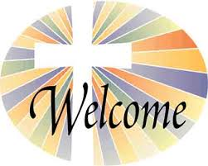
Do you have friends who attend churches that have a library but aren’t members of TCACLA? Why not share this issue of Off the Shelf with them and invite them to come with you on October 12? Your guests may come at the member rate.

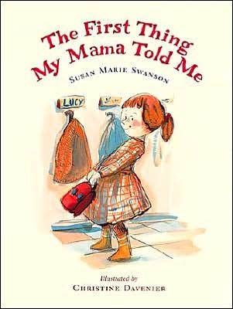
There won’t be any books available for sale at this meeting. However, if you already have copies of books that Susan Marie has written or want to buy some in advance, bring them with you. She’ll be happy to autograph them. In addition, she’s bringing a display of all of the books she’ll be discussing, along with copies of a printed list for attendees to take home.


During the annual business meeting on October 12, we will be electing a President and a Secretary for the 2020-2021 term. Next year, we will be electing a Vice President and a Treasurer for 2021-2022. If you, perhaps along with a friend, are interested in serving on the board, please contact any of the current members listed on page 2.

p. 5
PLYMOUTH CONGREGATIONAL CHURCH
1900 NICOLLET AVENUE, MINNEAPOLIS

Founded in 1857, Plymouth Congregational Church is a 167-year-old Minneapolis urban church with a progressive tradition of working for social justice. In 1858, before the start of the Civil War, the congregation took a strong anti-slavery position. The first church building, on the corner of Nicollet and 4th Street, was destroyed by fire in 1869 within days after the minister delivered a “fiery” temperance sermon that inspired the women to launch an effort to close the saloons.
How do I get there?
From the north via 35W – Merge onto I-94 west near downtown Minneapolis. Take I-94 west to the Lyndale-Hennepin exit. Stay in the right lane. Turn right on Dell Place, the first street after leaving the freeway. Turn right on Groveland, then right on LaSalle for one-half block. Turn left into the church parking lot.
From the south via 35W – Take the downtown exit on the left lane to 11th St. Turn left on 11th St., then continue on to LaSalle. Turn left on LaSalle, continue south to Groveland. Go a half-block further and enter the church parking lot on the left.
From the west via I-394 – Follow the downtown exits; exit at 12th St. Stay on 12th to LaSalle. Turn right on LaSalle, continue south to Groveland. Go a half-block further and enter the church parking lot on the left.
From the east via I-94 – Take the Lyndale-Hennepin exit. Stay in the right lane. Turn right on Dell Place, the first street after leaving freeway. Turn right on Groveland, then right on LaSalle for one-half block. Turn left into the church parking lot.
From the west via I-94 – Take the Hennepin-Lyndale exit. Continue on Lyndale to Franklin. Turn left on Franklin, continue until you cross Blaisdell on your right/LaSalle on your left. Turn left into the parking lot from Franklin.
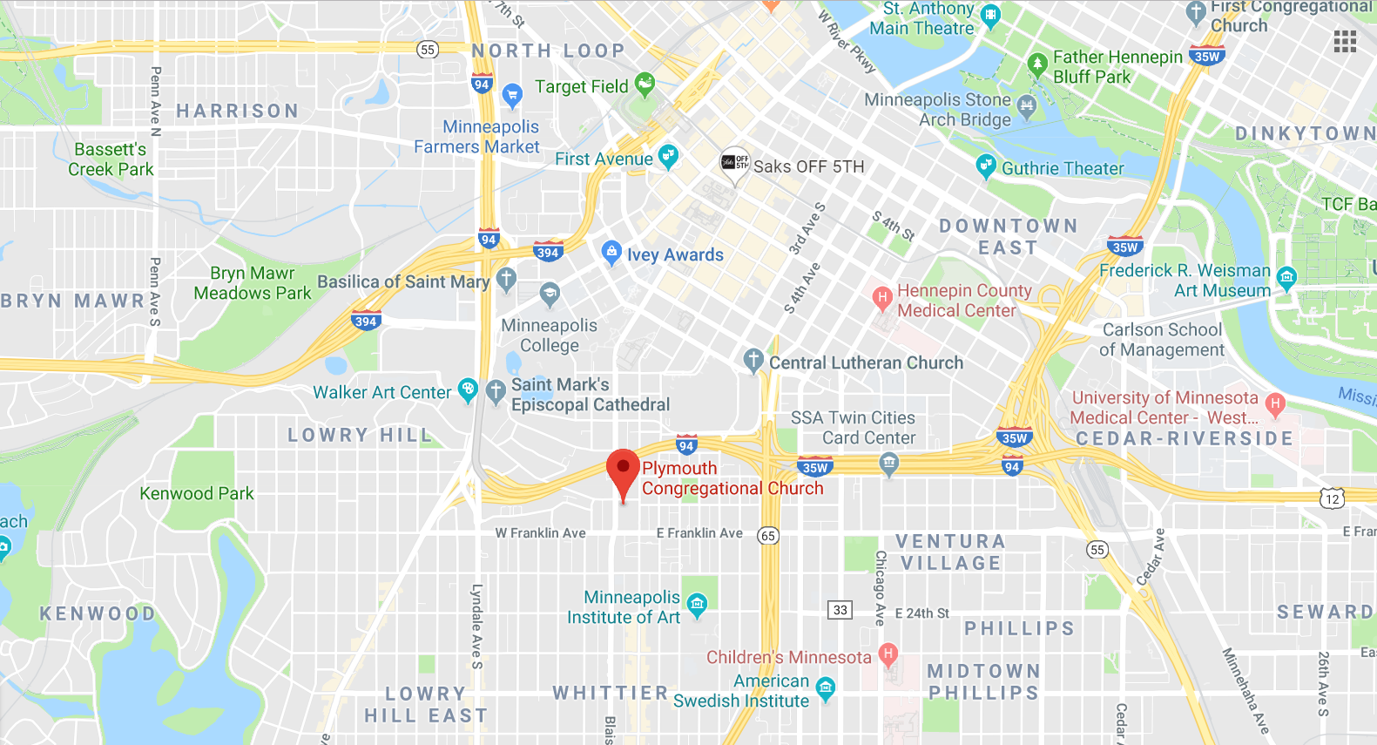
.
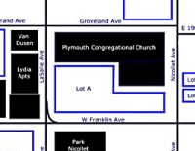
From the parking lot: Enter the church at the southwest door; the one under the colorful banner.

p. 6

Twin Cities Area Church Library Association Meeting
Saturday, October 12, 2019

The book swap and church library will be open all morning.

8:45 Registration
9:10 Welcome and Devotions / Business Meeting
9:30 The Best of Children’s Picture Books, Featuring Minnesota Authors -
Susan Marie Swanson, Speaker
10:15 Break
10:30 Workshop and Practice Session: Identifying Sexism and Racism in Books –
Meg Gisslen, Leader
11:30 Break
11:45 Lunch

---------------------------------------------------------------------------------------------------------------------------------------------------

TCACLA Spring Meeting
October 12, 2019
MEETING REGISTRATION FORM

Note: Please pre-register by October 7, 2019

Your church name: ________________________________________________________________

City: ___________________________Future Workshop Suggestions: _______________________

Name(s) of person(s) attending: _____________________________________________________

________________________________________________________________________________

Number of TCACLA member church registrants and their guests: _____ x $15.00 = ____________

Number of non-member church registrants: _____ x $18.00 = ____________

Make checks payable to TCACLA.

Mail to: Jan Nordin
5936 Candace Ave
Inver Grove Heights MN 55076-4484

Questions: Call Jan at 612.590.7884 or e-mail jan.lacher@hotmail.com.

p. 7
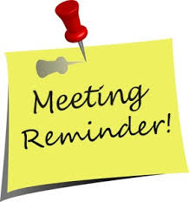
One of the missions of TCACLA is to provide a forum for church librarians to exchange information with each other. In addition to our meetings and our newsletter, we do this via our website at www.tcacla.com and our Facebook page, Twin Cities Area Church Library Association.



Dulcie Campana, our social media adminis-trator, is always looking for input from you. If you have an upcoming book event at your church, have had a special promotion for your library, want to recommend a new book, or have any other news that would interest our members, please send the information to her at livingoutfaith@hotmail.com.

TCACLA Fall Meeting
October 12, 2019

OFF THE SHELF
c/o Laura Dirks
333 8th St SE Apt 206
Minneapolis MN 55414-1246

