
Mission Statement: To energize church library ministry through education, resource sharing, spiritual encouragement and fellowship.
OFF THE SHELF

General Information

TCAC is an area chapter of the National Church Library Association, a non-profit support organization serving church librarians of all backgrounds. Membership is open to individuals or churches of all Christian denominations that desire assistance with church library development. Contact the national office or any TCAC board member if you are interested in joining or have questions.

Twin Cities Area
Chapter Board

Sandra Johnson, President
952-544-8117
sjj24@msn.com
Paula Erickson, Vice President
763-427-5128
pl.rcksn@gmail.com

Laura Dirks, Secretary
612-378-3026
Laura.Dirks@securian.com

Colleen Stieg, Treasurer
763-533-1702
cmks30@msn.com

National Office
National Church Library Association

275 South Third Street
Suite 101A
Stillwater, MN 55082
651-430-0770
info@churchlibraries.org
www.churchlibraries.org

Fall 2018
Inside This Issue
Treasurer’s Report  2019 Membership Renewal | 2
What Churches Are Reading | 3-4
Book Swap  Patron Saint of Librarians | 5
Election of Officers  Maternity of Mary Catholic Church | 6
Meeting Schedule  Registration Form | 7
www.tcacla.com | 8

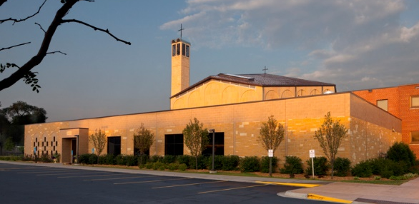

Maternity of Mary Catholic Church
1414 N. Dale Street Saint Paul, MN
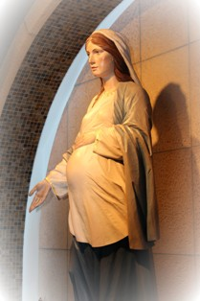

TCACLA Fall Meeting
Maternity of Mary Catholic Church
October 13, 2018
8:30 a.m. – 12:15 p.m.

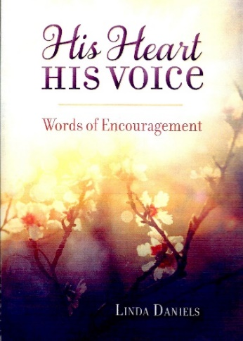
Our featured speaker is author Linda Daniels. Over her lifetime, Linda had received words from the Lord but they were sporadic and infrequent. This changed when an inspirational speaker, Gary Oates, came to her church about 8 years ago.

Gary taught a session on hearing the voice of God and writing His messages in a journal. Linda has been hearing and journaling daily since that experience. Those mes-sages, along with pertinent Scripture verses, are the basis of her devotional, HIS HEART, HIS VOICE; Words of Encouragement.

On October 13, Linda will share some simple steps to hearing God's voice. You will have time to listen, re-ceive, and write it down. Linda believes that when people receive and then share what God says to them, it encourages everyone and develops a hunger to hear more from Him.

The program also includes a workshop on marketing your library, the annual business meeting, a book swap and time to visit the church’s library. See the following pages for more information, including a registration form. NOTE: If you invite guests from other church libraries, they can come at the member rate.

General Information
The Twin Cities Area Church Library Association (TCACLA) is a non-profit support organization serving church librarians. Member-ship is open to individuals and churches of all denominations that desire to network with others on church library development and enrichment.
TCACLA BOARD
Grace Kurtz, Co-President 651-631-3726 gkurtz61@gmail.com

Jeanne Schleh, Co-President 612-729-6041 jerebob@aol.com

Lynn Tvedt, Vice-President 763-427-6576 ltvedt@q.com

Leslie Kallas, Secretary 612-978-9572 ljkallas@gmail.com

Deanna Gordon, Treasurer 952-544-5684 dgordon@iphouse.com

Historian
Jan Bolstad bolstadje@yahoo.com

Off the Shelf Editor
Laura Dirks otseditor@gmail.com
Website
www.tcacla.com

 |  |  | CON
Members: | 23 churches, 1 individual
01/01/2018 | $1,607.13 |  | Beginning Balance
 | $570.00 |  | Meeting Registration
 | $360.00 |  | 2018 Membership Dues
 | $930.00 |  | Income
 | -$369.81 |  | Meeting Costs
 | -$95.41 |  | Off the Shelf Printing & Postage
 | -$28.68 |  | Scrapbook Supplies
 | -$13.00 |  | Website Fee
 | -$23.95 |  | New Checks
 | -$530.85 |  | Expenses
08/31/2018 | $2,006.28 |  | Ending Balance

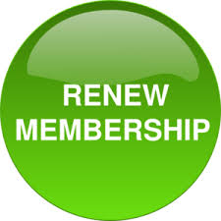
2019 MEMBERSHIP FORM
A 2019 new/renewal membership form is included in this issue of Off the Shelf if you want to pay the 2019 dues with funds in your 2018 budget. It’s not necessary to pay your dues for next year now, however. The form will be included again in the Winter issue.
If your church isn’t currently a member of TCACLA and you join now, you may attend the Fall 2018 meeting, along with all 2019 meetings, at the member rate.

PATRON SAINT OF LIBRARIANS
Who has been called the Patron Saint of Librarians: (a) Andrew Carnegie (b) St. Catherine of Alexandria (c) St. Jerome or (d) St. Lawrence of Rome? See p. 5 for the answer.

p. 2
WHAT CHURCHES ARE READING
The following books were recently added to the libraries of TCACLA member churches. I hope that all of you will share what your church is reading on a regular basis. All I need are the titles and authors of the books. Please e-mail this information to otseditor@gmail.com.

“We read books to find out who we are. What other people, real or imaginary, do and think and feel... is an essential guide to our understanding of what we ourselves are and may become.” - Ursula K. LeGuin
THE LIFE OF MARTIN LUTHER; A Pop-Up Book by Agostino Traini, Sparkhouse Family, 2017.

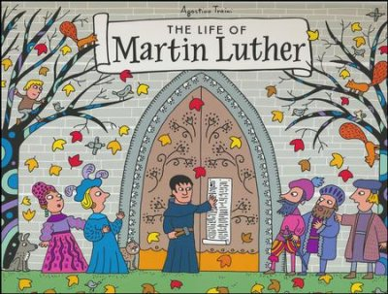

HARRIET BEECHER STOWE; A Spiritual Life by Nancy Koester, Wm. B. Eerdmans, 2014.
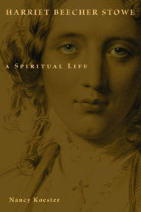

AND GRACE WILL LEAD ME HOME: The Jerry Evenrud Collection of images of the Parable of the Prodigal Son by Robert M. Brusic, Lutheran University Press, 2007.

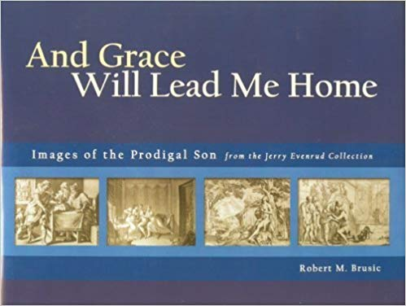

p. 3

The pages of this sturdy pop-up book open vertically to tell the story of Martin Luther and his role in sparking the Protestant Reformation. Vignettes include Luther's vow to become a monk while caught in a dangerous storm, the distribution of the 95 theses, his appearance before the Holy Roman Emperor, his escape to the Wartburg Castle, and his translation of the Bible into German. Traini is a renowned artist and paper engineer who has also created a children’s book on the birth of Jesus

Stowe became an overnight celebrity when her 1852 novel Uncle Tom’s Cabin converted readers by the thousands to the anti-slavery movement. While most biographies of her downplay Stowe’s Christian faith, Koester highlights it as central to her life, both her public fight against slavery and her own personal struggle through deep grief to find a gracious God. She traces Stowe's faith pilgrimage from evangelical Calvinism through spiritualism to Anglican spirituality. From the publisher’s Library of Religious Biography series.

The images in this collection encompass works from 1540 to 2005, which affirms the resonance of this parable. The media range from etchings, paintings, ceramics, sculpture, and fabric. Some artists depict the entire narrative in a series of works; others focus on one aspect, such as the pig pen or the return of the prodigal. The segment most frequently portrayed by a single print is the homecoming embrace by the father, the scene that represents the focus of the parable and thus of faith – grace and forgiveness.

BEFORE WE WERE YOURS; a Novel by Lisa Wingate, Random House, 2017.



LOCKING UP OUR OWN; Crime and Punish-ment in Black America by James Forman Jr., Farrar Straus & Giroux, 2017.

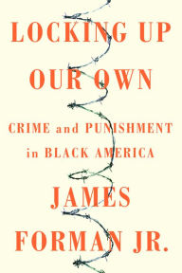

STARS IN THE GRASS; a Novel by Ann Marie Stewart, Gale Group, 2017.


SHE PERSISTED; 13 American Women Who Changed the World by Chelsea Clinton, Penguin Young Readers, 2017.

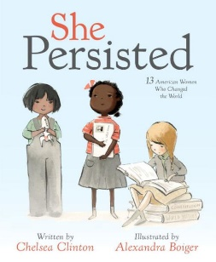
p. 4
Memphis, 1939: Thrown into a Children’s Home Society orphanage, the Foss children are assured that they will soon be returned to their parents, but they quickly realize the dark truth. Aiken, SC, present day: When Avery Stafford returns home to help her father weather a health crisis, a chance encounter leaves her with uncomfortable questions about her family history. A historical novel based on the true story of Georgia Tann, the director of a Memphis-based adoption organization who kidnapped and sold poor children to wealthy families all over the country.

A former public defender, Forman tells riveting stories of politicians, community activists, police officers, defendants, and crime victims. He writes with com-passion about individuals trapped in terrible dilem-mas, from the men and women he represented in court to officials struggling to respond to a public safety emergency. Locking Up Our Own, winner of a 2018 Pulitzer Prize, enriches our understanding of why our society became so punitive and offers important lessons to anyone concerned about the future of race and the criminal justice system in this country.

A Christy Award-winning novel that explores a family’s relationships and resiliency. At age 9, Abby has just experienced her greatest loss. In its wake, her family is unraveling with guilt, grief, and anger. Her father, Reverend McAndrews, cannot return to the pulpit because he has more questions than answers. Her older brother Matt’s actions speak louder than the words he needs to confess, as he acts out in dangerous ways. Her mother tries to hold her grieving family together, but when Abby’s dad refuses to move on, the family is at a crossroads.
Young readers are introduced to 13 inspirational women who helped shape our country through their tenacity, sometimes through speaking out, sometimes by staying seated, sometimes by captivating an audience: Harriet Tubman, Helen Keller, Clara Lemlich, Nellie Bly, Virginia Apgar, Maria Tallchief, Claudette Colvin, Ruby Bridges, Margaret Chase Smith, Sally Ride, Florence Griffith Joyner, Oprah Winfrey, and Sonia Sotomayor. Its message is that no matter what obstacles may be in our paths, we shouldn't give up on our dreams. Persistence is power.

BOOK SWAP
If you are new to TCACLA, you may not be familiar with the book swap table. Your library may have a duplicate copy of a book or you may have a gently used book that you no longer need. If so, consider bringing it to the next meeting to share with other TCACLA members. Despite the “swap” name, there is no requirement that you bring a book to take a book. If you bring a book that isn’t taken, please take it with you when you leave.
PATRON SAINT OF LIBRARIANS
The answer to the trick question on p. 2 is “all of the above.”
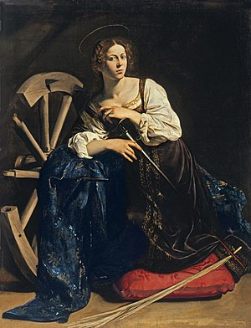
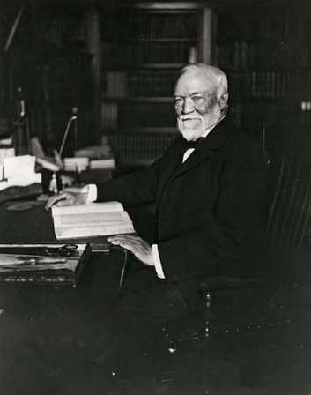
Andrew Carnegie, a Scottish-born American industrialist, led the enormous expansion of the American steel industry in the late 19th century. After selling Carnegie Steel Company to J. P. Morgan’s U.S. Steel Company, he devoted the rest of his life to philanthropic activities – one of which was the construction of libraries. A total of 2,509 Carnegie libraries were built between 1883 and 1929, including some belonging to public and university library systems. Of these, 1,689 were built in the U.S. Others were built in the United Kingdom, Ireland, Canada, Australia, South Africa, New Zealand, Serbia, Belgium, France, the Caribbean, Mauritius, Malaysia, and Fiji. By the time the last grant was made in 1919, nearly half of the 3,500 libraries in the U.S. were built with construction grants paid by Carnegie.
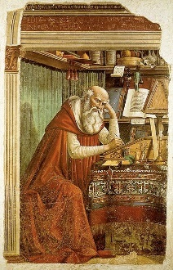
St. Catherine of Alexandria, born to nobility and learned in the sciences, confronted the Roman Emperor Maximus at the age of 18, debated his pagan philosophers, and succeeded in converting many of them to Christianity. Maximus imprisoned Catherine, executed her converts (including the empress), and ordered that Catherine herself be put to death on a spiked wheel. The wheel reportedly shattered the moment Catherine touched it. Maximus then had her beheaded. She became patron saint of libraries and librarians, as well as teachers, archivists, and all those associated with wisdom and teaching and all those whose livelihoods depended upon wheels.
St. Jerome, born in 347, was well educated in rhetoric, Latin, Greek, and the liberal arts. While still a student, he began to build a personal library, composed primarily of the pagan classics. When he joined a colony of Christian hermits in late 375, he added works of Christian authors to his collection. After 379, St. Jerome was ordained a priest and helped with the establishment of a papal library in Rome. He left Rome in 385, settling in Bethlehem at the monastery he founded. His library was installed there and was used by scholars of his time. It was destroyed in 416 when Bethlehem was sacked by bandits.
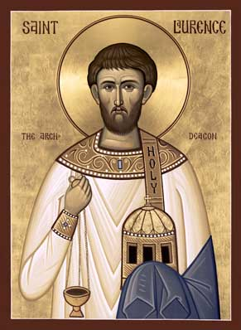
St. Lawrence of Rome, a deacon of the Church of Rome in 257, was placed in charge of the administration of church goods and care for the poor. For this duty, he is regarded as one of the first archivists and treasurers of the church and he was made the patron saint of librarians. Per legend, when Roman Emperor Valerian demanded that he turn over the treasures of the church, St. Lawrence presented the poor, handicapped, widows, orphans and the sick to the enraged Valerian. Because of a joke he made while being tortured on a gridiron as a result, St. Lawrence is also the patron saint of comedians, butchers, cooks and roasters.
p. 5
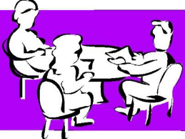
ELECTION OF OFFICERS
The two-year terms of Vice President Lynn Tvedt and Treasurer Deanna Gordon will end on December 31. At the business meeting on October 13, members present will vote on new candidates for these positions in 2019-2020. Per the Bylaws, here are their duties:

- The Vice President shall succeed the President if the President resigns or is unable to perform his/her duties and shall be responsible for program planning for membership meetings. (Note: All Board members participate in planning the programs; the VP doesn’t have to do this alone.)
- The Treasurer shall make a financial report at each Board meeting. The Treasurer shall assist in the preparation of the budget, make financial information available to members, and maintain membership records.
If you are interested in filling one of these positions, or any other position on the board, please contact any officer listed on p. 2.
MATERNITY OF MARY CATHOLIC CHURCH

The parish of the Maternity of the Blessed Mary was established on February 20, 1949. When the first Mass was offered in the basement of a parishioner’s home, 138 adults and 44 children attended; the collection was $67.24; and the first baptism took place.
The present church was built in 1961-62. It is designed according to a Romanesque style of architecture and incorporates many symbols designed to enhance prayer within the church. Some of these include: (1) Twelve groups of 12 unique stained-glass windows on the north and south sides that symbolize the 144,000 seated as mentioned in the book of Revelations. (2) The Rose Window which depicts the Maternity of the Blessed Virgin. (3) The arches that support the walls and seem to say, “This is the royal temple of Christ.” (4) The Baldachin, the canopy over the main altar, that marks it as the throne of Christ.
Be sure to visit the parish library in Sirba Hall during the morning. It’s celebrating its 20th anniversary this year. The library, which is open after each of the weekend Masses, offers books, videos, and other resources for faith building for all ages. If you’d like a sneak peek at the collection, go to the Library Search section of the church website at maternityofmarychurch.org.

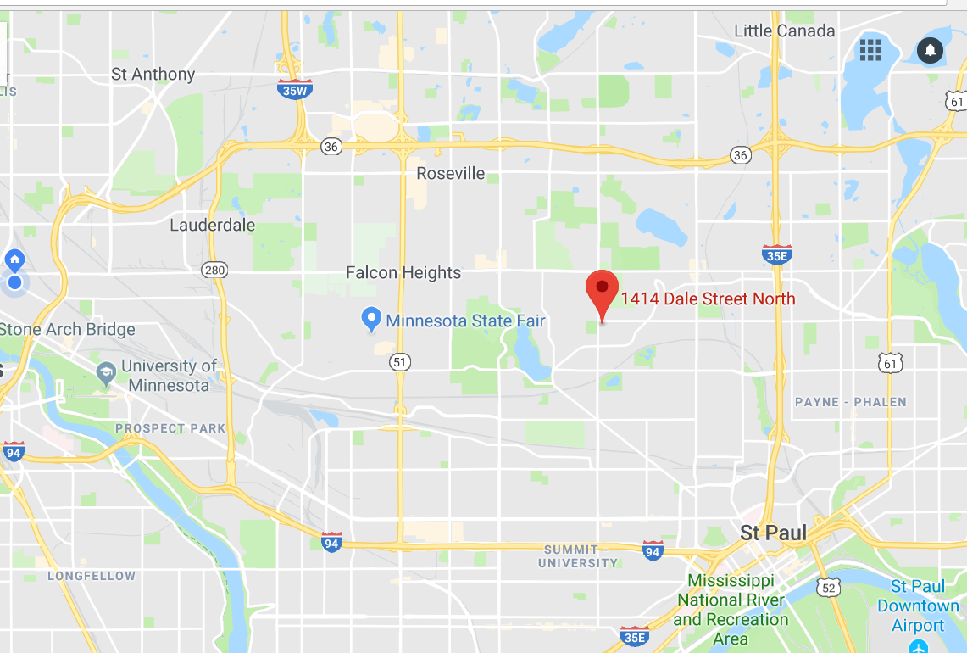
1414 N. Dale Street · Saint Paul · 651-489-8825

From I-94: Exit on Dale St. and go north. Remain on Dale St. for 2 miles to Cottage Ave. Turn right on Cottage Ave. to enter the church parking lot.
From I-35E: Exit on Maryland Ave. and go west. Remain on Maryland Ave. to Dale St. Proceed north on Dale St. to Cottage Ave. Turn right on Cottage Ave. to enter the church parking lot.
From Hwy 36: Exit on Dale St. and go south. Remain on Dale St. for 2 miles to Cottage Ave. Turn left on Cottage Ave. to enter the church parking lot.
p. 6

Twin Cities Area Church Library Association Meeting
Saturday, October 13, 2018

The book swap and church library will be open all morning.

8:45 Registration
9:00 Welcome and Devotions
9:10 Presentation by Linda Daniels
10:00 Break
10:15 Workshop: Marketing Your Library – Roberta Shaw
11:00 Annual Business Meeting
11:15 Break
11:30 Lunch

---------------------------------------------------------------------------------------------------------------------------------------------------

TCACLA Spring Meeting
October 13, 2018
MEETING REGISTRATION FORM

Note: Please pre-register by October 8, 2018

Your church name: ________________________________________________________________

City: ____________________________ Workshop Topic Suggestions: ______________________

Name(s) of person(s) attending: ______________________________________________________

________________________________________________________________________________

Number of TCACLA member church registrants and their guests: _____ x $15.00 = ____________

Number of non-member church registrants: _____ x $18.00 = ____________

Make checks payable to TCACLA.

Mail to: Deanna Gordon
1600 Maryland Ave S
St. Louis Park, MN 55426

Questions: Call Deanna at 952.544.5684 or e-mail dgordon@iphouse.com.

p. 7


One of the missions of TCACLA is to provide a forum for church librarians to exchange information with each other. In addition to our meetings and our newsletter, we also do this via our website at www.tcacla.com.


We’re always looking for input from you. If you have an upcoming book event at your church, have had a special promotion for your library, want to recommend a new book, or have any other news that other members would be interested in, please send the information to livingoutfaith@hotmail.com.

TCACLA Fall Meeting
October 13, 2018

OFF THE SHELF
c/o Laura Dirks
333 8th St SE, Apt 206
Minneapolis, MN 55414-1246

