
Mission Statement: To energize church library ministry through education, resource sharing, spiritual encouragement and fellowship.
OFF THE SHELF

General Information

TCAC is an area chapter of the National Church Library Association, a non-profit support organization serving church librarians of all backgrounds. Membership is open to individuals or churches of all Christian denominations that desire assistance with church library development. Contact the national office or any TCAC board member if you are interested in joining or have questions.

Twin Cities Area
Chapter Board

Sandra Johnson, President
952-544-8117
sjj24@msn.com
Paula Erickson, Vice President
763-427-5128
pl.rcksn@gmail.com

Laura Dirks, Secretary
612-378-3026
Laura.Dirks@securian.com

Colleen Stieg, Treasurer
763-533-1702
cmks30@msn.com

National Office
National Church Library Association

275 South Third Street
Suite 101A
Stillwater, MN 55082
651-430-0770
info@churchlibraries.org
www.churchlibraries.org

Summer 2018

Inside This Issue
Treasurer’s Report  Election of Officers | 2
What Churches Are Reading | 3-4
Spring Meeting Highlights | 5-6
Weeding Library Materials | 7
www.tcacla.com | 8

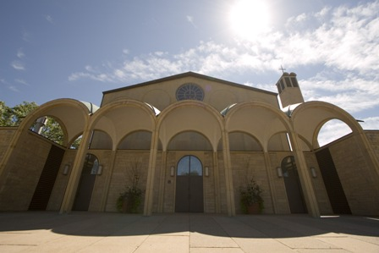

Maternity of Mary Catholic Church 1414 N. Dale Street · St. Paul, MN

A Catholic community which seeks to be a living sign of Jesus Christ in His sav-ing love for the kingdom. Thus the people forming the parish family are called by God to respond to this mission in unity with the Spirit, through their worship, witnessing and service to one another.


TCACLA Fall Meeting October 13, 2018

The next TCACLA meeting will be on the morning of Saturday, October 13, at Maternity of Mary Catholic Church in St. Paul.

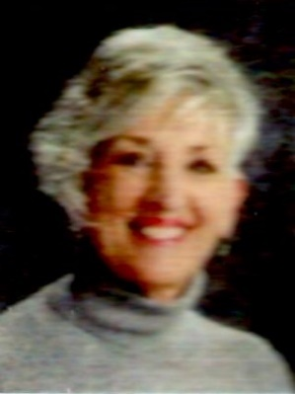
Our keynote speaker is Linda Daniels, author of HIS HEART, HIS VOICE; Words of Encouragement. Several years ago, Linda started writing down what God was saying to her when she read the Bible. When she offered to send a weekly e-mail of personal encouragement to her fellow school teachers, her mailing list grew and grew. Her book is a compila-tion of these devotional thoughts and Scripture verses, otherwise known as “God’s kisses.” Linda wants everyone to know how much the Lord loves us and wants to spend time with us.

Although the agenda for the meeting hasn’t been finalized yet, the annual business meeting and a workshop on marketing your church library are being planned. There will also be opportunities to exchange ideas with other church librarians, visit the church’s library, and participate in the book swap.

The Fall issue of Off the Shelf will include a complete schedule for the morning, along with a registration form.

General Information
The Twin Cities Area Church Library Association (TCACLA) is a non-profit support organization serving church librarians. Member-ship is open to individuals and churches of all denominations that desire to network with others on church library development and enrichment.
TCACLA BOARD
Grace Kurtz, Co-President 651-631-3726 gkurtz61@gmail.com

Jeanne Schleh, Co-President 612-729-6041 jerebob@aol.com

Lynn Tvedt, Vice-President 763-427-6576 ltvedt@q.com

Leslie Kallas, Secretary 612-978-9572 ljkallas@gmail.com

Deanna Gordon, Treasurer 952-544-5684 dgordon@iphouse.com

Historian
Jan Bolstad bolstadje@yahoo.com

Off the Shelf Editor Laura Dirks
otseditor@gmail.com

Chapter Website www.tcacla.com

 |  | CON
Members: | 23 churches, 1 individual
01/01/2018 | $1,607.13 |  | Beginning Balance
 | $570.00 |  | Meeting Registration
 | $360.00 |  | 2018 Membership Dues
 | $930.00 |  | Income
 | -$369.81 |  | Meeting Costs
 | -$95.41 |  | Off the Shelf Printing & Postage
 | -$28.68 |  | Scrapbook Supplies
 | -$23.95 |  | New Checks
 | -$517.85 |  | Expenses
06/20/2018 | $2,019.28 |  | Ending Balance

*********************************************************



ELECTION OF OFFICERS
During the business meeting on October 13, we will be electing a new Vice-President and a new Treasurer for the 2019-2020 term. If you, perhaps along with a friend, are interested in run- ning for a position, please contact any of the board members listed on this page.

p. 2
WHAT CHURCHES ARE READING

The following Christian series have recently been added to the libraries of TCACLA member churches. Your suggestions for this column are always welcome. Please e-mail the titles and authors to otseditor@gmail.com.
“You can never get a cup of tea large enough or a book long enough to suit me.” –C. S. Lewis

GWEN MARCEY NOVELS by Carrie Stuart Parks, Thomas Nelson, 2014-2017, 4 volumes.
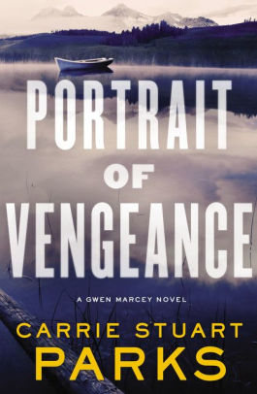

LONE STAR HERO’S LOVE STORY SERIES by Shelley Shepard Gray, Zondervan, 2016-2017, 3 volumes.
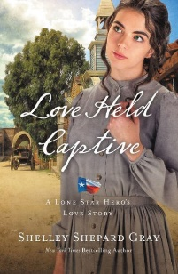

HIDDEN MASTERPIECE SERIES by Kristy Cambron, Thomas Nelson, 2014-2015, 2 volumes.
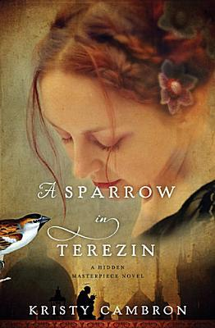

p. 3
Gwen Marcey is a forensic artist (as is the author), a single mother, and a cancer survivor who has serious self-image problems. Each novel centers on a crime or series of related crimes, with an underlying thread about Gwen’s relationships with her digitally obsessed unruly 15-year-old daughter and her conniving and controlling ex-husband. Reviewers write: “Wonderful blend of faith and mystery” and “impossible to put down.” It is recommended that the books be read in order.

Before anything was known about PTSD, survivors of war had to deal with the trauma alone. These historical romance novels, set in post-Civil War Texas, focus on the emotional toll that the war took on a group of men who were in a POW camp in Ohio together. Their forged friendship with one another allows them to move forward in their lives with the support of each other and the women who love them. While some of the characters appear in more than one book, they can be read as stand-alones.

Both mysteries weave the story of Sera James, a present-day gallery owner who appears to have a charmed life, with the story of another woman who lived during the Holocaust. In 1943, while a con-script at Auschwitz-Birkenau, gifted violinist Adele von Bron is forced to play in camp orchestras for the daily death marches. In 1942, when London journalist Kája Makovsky risks everything to help her Jewish relatives escape from Prague, she ends up as the children’s art teacher in the Terezin concentration camp. A common theme is love that can look past the darkness and still see hope.

THE HALF-STITCHED AMISH QUILTING CLUB SERIES by Wanda E. Brunstetter, Barbour Publishing, 2012-2014, 3 volumes.
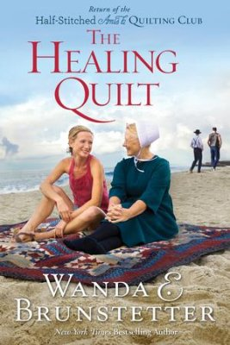

THE WINGFEATHER SAGA by Andrew Peterson, Rabbit Room Press, 2008-2015, 4 volumes.

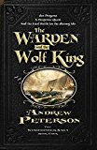

THE BAXTER FAMILY SERIES by Karen Kingsbury, Howard Books, 2017-2018, 3 volumes.



TALES FROM IVY HILL by Julie Klassen, Baker Publishing, 2016-2017, 2 volumes.


p. 4

In each book, Amish widow-turned-newlywed Emma Yoder Miller leads a different quilting class of diverse students, including “Englishers” and Amish, women and men, all of whom have tattered pieces of their lives that need mending. In the classes, they find friendship, faith, healing and restoration with the helping hands of each other and the healing hand of God. The first book inspired a musical.

Fantasy-adventure novels for teens about the three Igiby children, Janner, Kalmar, and Leeli. They’re accompanied by Leeli’s dog Nugget, their mother Nia, and their ex-pirate grandfather Podo Helmer. They live in a world called Aerwiar, which is exactly like our world – except they don’t have electricity or gunpowder, and there are creepy animals, like sea dragons and toothy cows. There are 2 other related books, an animated film and a website.

The 1st volume tells the backstory of how John and Elizabeth first fell in love and provides closure on the complicated relationship between Baxter family friends Cody and Andi. In the 2nd volume, attorney Luke Baxter becomes involved in the case of a beloved high school principal who started a voluntary Bible study class at his public high school. Ashley Baxter Blake helps a man connect with a young woman he met 12 years ago on the day of the Oklahoma City bombing in the 3rd volume. The 4th volume, a story about second chances, is scheduled to be released in October 2018.

sHistorical romance set in the Regency era. Ivy Hill is a beautiful English village where friendships thrive, love blossoms and mysteries await. The story follows several women as they become accustomed to their changing circumstances with grace and faith. The series’ website includes a map of the village and a list of the characters. The 3rd and final volume is scheduled to be released in December 2018.

TCACLA SPRING MEETING HIGHTLIGHTS

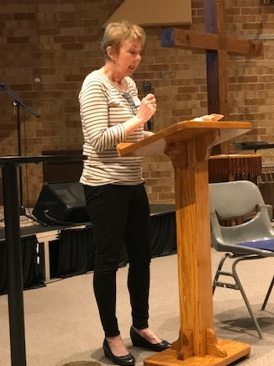
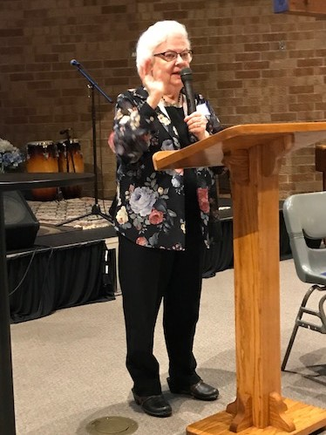
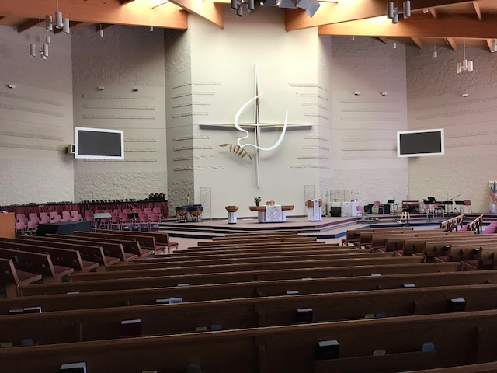
The meeting was at Prince of Peace Lutheran Church in Brooklyn Park on April 21, 2018. Sally Onstad and Jan Bolstad welcomed members and friends of TCACLA to their church and led us in devotions.

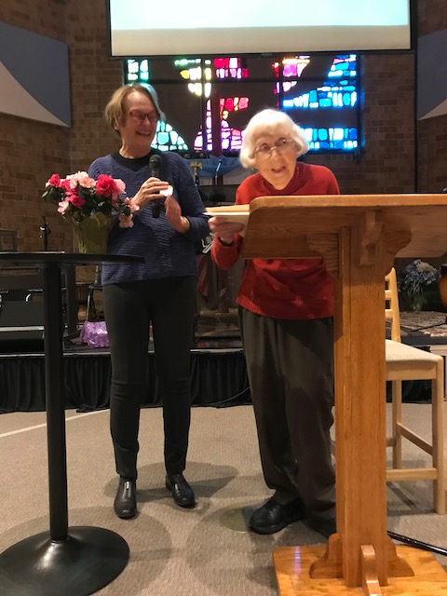
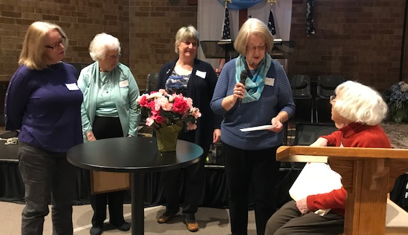
Marlys Johnson, who has been a member of our association longer than anyone else, presented a brief history of the organization. Afterward, she was surprised by gifts of a flowering plant from TCACLA Co-President Jeanne Schleh and a Lauraine Snelling print from her library team at Calvary Lutheran Church.

p. 5
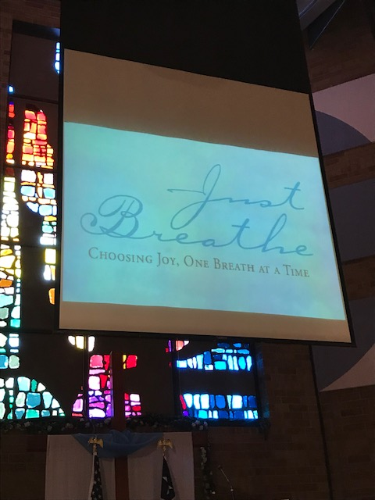
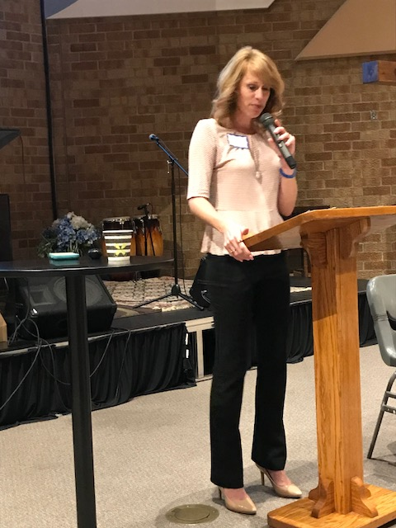
Keynote speaker Leeanne Waterworth talked about her faith journey as she and her family have been faced with medical and financial challenges. Her book, Just Breathe: Choosing Joy, One Breath at a Time, is widely available. She periodically updates her story on her blog at www.leannewaterworth.com.

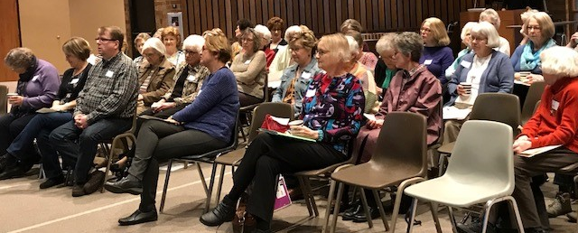

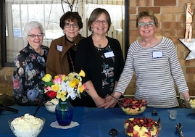
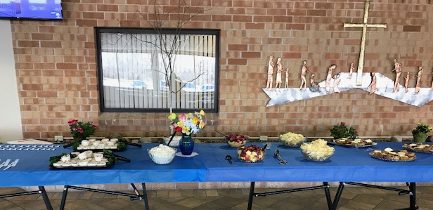

p. 6
FROM THE WORKSHOP ON WEEDING

According to Will Manley, author of The Manley Art of Librarianship, "Next to emptying the outdoor book drop on cold and snowy days, weeding is the most undesirable job in the library. It is also one of the most important. Collections that go unweeded tend to be cluttered, unattractive, and unreliable informational resources."
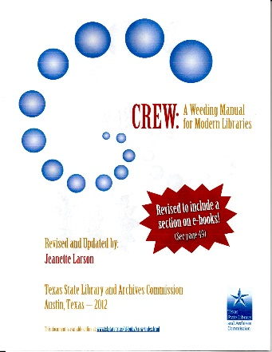
The Texas State Library and Archives Commission created the acronym MUSTIE to describe 6 factors that make books and other library materials prime candidates for weeding:
- M = Misleading and/or factually inaccurate
- U = Ugly - worn and beyond mending or rebinding
- S = Superseded by a truly new edition or by a much better book on the subject
- T = Trivial - of no discernible merit; usually of ephemeral interest at some time in the past
- I = Irrelevant to the needs and interests of your community
- E = The material or information may be obtained Elsewhere through interlibrary loan, reciprocal borrowing, or in electronic format.
Their comprehensive 107-page publication, CREW: A Weeding Manual for Modern Libraries, is available online at: www.tsl.state.tx.us/ld/pubs/crew/index.html.

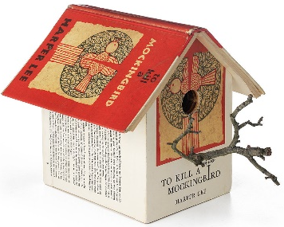

Per A Handbook for Church Librarians by the National Church Library Association, after the decision has been made to withdraw the item from your library:
- Remove all ownership information from the book and write “discard” or “withdrawn” on it.
- Delete all information from your catalog, paper or electronic.
- Update accession records.
- Update any booklists in which the item may appear.
- Remove the material from the library.

Suggestions from the attendees on what to do with the books and other materials that are being removed:

- Give-away shelf of free books in your library

- Book sales in your church
- Bloomington Book ‘Em Used Book Sale
- TCACLA book swap
- Books for Africa
- Bethany Prison Ministry
- Northfield Hospital Auxiliary Book Fair
- A Greener Read Used Book Store
- Senior Centers
- Check out the Internet for amazing things you can make from old books
If all else fails and the book is too shabby for reuse – i.e. in the “Ugly” category above, remove the cover and binding and recycle the loose pages.

p. 7


One of the missions of TCACLA is to provide a forum for church librarians to exchange information with each other. In addition to our meetings and our newsletter, we also do this via our website at www.tcacla.com.


We’re always looking for input from you. If you have an upcoming book event at your church, have had a special promotion for your library, want to recommend a new book, or have any other news that other members would be interested in, please send the information to livingoutfaith@hotmail.com.

Fall TCACLA Meeting
October 13, 2018

