
Mission Statement: To energize church library ministry through education, resource sharing, spiritual encouragement and fellowship.
OFF THE SHELF

General Information

TCAC is an area chapter of the National Church Library Association, a non-profit support organization serving church librarians of all backgrounds. Membership is open to individuals or churches of all Christian denominations that desire assistance with church library development. Contact the national office or any TCAC board member if you are interested in joining or have questions.

Twin Cities Area
Chapter Board

Sandra Johnson, President
952-544-8117
sjj24@msn.com
Paula Erickson, Vice President
763-427-5128
pl.rcksn@gmail.com

Laura Dirks, Secretary
612-378-3026
Laura.Dirks@securian.com

Colleen Stieg, Treasurer
763-533-1702
cmks30@msn.com

National Office
National Church Library Association

275 South Third Street
Suite 101A
Stillwater, MN 55082
651-430-0770
info@churchlibraries.org
www.churchlibraries.org

Spring 2018

Inside This Issue
Treasurer’s Report  Meeting Invitation | 2
What Churches Are Reading | 3-4
Odds & Ends | 5
Information on Prince of  Peace Lutheran Church | 6
Meeting Schedule  Registration Form | 7
www.tcacla.com | 8

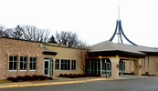

7217 W Broadway Ave
Brooklyn Park, MN

As always, there will be a book swap, time to visit the church library, and an opportunity to network with other church librarians. More information on the program, directions to the church, and a registration form are included in the following pages.

TCACLA Spring Meeting
Prince of Peace Lutheran Church
April 21, 2018
8:45 a.m. – 12:30 p.m.

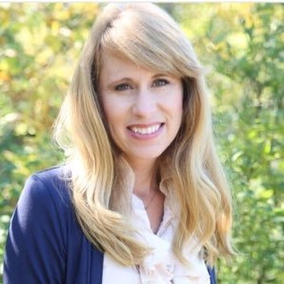
Our featured speaker is Leanne Waterworth, inspirational author of Just Breathe; Choosing Joy, One Breath at a Time. A Wis-consin resident, Leanne blogs about the challenges she faces as the mother of two boys who have cystic fibrosis. In her Jan-uary 25 post, “Lamentations,” she reported that her 15-year-old son had been struggling with debilitating back pain, her younger son had been hospitalized for persistent vomiting, her gymnast daughter had broken both heels and the entire family was adjusting to a recent move to a smaller home for financial reasons. She wrote: “In spite of our circumstances, I still have joy. I love my husband, my children…Life is really, really hard sometimes. God is still good. Each day is new and I am able to find reasons to praise him.” Copies of her book will be available for sale throughout the morning.


The program also includes a continuation of the conversation on weeding that began in the Fall 2017 Library “Nuts & Bolts” workshop. How do you decide when it’s time to remove an item from your collection? What do you do with items you no longer want? Do you have different rules if the item was donated by a church member? We anticipate a lively discussion.

General Information
The Twin Cities Area Church Library Association (TCACLA) is a non-profit support organization serving church librarians. Member-ship is open to individuals and churches of all denominations that desire to network with others on church library development and enrichment.
TCACLA BOARD
Grace Kurtz, Co-President 651-631-3726 gkurtz61@gmail.com

Jeanne Schleh, Co-President 612-729-6041 jerebob@aol.com

Lynn Tvedt, Vice-President 763-427-6576 ltvedt@q.com

Leslie Kallas, Secretary 612-978-9572 ljkallas@gmail.com

Deanna Gordon, Treasurer 952-544-5684 dgordon@iphouse.com

Historian
Jan Bolstad bolstadje@yahoo.com

Off the Shelf Editor
Laura Dirks otseditor@gmail.com
Website
www.tcacla.com

 |  | CON
Members: | 16 churches, 1 individual
01/01/2018 | $1607.13 |  | Beginning Balance
 | $145.00 |  | 2018 Membership Dues
 | -$28.68 |  | Scrapbook Supplies
- | -$52.41 |  | Off the Shelf Printing & Postage
03/25/2018 | $1671.04 |  | Ending Balance

Note: Our Treasurer has been in Tucson AZ. Renewals that
were mailed to her in recent weeks are not reflected here. If your
church hasn’t renewed its 2018 membership yet, you will re-
ceive an e-mailed reminder when she returns.


We all have friends who attend churches that have libraries
but aren’t members of TCACLA. Why not share this issue of
Off the Shelf with them and invite their church library teams to
come to the Spring meeting? They may come at the $15.00
member rate.

p. 2
WHAT CHURCHES ARE READING
The following books were recently added to the libraries of TCACLA member churches. I hope that all of you will share what your church is reading on a regular basis. All I need are the titles and authors of the books. Please e-mail this information to otseditor@gmail.com.

“When I'm really into a novel, I'm seeing the world differently during that time— not just for the hour or so in the day when I get to read. I'm actually walking around in a haze, spellbound by the book and looking at everything through a different prism.” – Colin Firth

CARING FOR CREATON; The Evangelical’s Guide to Climate Change and a Healthy Environment by Mitch Hescox and Paul Douglas, Bethany House, 2016.

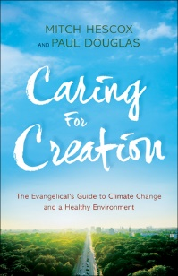

PAPA LUTHER; a Graphic Novel by Daniel Maurer, Augsburg Fortress, 2016.
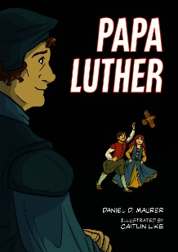

MARY, CHOSEN OF GOD by Diana Wallis Taylor, Whitaker House, 2016.



p. 3

The authors’ goal is to connect the dots between science and faith. They explore the climate change debate, suggest ways in which Christians can take the lead in caring for God's creation, and discuss stewarding the earth in light of evangelical values. "Acting on climate change is not about political agendas," they say. "It's about our kids. It's about being a disciple of Jesus Christ." Simple action steps are included.

A colorful 88-page “comic book” that takes readers inside the Luther family household. It is geared toward children ages 8 to 13 but will appeal to older ages as well. A free Leader’s Guide on the publisher’s website includes information on the historical framework and Biblical basis of each section and ways to connect the material to children and how it relates to their lives. The author is a member of Gloria Dei Lutheran Church in St. Paul.

Readers of this Biblical novel experience the life of Jesus through the eyes of his mother. Mary was an ordinary girl from Nazareth---helping her mother with household chores while daydreaming about Joseph, a handsome carpenter’s son---when suddenly a heavenly visitor appears, and her life is changed forever. Mary witnesses Jesus grow, mature, minister, and even be crucified—and then raised again, to the kindling of her new faith.

CONFESSIONS OF AN ADOPTIVE PARENT: Hope and Help from the Trenches of Foster Care and Adoption by Mike Berry, Harvest House Publishers, 2018.
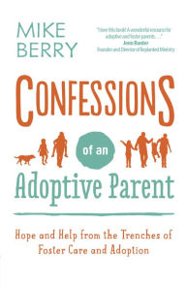

LONG WAY GONE by Charles Martin, Thomas Nelson Inc., 2017.

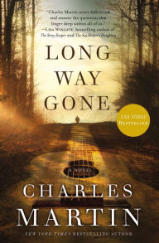

STEPPING STONES: A Refugee Family’s Journey by Margriet Ruurs, Orca Book Publishers, 2016.
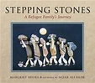

ALL SHE LEFT BEHIND by Jane Kirkpatrick, Baker Publishing Group, 2017.


p. 4

A how-to guide designed to address the specific needs of parents of adopted or foster children. From parenting children with traumatic pasts, to dealing with attachment issues, to raising a child with special needs, it can sometimes be a struggle just getting through the day. Per the publisher: “With a refreshing dose of honesty, empathy, and care,” readers will “discover you are definitely not alone on your journey and God has a very special plan for you and your family.” Berry is the co-creator of a blog with the same name.

A retelling of the prodigal son story. At the age of 18, musician Cooper O’Connor took everything his father held dear and drove 1,200 miles from home to Nashville, his life riding on a bold wager that he had talent. Five years after losing everything, he falls in love with Daley Cross, an angelic voice in need of a song. But just as he realizes his love for Daley, Cooper faces a tragedy that threatens his life as well as his career. With nowhere else to go, he returns home to the remote Colorado moun-tains, searching for answers about his father and his faith.

A multiple-award winning children’s book that will appeal to all ages. Rama and her family are forced to flee their once peaceful village in Syria to escape the ravages of the civil war raging ever closer to their home. With only what they can carry on their backs, Rama, her parents, brother and grandfather set out to walk to freedom in Europe. Nizar Ali Badr’s stunning stone images illustrate the story.

A carefully researched historical novel based on the real-life story of Jennie Pickett, one of the first female doctors in the Oregon frontier. She over-came spousal abuse, the loss of a baby, financial disaster, and humiliation among family and community to rise above and be heralded as a forceful and strong woman who kept her faith during troubled times. As a physician, she was particularly interested in the challenges of drug addiction and alcoholism.


Magers & Quinn Booksellers – Surprise Spring Break Sale

Everything is 20% off on April 2 and April 3 during normal business hours (10 a.m. - 10 p.m.). The store is located at 2038 Hennepin Ave. S in Minneapolis The website address is www.magersandquinn.com.

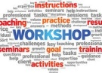
Fall Workshops

The TCACLA board has begun making plans for the Fall meeting workshops. They would love to get your suggestions for workshop topics. There is a place on the meeting registration form for you to provide them. Not able to come to the Spring meeting? Send your workshop suggestions to otseditor@gmail.com.

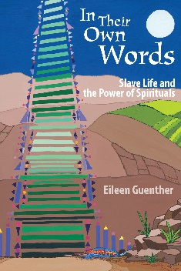



From awesomelibrarians.com
p. 5

IN THEIR OWN WORDS: Slave Life and the Power of Spirituals by Eileen Guenther, MorningStar Music Publishers, 2016.

Did you know that slaves sang “Swing Low, Sweet Chariot” to communicate that the conductor of the Underground Railroad was coming?
Dr. Guenther is Professor of Music at Wesley Theology Seminary. The following summary of her recent book is from Amazon.com: "This ground-breaking study of slavery and spirituals is the first to place the unique voices of an enslaved people squarely within the context of their daily lives. Dr. Guenther's deeply researched ac-count weaves a succinct history of America's original sin into an examination of the role of singing and religion in slave life and directly correlates slave testimonies in their own words to the themes of Spirituals. In addition to sur-veying the musical styles, performance prac-tices, and melodic and rhythmic characteristics of spirituals, In Their Own Words includes a biblical concordance to 100 of the spirituals most frequently sung."
Eileen Guenther is also the wife of TCACLA Treasurer Deanna Gordon’s cousin Ray.

PRINCE OF PEACE LUTHERAN CHURCH

The vision of Prince of Peace Lutheran Church is to be “a life transforming community relevant in a changing culture.” The church opened on February 21, 1960, when 153 people worshiped at Park Brook Elementary School. The official sanctuary opened on April 10, 1960. That sanctuary is now being used as a small chapel and for Sunday School rooms. A second sanctuary, dedicated on December 11,1977, is now known as the Community Life Center and is used for Sunday evening worship, adult forums, receptions, fellowship, meals and large group meetings. The current worship center, which has room for 750 people, was dedicated in October, 1997. That addition added more Sunday School rooms and a new kitchen.

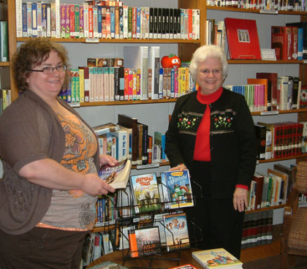
The church library is a welcoming, informal room, with resources to help people grow in their faith journeys. It is open before and after each Sunday worship service. New books and other items are added every month. They are either purchased by the library team or provided as donations. The team has several dedicated members who volunteer for tasks they enjoy, such as staffing the library on Sundays, re-shelving books, promoting library use, purchasing new materials, cataloging and processing new materials, writing short book reviews or working on special projects.
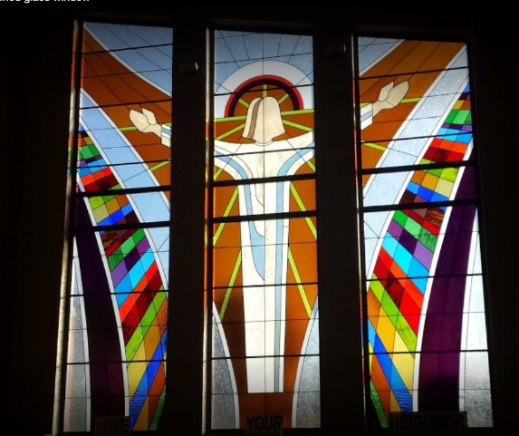

During your visit to the church, be sure to look at the beautiful 50th Anniversary Stained Glass Memorial Window which was dedicated on Palm Sunday, March 28, 2010.

7217 West Broadway Ave, Brooklyn Park

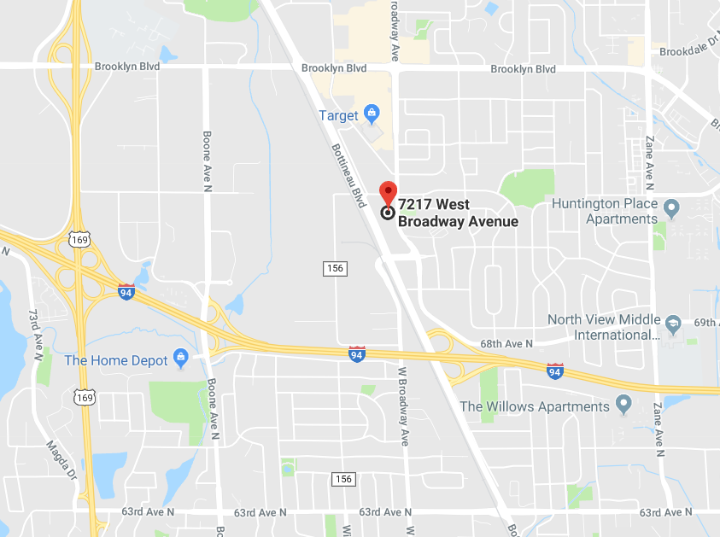

Directions from I94/I694 in Brooklyn Park:

- Take the exit for north Bottineau Blvd/Hwy 81. It’s east of Hwy 169.
- Continue on Bottineau Blvd. until you pass the church your right.
- Turn right on 73rd Ave N.
- Turn right again on W. Broadway Ave.
- Turn right into the church parking lot, then drive to the front of the building.
- Enter the church using the door on the left.

p. 6
Twin Cities Area Church Library Association Meeting
Saturday, April 21, 2018

The book swap and church library will be open all morning.

8:45 Registration and Connection Time
9:00 Welcome and Devotions
9:10 Marlys Johnson – A Look Back at the Early Years of Church Libraries
9:25 Short Break
9:30 Presentation by Leanne Waterworth
10:30 Break
10:45 Workshop: Weeding and Discarding Unwanted Library Materials
11:30 Lunch

---------------------------------------------------------------------------------------------------------------------------------------------------

TCACLA Spring Meeting
April 21, 2018
MEETING REGISTRATION FORM

Note: Please pre-register by April 16, 2018

Your church name: ________________________________________________________________

City: ____________________________ Workshop Topic Suggestions: ______________________

Name(s) of person(s) attending: ______________________________________________________

________________________________________________________________________________

Number of TCACLA member church registrants and their guests: _____ x $15.00 = ____________

Number of non-member church registrants: _____ x $18.00 = ____________

Make checks payable to TCACLA.

Mail to: Deanna Gordon
1600 Maryland Ave S
St. Louis Park, MN 55426

Questions: Call Deanna at 952.544.5684 or e-mail dgordon@iphouse.com.

p. 7


One of the missions of TCACLA is to provide a forum for church librarians to exchange information with each other. In addition to our meetings and our newsletter, we also do this via our website at www.tcacla.com.


We’re always looking for input from you. If you have an upcoming book event at your church, have had a special promotion for your library, want to recommend a new book, or have any other news that other members would be interested in, please send the information to livingoutfaith@hotmail.com.

TCACLA Spring Meeting
April 21, 2018

OFF THE SHELF
c/o Laura Dirks
333 8th St SE, Apt 206
Minneapolis, MN 55414-1246

