
Mission Statement: To energize church library ministry through education, resource sharing, spiritual encouragement and fellowship.
OFF THE SHELF

General Information

TCAC is an area chapter of the National Church Library Association, a non-profit support organization serving church librarians of all backgrounds. Membership is open to individuals or churches of all Christian denominations that desire assistance with church library development. Contact the national office or any TCAC board member if you are interested in joining or have questions.

Twin Cities Area
Chapter Board

Sandra Johnson, President
952-544-8117
sjj24@msn.com
Paula Erickson, Vice President
763-427-5128
pl.rcksn@gmail.com

Laura Dirks, Secretary
612-378-3026
Laura.Dirks@securian.com

Colleen Stieg, Treasurer
763-533-1702
cmks30@msn.com

National Office
National Church Library Association

275 South Third Street
Suite 101A
Stillwater, MN 55082
651-430-0770
info@churchlibraries.org
www.churchlibraries.org

Summer 2016

Inside This Issue
Treasurer’s Report  TCACLA Historian | 2
What Churches Are Reading | 3-4
Spring Meeting Highlights | 5-6
www.tcacla.com | 7

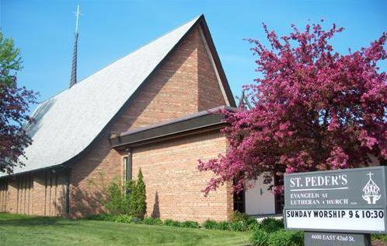

St. Peder’s Evangelical Lutheran Church

Begun by Danish seminary students, St. Peder’s Evangelical Lutheran Church’s roots are grounded in the Grundtvig tradition – affirming life and rejoicing in creation, re- specting the world and caring for it, claiming the beauty and goodness of ordinary life and the integrity of working with one’s own hands, and engaging in lifelong learning and education. There are several families with third generation presence who remain active in this small but socially active congregation that has a commitment to serve with “open hearts, open hands, and open doors.”

 TCACLA Fall Meeting October 22, 2016

The next TCACLA meeting will be on the morning of Saturday, October 22, at St. Peder’s Evangelical Lutheran Church. The church is located at 4600 East 42nd Street in south Minneapolis.

Although the agenda for the meeting hasn’t been finalized yet, the following activities are being planned:

- A presentation by Jessica Zillhart from the Anoka County Library about religious materials in the public library system.

- The annual business meeting where we’ll be electing a Vice President and Treasurer for the 2017-2018 term.

- Concurrent roundtable discussions on (1) cataloging and classification, (2) weeding and rotation of older materials, and (3) church library presence in social media: your church’s website, Facebook, Twitter, etc.

As always, there will be opportunities to exchange ideas with other church librarians, visit the church’s library, and participate in the book swap.

The Fall issue of Off the Shelf will include a complete schedule for the morning, along with a registration form.

General Information
The Twin Cities Area Church Library Association (TCACLA) is a non-profit support organization serving church librarians. Member-ship is open to individuals and churches of all denominations that desire to network with others on church library development and enrichment.

TCACLA BOARD
Ann Steen, Co-President 763-755-3388 annsteenmn@gmail.com

Jeanne Weingart, Co-President 952-942-7402 weingartjj@msn.com

Helen Heitz, Vice-President 612-238-2753 helenorm@usfamily.net

Janet Brownell, Secretary 651-765-4990 jjbewb488@comast.net

Deanna Gordon, Treasurer 952-544-5684 dgordon@iphouse.com

Chapter Website
http://www.tcacla.com

Off the Shelf Editor
otseditor@gmail.com

 |  | CON
Members: | 28 churches, 1 individual
04/04/2016 | $771.33 |  | Beginning Balance
 | $616.00 |  | Spring Meeting Registration
 | $60.00 |  | 2016 Membership Dues
 | $676.00 |  | Income
 | -$41.85 |  | Off the Shelf Printing & Postage
 | -$331.05 |  | Spring Meeting Costs
 | -$372.90 |  | Expenses
06/30/2016 | $1074.43 |  | Ending Balance

TCACLA HISTORIAN

Sally Onstad has served as our Historian for the past 7 years. During this time, she has maintained paper copies of all of our publications, taken pictures at all of our events, created scrapbooks from these materials, and brought the recent scrapbooks to our meetings. In addition, she has served as an ex-officio member of the board. Sally recently notified the board that she felt it was “time for some new blood in the position.” Happily, Jan Bolstad, also from Prince of Peace Lutheran Church, has agreed to replace Sally in this important role.

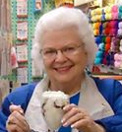


p. 2
WHAT CHURCHES ARE READING
The following books have recently been discussed by various groups at Hennepin Avenue United Methodist Church. Your suggestions for this column are encouraged. Please e-mail them to otseditor@gmail.com.

“Never put off till tomorrow the book you can read today.” ― Holbrook Jackson

ASK THE BEASTS: Darwin and the God of Love by Elizabeth Johnson, Bloomsbury, 2014.
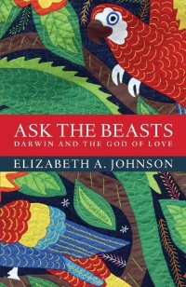

THE GOOD BOOK: Writers Reflect on Favorite Bible Passages edited by Andrew Blauner, Simon & Schuster, 2015.
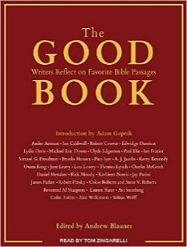

THE BOHEMIAN FLATS; a Novel by Mary Relindes Ellis, University of Minnesota Press, 2014.

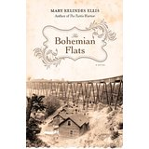

The book’s title comes from Job 12:7: "Ask the beasts and they will teach you." It explores the connections between Darwin's account of the origin of the species and the Christian story of the mercy and love of God recounted in the Nicene Creed. The author concludes that love of the natural world is an intrinsic element of faith in God and that far from being an add-on, ecological care is at the center of moral life.

Per Garrison Keillor, this books is "the Sunday School class you've been waiting for, the one whose members have thought hard about the texts and are free to say what they think.” It’s a collection of essays by a diverse group of well-known authors and journalists on the effect that the Bible has had on their lives. Some pieces are short and humorous; others are insightful commentaries about a personal hardship. Some pieces center on specific stories in the Bible; others encompass entire books or themes.

Raimund and Albert Kaufmann leave their 19th century family farm in Germany to build a new life in America. They land in the Flats, a diverse milling community on the banks of the Mississippi River. There the immigrant brothers confront prejudice, but they also find a chance to remake their lives according to their own principles and wishes--until World War I makes their German roots inescap-able. Per a review in the Star Tribune, “From the walks Raimund takes through Minneapolis neighborhoods, to the sort of food he eats and the sort of beer his Bohemian neighbors brew, the authenticity of his life comes fairly bounding off the page."

p. 3

HELP, THANKS, WOW; Three Essential Prayers by Anne Lamott, Riverhead Books, 2012.

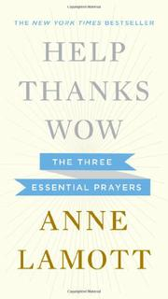

UNBOUND: The Transformative Power
of Youth Mission Trips by Jann Treadwell, Huff Publishing, 2014.

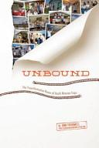

CRAZY by Linda Vigen Phillips, Eerdmans Books for Young Readers, 2014.
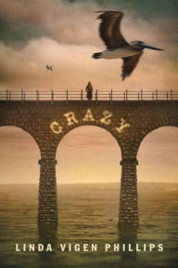

MANGA MESSIAH by NEXT, Tyndale House, 2007.
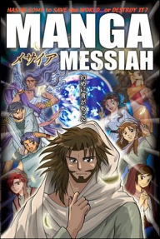
p. 4

The New York Times best-selling author has coalesced everything she knows about prayer into three fundamentals. She believes that asking for assistance from a higher power, appreciating what we have that is good, and feeling awe at the world around us can get us through the day and show us the way forward. In this brief book, she writes about how she came to these insights, explains what they mean to her and how they have helped, and explores how others have embraced these same ideas

The purpose of this guide is to encourage and inspire adults, both lay and professional from any faith-based group, to plan mission trips for the youth with whom they work. While filled with practical insights and details on planning and leading a trip, it is theologically grounded. A Resource section includes samples for an evening worship time, a budget worksheet, a recipe for an easy supper after the first day of work, a "chores chart," and a basic shopping list.
.

Fifteen-year-old Laura is a typical 1960’s teenager navigating her way through classes, friendships and even a new romance. But she has a secret—her mother is suffering from mental illness. No one in her family will talk about it, and Laura is confused and frightened. She finds solace in art, but when her mother, also an artist, breaks down, Laura fears she will follow in her footsteps. Beautifully written in verse for teens, the book speaks to adults as well.

“Manga” is the Japanese word for comics. This edgy style has become very popular with US teens and tweens. The rendition of the Gospel accounts in this book is both compelling and highly engaging. Cutting-edge art is combined with fast-paced storytelling to deliver Biblical truths to a group that is often a challenge to reach. Includes illustrated character profiles of key Bible figures and a map of Galilee, Samaria, and Judea.

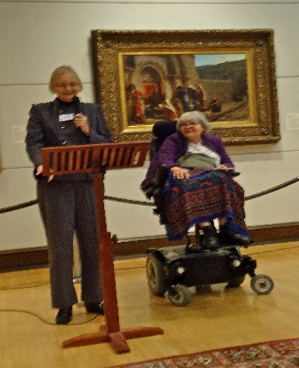
TCACLA SPRING MEETING HIGHTLIGHTS

Members and friends of TCACLA gathered in the Art Room of Hennepin Avenue United Methodist Church (HAUMC) in Minneapolis on May 14, 2016. The meeting began with Laura Dirks, a member of the host church, welcoming the group and making some general announcements. Vice President Helen Heitz then led devotions from the book, THE BAREFOOT ZONE, written by HAUMC pastor Sally Howell Johnson, and concluded with a prayer.

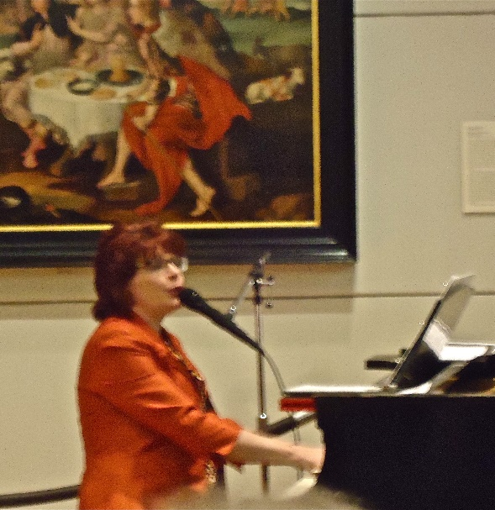
Co-president Jeanne Weingart introduced the speaker, Natalia Peterson, who read from her book I’M NOT THE PASTOR’S WIFE: I’m Just Married to Him and spoke and sang about her life’s journey. She is the daughter of Ukrainian immigrants, grew up in St. Paul, and is a musician and performer. She was married, then divorced and, suddenly, a single mother raising a daughter. Later, falling in love with a pastor presented a whole new set of problems and opportunities. She is candid about her mental health issues and struggles with the Christian faith. She has learned that you can’t do all the “shoulds” in life, and the beauty of imperfection is that you can become better. She advises us to embrace our authenticity and not be afraid to step outside the box to try something new.

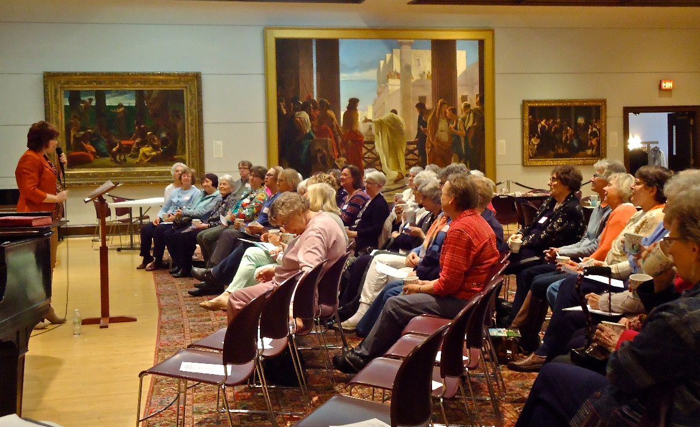

p. 5
During the break, there were opportunities to visit the HAUMC library, check out the book swap table, and visit with fellow church librarians. Luncheon salad and rolls were provided by Kowalski’s Catering; the desserts were provided by members of the HAUMC library team and the TCACLA board.

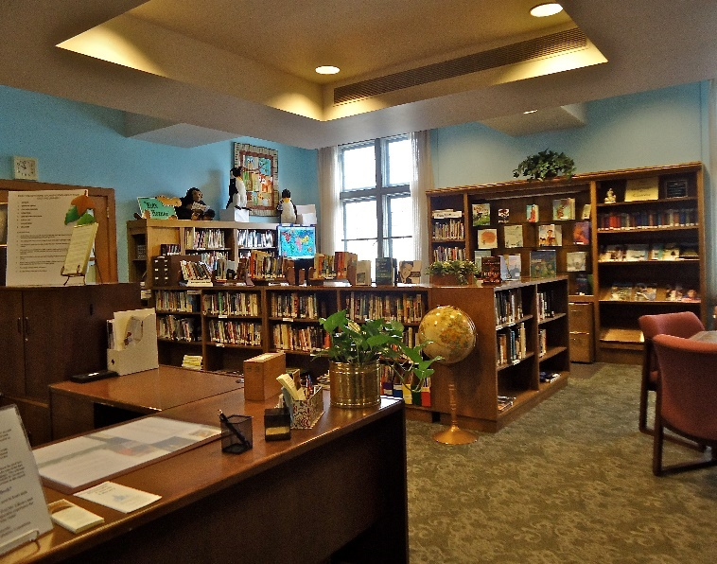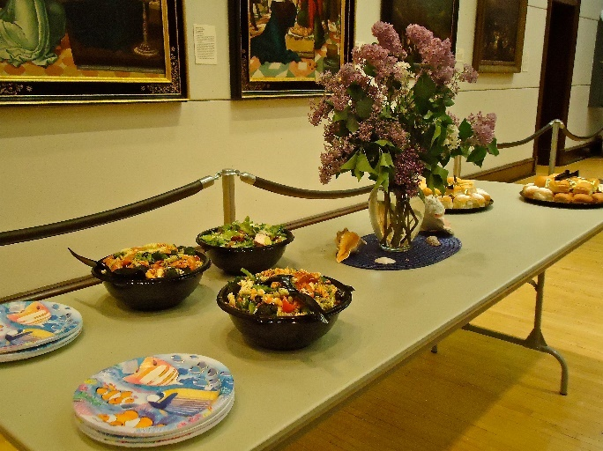
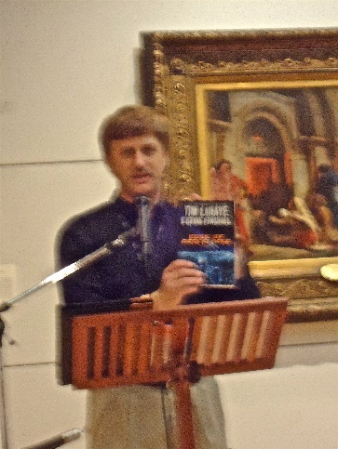

After lunch, Craig Bartels of LifeWay Christian Stores gave a presentation about their ministry, then spoke about many new books. Books were available for purchase, plus some were given away as door prizes. Everyone present received a Minister’s Discount form which enables local churches to get a 20% discount on almost all of the items in the stores.

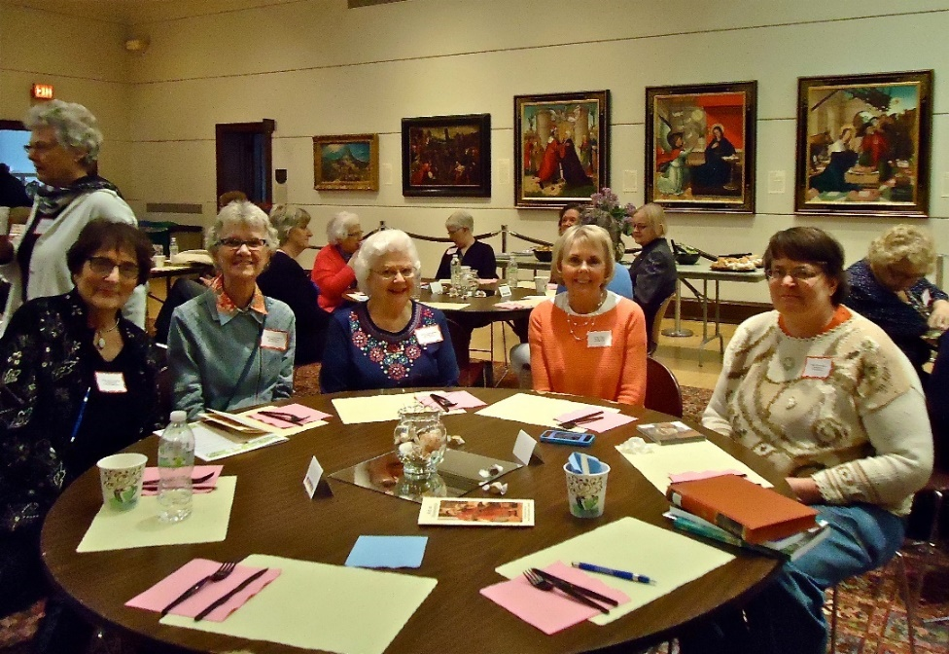
Special thanks to Janet Brownell and Sally Onstad for their contributions to this section.
p. 6



One of the missions of TCACLA is to provide a forum for church librarians to exchange information with each other. In addition to our meetings and our newsletter, we also do this via our website at www.tcacla.com.


We’re always looking for input from you. If you have an upcoming book event at your church, have had a special promotion for your library, want to recommend a new book, or have any other news that other members would be interested in, please send the information to livingoutfaith@hotmail.com.

Fall TCACLA Meeting
October 22, 2016

