
Mission Statement: To energize church library ministry through education, resource sharing, spiritual encouragement and fellowship.
OFF THE SHELF

General Information

TCAC is an area chapter of the National Church Library Association, a non-profit support organization serving church librarians of all backgrounds. Membership is open to individuals or churches of all Christian denominations that desire assistance with church library development. Contact the national office or any TCAC board member if you are interested in joining or have questions.

Twin Cities Area
Chapter Board

Sandra Johnson, President
952-544-8117
sjj24@msn.com
Paula Erickson, Vice President
763-427-5128
pl.rcksn@gmail.com

Laura Dirks, Secretary
612-378-3026
Laura.Dirks@securian.com

Colleen Stieg, Treasurer
763-533-1702
cmks30@msn.com

National Office
National Church Library Association

275 South Third Street
Suite 101A
Stillwater, MN 55082
651-430-0770
info@churchlibraries.org
www.churchlibraries.org

Winter 2017
Inside This Issue
Treasurer’s Report  2017 Membership Renewal | 2
What Churches Are Reading | 3-4
Fall Meeting Highlights | 5-6
Odds & Ends | 7
www.tcacla.com | 8

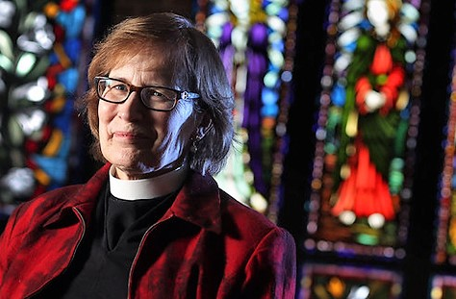
Lindsay Hardin Freeman is a Minnesota-based Episcopal priest who has won over thirty awards for journalistic excellence, including the 2015 Gold Medal Award in Bible Study from Independent Publisher.
From 2010-2014, she and a research team worked to do something never done before: to document every word spoken in the Bible by women. Her work takes her around the country, speaking to groups about the accomplishments and struggles of Bible women. She enjoys finding humor and grace in the Bible, and shares it fully.

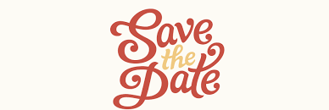

TCACLA Spring Meeting
April 29, 2017
9:30 a.m.-12:15 p.m.

The next TCACLA meeting will be on Saturday, April 29, at St. Michael’s Lutheran Church in Bloomington. Our featured speaker is Lindsay Hardin Freeman, author of Bible Women: All Their Words and Why They Matter.

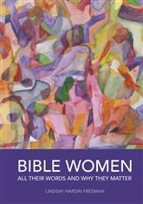
In her groundbreaking book, Rev. Freeman identifies every woman who speaks in the Bible, provid-ing her words, context, and his-torical background. Each entry lists the woman, her prominent traits, where to find her story, a “classic moment”, and her Bib-lical profile. There is a summary of her words, a quick recap of her story, and then some reflections on her life and how she might relate to various areas of modern life.
Rev. Freeman’s other books include a children’s book, The Spy on Noah’s Ark: Bible Stories from the Inside Out and Wisdom Found: Stories of Women Transfigured by Faith. You won’t want to miss her. At her presentation to a group at The Church of St. Martin-in-the-Fields in Philadelphia, she received a standing ovation.
The Spring issue of Off the Shelf will include a complete schedule for the morning, along with a registration form.
General Information
The Twin Cities Area Church Library Association (TCACLA) is a non-profit support organization serving church librarians. Member-ship is open to individuals and churches of all denominations that desire to network with others on church library development and enrichment.
TCACLA BOARD
Ann Steen, Co-President 763-755-3388 annsteenmn@gmail.com

Jeanne Weingart, Co-President 952-942-7402 weingartjj@msn.com

Lynn Tvedt, Vice-President 763-427-6576 ltvedt@q.com

Janet Brownell, Secretary 651-765-4990 jjbewb488@comast.net

Deanna Gordon, Treasurer 952-544-5684 dgordon@iphouse.com

Chapter Historian
Jan Bolstad bolstadje@yahoo.com
Off the Shelf Editor
Laura Dirks otseditor@gmail.com

 |  | CON
Members: | 29 churches, 1 individual
08/20/2016 | $1,011.43 |  | Beginning Balance
 | $632.00 |  | Fall Meeting Registration
 | $225.00 |  | 2017 Membership Payments
 | $857.00 |  | Income
- | -$30.87 |  | Off the Shelf Printing & Postage
 | -$13.00 |  | Website Domain Fee
 | -$408.59 |  | Fall Meeting Food & Supplies
 | -$452.46 |  | Expenses
01/01/2017 | $1,415.97 |  | Ending Balance

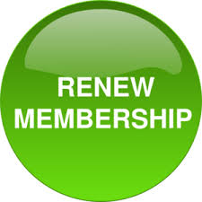

If your church hasn’t renewed its membership for 2017 yet,
you have received a renewal form with this issue of Off the
Shelf. For just $20.00, any number of people from your church
can attend all TCACLA events at the member rate. Please
complete both sides of the form, then send it to our Treasurer
with your check by no later than March 31, 2017.

p. 2
WHAT CHURCHES ARE READING

The following books were added to the collection of the St. Philips Lutheran Church library in 2016. Your suggestions for this column are always welcome. Please send them to otseditor@gmail.com.
“In the highest civilization, the book is still the highest delight. He who has once known its satisfactions is provided with a resource against calamity.” – Ralph Waldo Emerson

CHRIST ACTUALLY: The Son of God for the Secular Age by James Carroll, Penguin, 2014.
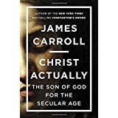

GOOD NIGHT, MR. WODEHOUSE; a Novel by Faith Sullivan, Milkweed, 2015.
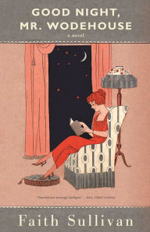

THE WARMTH OF THE HEART PREVENTS YOUR BODY FROM RUSTING; A French Recipe for a Long Life, Well-Lived by Marie de Hennezel, Penguin Books, 2013.
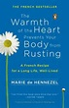

Carroll looks at anti-Nazi Lutheran pastor and martyr Dietrich Bonhoeffer’s question: Who actually is Christ for us today? Per Library Journal, in doing so, he “takes a fresh look at biblical figures such as John the Baptist, Paul, Peter, and Mary Magdalene, and their connections with Jesus in light of the Roman war's impact on the Christian scriptures. The end result is a beautiful portrait of Christ and faith in a post-Auschwitz world.”

The latest in Minnesota native Sullivan’s novels about life in rural Harvester, MN. In the beginning of the 20th century, Nell Stillman, a widow and third grade teacher, struggles to raise her son while escaping into the novels of P. G. Wodehouse at night. Per Booklist, “Nell manages to thrive in a rapidly changing world and survive the losses that inevitably befall and affect a tight-knit community.” This is “a fresh glimpse into small-town life, that gently but piercingly acknowledges the essential values of kindness and compassion that foster courage in the face of hardship.”

The author, a French clinical psychologist, writes about people who have grown old gracefully. In doing so, she shows readers how to make the most of this time in our lives, to avoid depression and to stay happy. She feels that if we can maintain energy in our hearts and believe in the power of joy and human warmth, this can transform us and the way we look at the world. This book was a best-seller in France. Critics have described it as “a must read” guide for caregivers and seniors, “a wonderful lesson that will inspire anyone who wants to age without becoming old,” and an “eloquent meditation.”
p. 3

STITCHES: A Handbook on Meaning, Hope and Repair by Anne Lamott, Penguin Publishing, 2013.

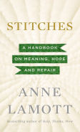

THE SENATOR NEXT DOOR; A Memoir from the Heartland by Amy Klobuchar, Henry Holt, 2015.

.
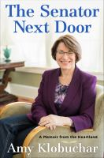

THE RACE OF MY LIFE; 50 Essays on Living with Cancer by Dr. David Eitrheim, Create Space Publishing, 2016.
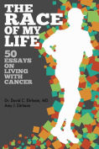

THE TRUTH ACCORDING TO US by Annie Barrows, Random House, 2015.

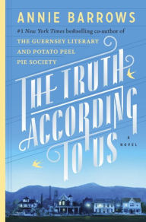
p. 4

What do we do when life lurches out of balance? How can we reconnect to one other and to what’s sustaining, when evil and catastrophe seem inescapable? Lamott explores how we find meaning and peace in these loud and frantic times; where we start again after personal and public devastation; how we recapture wholeness after loss; and how we locate our true identities in this frazzled age. Both humorous and thought-provoking.

From the dust jacket: "Senator Amy Klobuchar has tackled every obstacle she's encountered--her parents' divorce, her father's alcoholism and recovery, her political campaigns and Washington's gridlock--with honesty, humor and pluck. Now, in The Senator Next Door, she chronicles her remarkable heartland journey, from her immigrant grandparents to her middle-class suburban upbringing to her rise in American politics…Amy Klobuchar proves that politics is still the art of the possible."

When Dr. David Eitrheim was diagnosed with an aggressive form of tongue cancer, he was given 6-9 months to live. With an abrupt end to his medical career and his running days probably over, he decided use the time remaining in his life to share his faith; to tell stories; and to educate readers on issues surrounding death, dying, and end-of-life care. Questions at the end of each essay are meant to generate conversation and to encourage people to think about their own wishes for end-of-life care.

Described in the BookBrowse Review as “an irresistible novel, a sly charmer of a story about a small town in Depression-era West Virginia whose history is rewritten by a debutante on the run. Fam-ily histories, too are unraveled, but mended by the fierce, strong women who dominate this delightful page-turner, a tribute to the power of love and forgiveness to heal even the most heartbreaking betrayals.” Barrows is the co-author of The Guernsey Literary and Potato Peel Society.

TCACLA FALL MEETING HIGHTLIGHTS

Members and friends of TCACLA gathered at St. Peder’s Evangelical Lutheran Church in Minneapolis on October 22, 2016. After a welcome by Jeanne Schleh and a prayer by Shannon Kearns from St. Peder’s, Co-President Ann Steen called a short business meeting to order.

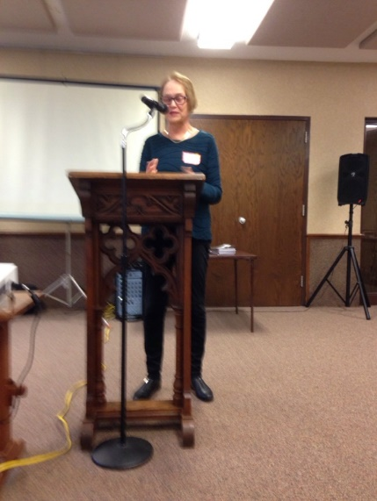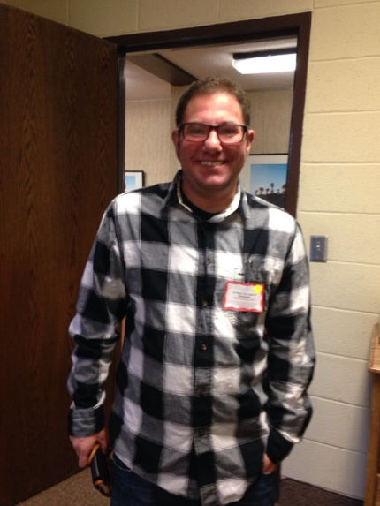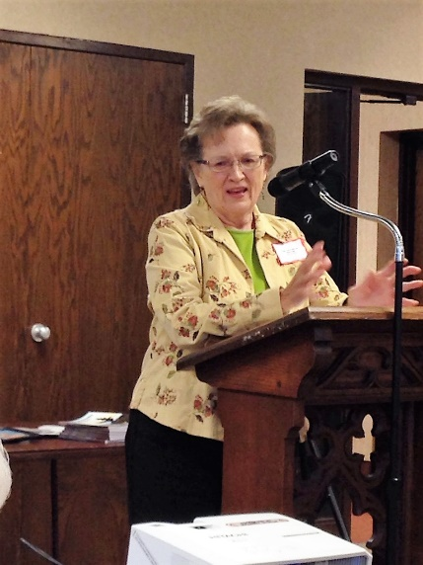

During the business meeting, Lynn Tvedt was elected to a two-year term as Vice-President, succeeding Helen Heitz whose term has expired, and Deanna Gordon was elected to a second two-year term as Treasurer. In addition, it was announced that Jan Bolstad will replace Sally Onstad as our Historian. Ann thanked Helen, who wasn’t able to attend the meeting, and Sally for their service.

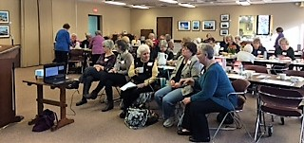

Front Row: Jan Bolstad, Historian; Jeanne Weingart, Co-President; Lynn Tvedt, Vice-President

Back Row: Ann Steen, Co-President; Sally Onstad, outgoing Historian; Deanna Gordon, Treasurer; Laura Dirks, Off the Shelf Editor

Not Pictured: Janet Brownell, Secretary

TCACLA Leadership Team

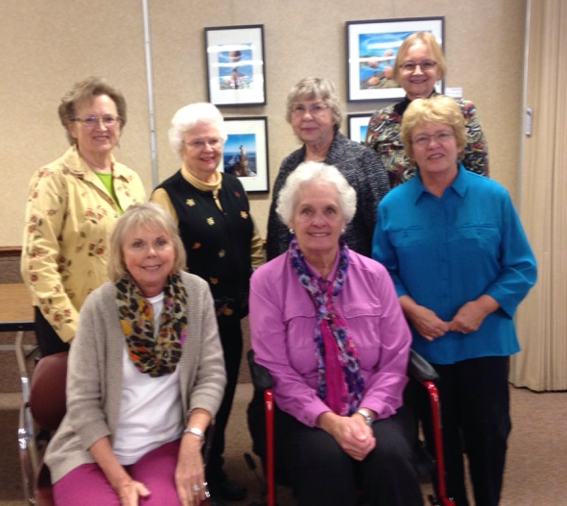
p. 5
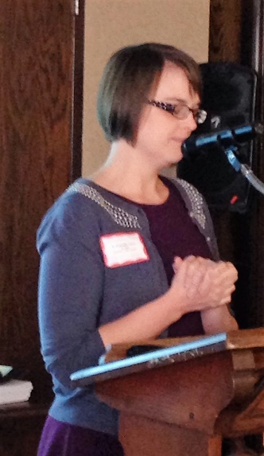
The morning’s keynote speaker was Jessica Zillhart, Materials Selection Librarian with the St. Paul Public Library. She made an excellent presentation on selection criteria, including the library’s vision, patron demand and community interests, cost, and relationship to the existing collection. She also spoke about how emotion, mood and bias can affect the selector’s choices. She concluded with examples of how she decided to buy or not to buy three specific books.

If you would like a copy of Jessica’s presentation, see the 2016 Fall Program Highlights post on our website (www.tcacla.com). It includes a chart from Pew Research about religious affiliation in the Twin Cities area.

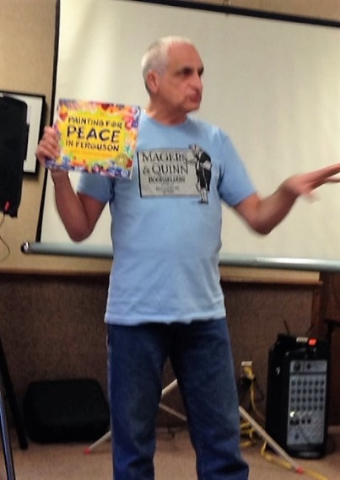
Gary Mazzone, Outreach & Sales Director at Magers & Quinn Book-sellers spoke about each of the books he’d brought on two current social justice issues, race and climate change. They included a wide variety of adult and children’s titles, both fiction and nonfiction. During a delicious lunch of squash soup, a variety of salads, and homemade bars, the books were given away based on a lottery system. Each person was given an opportunity to choose at least 2 free books, thanks to Gary.
Gary also talked about churches hosting author events and how to arrange discounts for your church purchases. Contact him at gary@magersandquinn.com or 612-875-2642 for more information on either of these items and/or to receive periodic e-mails about new books and author events at the store. Better yet, stop by the store!

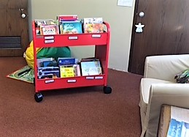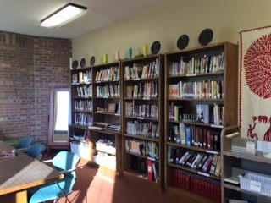

The St. Peder’s library has books, DVDs, media and magazines for all ages and interests. Its online catalog is available at www.librarything.com/catalog/StPeders.

p. 6
DONATION TO THE FRIENDS OF
THE SAINT PAUL PUBLIC LIBRARY

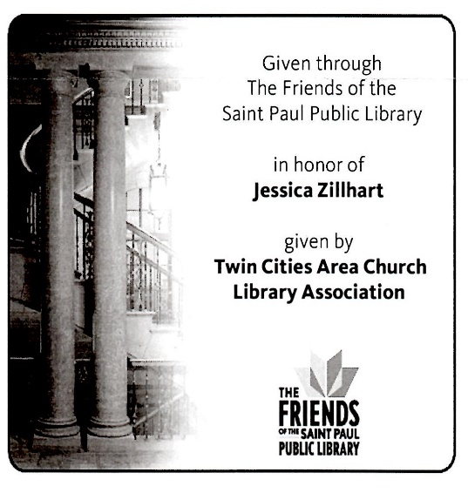
In lieu of a speaker’s honorarium to Jessica Zillhart, the TCACLA Board made a $50.00 contribution to The Friends of the Saint Paul Public Library in her honor. In his thank you letter to the board, Greg Giles, the Vice President of Development and Community Development, wrote that the money will be used to purchase two books. Each book will contain a bookplate similar to this one.

CHURCH-WIDE BOOK STUDIES

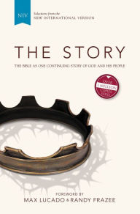
Two of our members have recently sponsored a church-wide book study. In the case of Zion Lutheran Church, the book is The Story. Using the clear, accessible text of the NIV Bible, it allows the stories, poems, and teachings of the Bible to read like a novel. And like any good story, The Story is filled with intrigue, drama, conflict, romance, and redemption. From the foreword by Max Lucado and Randy Frazee: “This book tells the grandest, most compelling story of all time: the story of a true God who loves his children, who established for them a way of salvation and provided a route to eternity.” The publisher, Zondervan, supports the book with multiple resources including promotional materials, a teen edition, a children’s curriculum, webinars and music. For more information, go to www.TheStory.com.
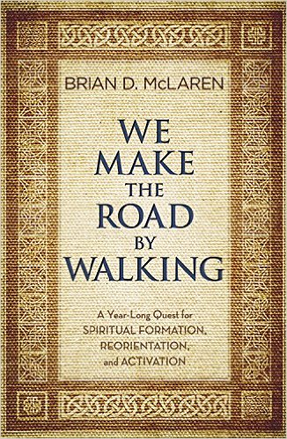
In the case of Hennepin Avenue United Methodist Church, the book is We Make the Road by Walking; A Year-Long Quest for Spiritual Formation, Reorientation, and Activation by Brian D. McLaren. The intent of the book is to explore how an honest, living, growing faith can make a difference in our world today. It is organized around the traditional church year. Each 4-page weekly reading includes discussion questions (including one for children), an action item, and a meditation topic. Several small neighborhood groups have formed to discuss the book. They meet at the church, in a member’s home, or a public place such as a coffee shop.

HOST CHURCHES NEEDED

Did you know that if your church hosts a TCACLA meeting your only responsibilities are to provide beverages and a library tour? While the board would welcome your assistance, they will be responsible for setting up the room, arranging the meal, and planning the program. It is expected that TCACLA would pay your church’s standard fees for use by an outside group. Please consider hosting the Fall 2017 meeting or one in 2018. Contact any board member (see p. 2) for more information.
p. 7


One of the missions of TCACLA is to provide a forum for church librarians to exchange information with each other. In addition to our meetings and our newsletter, we also do this via our website at www.tcacla.com.


We’re always looking for input from you. If you have an upcoming book event at your church, have had a special promotion for your library, want to recommend a new book, or have any other news that other members would be interested in, please send the information to livingoutfaith@hotmail.com.

TCACLA Spring Meeting
April 29, 2017

OFF THE SHELF
c/o Laura Dirks
333 8th St SE, Apt 206
Minneapolis, MN 55414-1246

