
Mission Statement: To energize church library ministry through education, resource sharing, spiritual encouragement and fellowship.
OFF THE SHELF

General Information

TCAC is an area chapter of the National Church Library Association, a non-profit support organization serving church librarians of all backgrounds. Membership is open to individuals or churches of all Christian denominations that desire assistance with church library development. Contact the national office or any TCAC board member if you are interested in joining or have questions.

Twin Cities Area
Chapter Board

Sandra Johnson, President
952-544-8117
sjj24@msn.com
Paula Erickson, Vice President
763-427-5128
pl.rcksn@gmail.com

Laura Dirks, Secretary
612-378-3026
Laura.Dirks@securian.com

Colleen Stieg, Treasurer
763-533-1702
cmks30@msn.com

National Office
National Church Library Association

275 South Third Street
Suite 101A
Stillwater, MN 55082
651-430-0770
info@churchlibraries.org
www.churchlibraries.org

Winter 2016
Inside This Issue
Treasurer’s Report | 2
What Churches Are Reading | 3-4
Fall Meeting Highlights | 5-6
Annual Meeting Summary  eBook Sources | 7
www.tcacla.com | 8

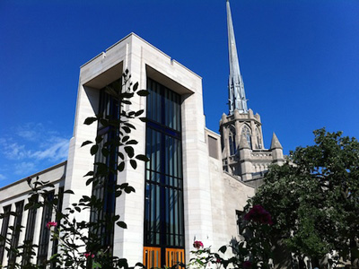

Hennepin Avenue United Methodist Church

The church began in 1875 when an adult Sunday School class wanted to live out its beliefs. Determined to have a presence in the city, the founders reached out to their neighbors and got everyone involved in ministry – even raising money for the first ambulance at the hospital in town. Today the story continues through Community Meals, the Dignity Center, the Steeple People thrift store, and many other outreach ministries of dignity that focus on the needs of the city and the needs of people to be in community and think intellectually about their faith.

TCACLA Spring Meeting
May 14, 2016
9:15 a.m.-1:00 p.m.

The next TCACLA meeting will be on Saturday, May 14, at Hennepin Avenue United Methodist Church. Our featured speaker is Natalia Peterson, author of I’m Not the Pastor’s Wife; I’m Just Married to Him.


From the author’s website: “Enter Talia, a worldly woman raised in a lively, embracing community of Ukrainian immigrants. A chance meeting with a Lutheran pastor, Charles, surprisingly takes them down the aisle. Talia has always been the big-city individualist – Charles is a small-town guy raised on a dairy farm. Talia has an unfettered spirit and personality – Charles has been called to serve as a Lutheran congregation in a small, conservative and very Scandinavian community.”

This memoir is full of quirky observations and candid stories, sometimes humorous and other times tragic, that are intended to show the reader what it takes to find the strength to lead an authentic life.

The Spring issue of Off the Shelf will include a complete schedule for the morning, along with a registration form.

General Information
The Twin Cities Area Church Library Association (TCACLA) is a non-profit support organization serving church librarians. Membership is open to individuals and churches of all denominations that desire to network with others on church library development and enrichment.

TCACLA BOARD
Ann Steen, Co-President 763-755-3388 annsteenmn@gmail.com

Jeanne Weingart, Co-President 952-942-7402 weingartjj@msn.com

Helen Heitz, Vice-President 612-238-2753 helenorm@usfamily.net

Janet Brownell, Secretary 651-765-4990 jjbewb488@comast.net

Deanna Gordon, Treasurer 952-544-5684 dgordon@iphouse.com

Chapter Website
http://www.tcacla.com

Off the Shelf Editor
otseditor@gmail.com

 |  | CON
Members: | 31 churches, 2 individuals
09/11/2015 | $756.10 |  | Beginning Balance
 | $314.00 |  | Fall Meeting Registration
 | $179.00 |  | 2016 Membership Dues
 | $493.00 |  | Income
 | -$50.88 |  | Off the Shelf Printing & Postage
 | -$301.97 |  | Fall Meeting Costs
 | -$352.85 |  | Expenses
02/01/2016 | $896.25 |  | Ending Balance



If your church hasn’t renewed its membership for 2016 yet,
you have received a renewal form with this issue of Off the
Shelf. For just $12.00, any number of people from your church
can attend all TCACLA events at the member rate. Please
complete both sides of the form, then send it to our Treasurer
with your check by no later than March 31, 2016.

p. 2
WHAT CHURCHES ARE READING

The following books are recommended by Calvary Lutheran Church, Golden Valley Lutheran Church, Hennepin Avenue United Methodist Church, Salem Lutheran Church, St. Michael’s Lutheran Church, and St. Philip’s Lutheran Church. Your suggestions for this column are always welcome. Please e-mail them to otseditor@gmail.com.

“No man can be called friendless who has God and the companionship of good books.” - Elizabeth Barrett Browning

MRS. LINCOLN’S DRESSMAKER by Jennifer Chiaverini, Dutton, 2013.
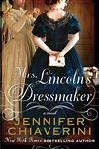

THE WEIGHT OF MERCY: A Novice Pastor on the City Streets by Deb Richardson-Moore, 2012.
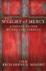

THE PRAYER BOX (A Carolina Heirlooms Novel) by Lisa Wingate, Tyndale House, 2013.

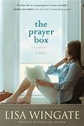

This well researched historical novel is based on the true life of Elizabeth Keckley. Born a slave, she ultimately became a sought after seamstress by the elite in Washington, DC - including Mary Todd Lincoln. Through Lizzy’s eyes, readers learn what it was like to live in Washington during the Civil War, how the faiths of Elizabeth and President Lincoln shaped their lives, and what became of the remaining members of the former First Family after the assassination.

After 27 years as a journalist, the author answered a call to the ministry. Pastor Deb describes the difficulties surrounding her first years at an inner-city church which was a gathering place for homeless men and women suffering from mental illness, crack addiction and alcoholism. During this time, she learns not only to see Christ among “the least of these,” but she also experiences Christ’s redemptive power. Richardson-Moore tells a touching and sometimes humorous story with engaging characters while sharing her vision of what the Christian church could be.

When Tandi Jo Reese wants to escape from her abusive marriage, she and her children go to the Outer Banks of NC where Tandi spent happy childhood days with her grandparents. When her landlady there dies, Tandi agrees to clean out the house. While doing this, she discovers a closet full of decorated prayer boxes. As she reads through the letters in each box, Tandi comes to know both Iola Anne Poole and her loving Father. She also discovers the woman she herself will become. This story of family ties and redemption was a finalist for several Christian book awards.
p. 3
HOUSE OF LIVING STONES by Katie Schuermann, Concordia Publishing House, 2014.



CONVERSATIONS WITH SAINT BERNARD: a Novel by Jim Kraus, Abingdon Press, 2015.

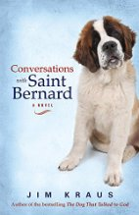

BLUE GOLD; a Novel by Elizabeth Stewart, Annick Press, 2014.
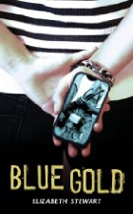

A SENSIBLE ARRANGEMENT by Tracie Peterson, Bethany House, 2014.

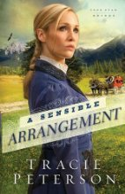
p. 4
Emily Duke is hired to be the new director of a long established choir at Zion Lutheran Church in a small college town in IL. This change impacts the lives of many people, including the crusty church secretary, the pompous organist, and the new young pastor. Even Emily needs to come to terms with her past. The quirky characters will have you laughing; music lovers will enjoy the references to instruments and singing. The author returns to Zion for “the wedding of the century” in the sequel, The Choir Immortal.

One of the items on George Gibson’s bucket list is to travel across America to visit the places that he never got to see with his wife before she died. His daughter encourages him to temporarily adopt a St. Bernard and take him along as a travel companion. Lewis turns out to be a great listener who loves unconditionally. In addition to enjoyment, the author presents the reader with significant questions about the nature of God, the power of faith, the influences of pain and suffering, and the awfulness of guilt.

Three teen girls on three continents are linked by the rare mineral coltan, also known as blue gold, which is used in manufacturing cell phones. Sylvie is a Congolese refugee living in a brutal camp in Tanzania, where her family has fled the conflict over the mineral. Laiping lives in China and is exploited in a factory that assembles cell phones. Fiona is a middle class high school student in Canada who experiences cyber bullying. Caution: while this novel is about teens, the book addresses topics such as violence, rape and sweatshops, that may not be appropriate for younger readers.

In the first of Peterson’s 3 book Lone Star Brides series, set in 1892, widow Marty Olson travels from her Texas ranch to Denver to marry widower Jake Wythe, a banker she’s never met. Jake has arranged this marriage of convenience because his employer requires that he be married. Some of the story lines started in this book continue in the 2nd one, A Moment in Time, and the 3rd one, A Matter of Heart. Per one reviewer, Peterson is an expert at weaving the Christian message into the fabric of an enchanting historical romance.

TCACLA FALL MEETING HIGHTLIGHTS

Members and friends of TCACLA gathered at the SpringHouse Ministry Center in Minneapolis on October 24, 2015. Co-president Jeanne Weingart welcomed attendees and introduced Barbara Livdahl from Salem English Lutheran Church, one of our hosts. Barb described how three churches from three denominations collaborated to create the joint ministry center. She skillfully wove a devotional message around their combined social ministry, a Bible reading, and the hymn, We Are Called.

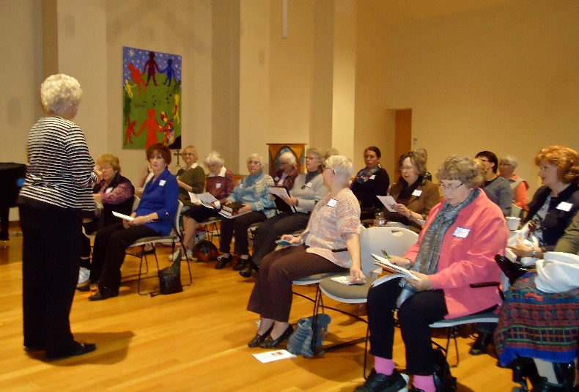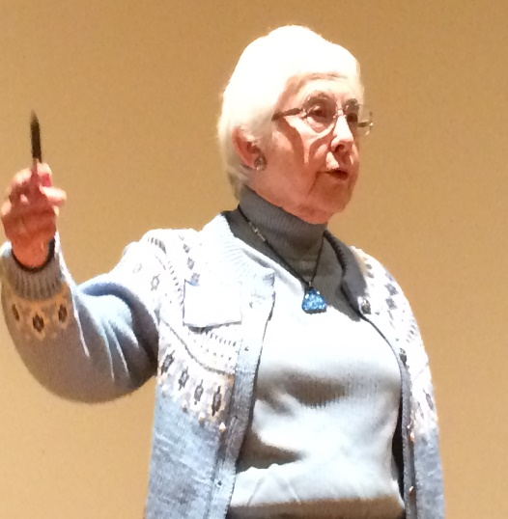

Co-president Ann Steen introduced our keynote speaker, Chris Magnusson. Chris is the Automation Librarian/Legacy Program Coordinator with the Arrowhead Library System as well as the Library Director at Our Savior's Lutheran Church in Hibbing. She introduced the group to the American Library Association’s Center for the Future of Libraries and encouraged everyone to share resources, work with our church Facebook coordinators, use technology, and build services as well as collections.

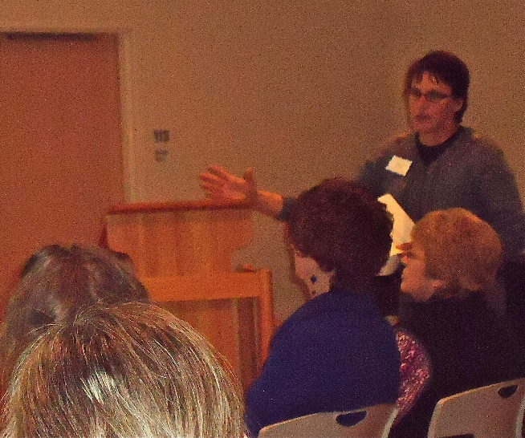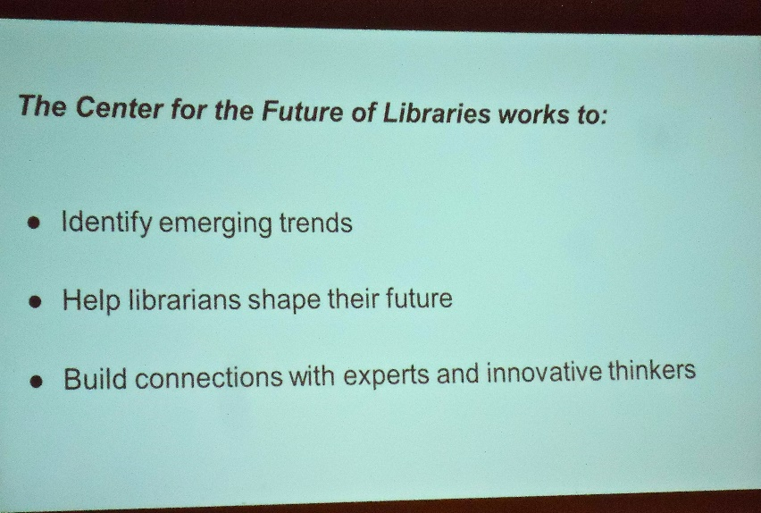

p. 5
Attendees next had an opportunity to attend a breakout session on managing a small church library; recruiting, scheduling and training volunteers; or working with non-print materials.
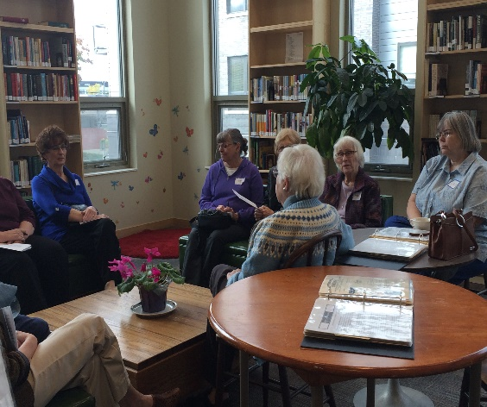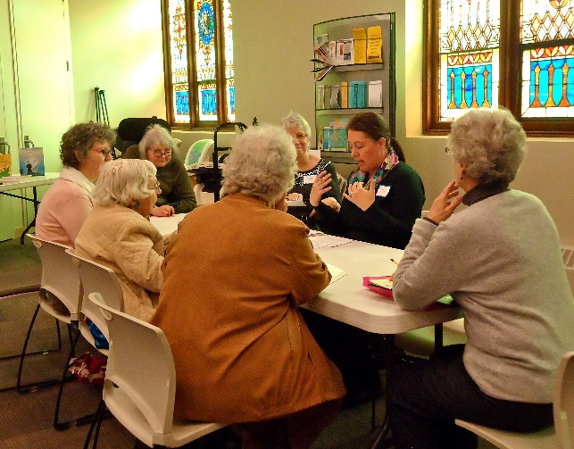

Of course there was also time to see the beautiful worship areas, tour the library, and look for a good book in the book swap. During a delicious lunch, catered by House of Hunger, a table topic - library automation systems - was suggested. However, everyone seemed so stimulated by what they’d heard during the morning that they didn’t need encouragement to share their thoughts about many topics with others at their tables.

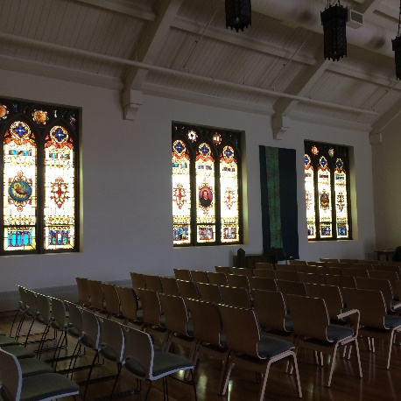

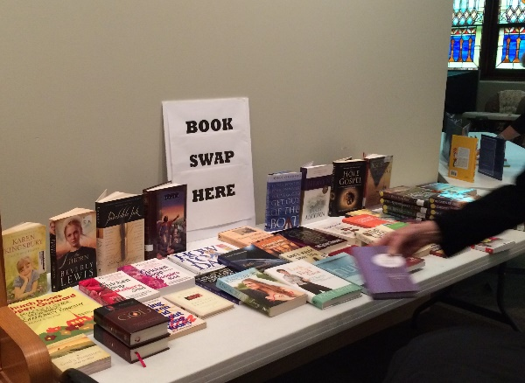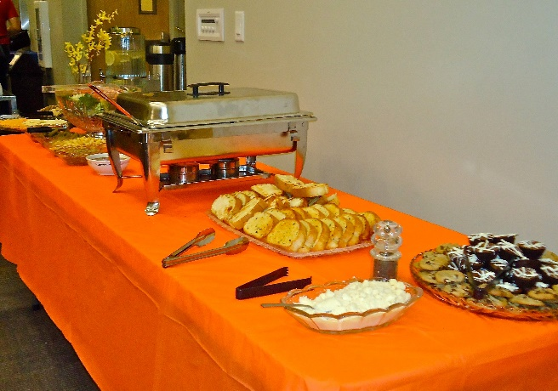
p. 6
SUMMARY OF THE 10/24/2015 ANNUAL BUSINESS MEETING

Co-president Ann Steen called the meeting to order. A printed copy of the Treasurer’s Report was distributed to everyone; the Secretary read the report of last year’s meeting. Both were accepted as presented.
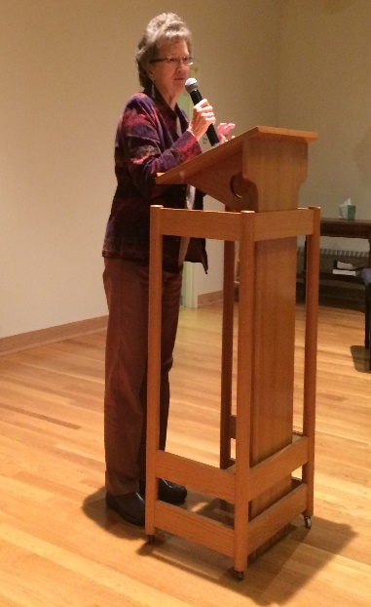
Ann reported that the board has decided to have two meetings per year going forward. One meeting will feature a main speaker, typically an author, of general interest to a wider audience than just church librarians. The second meeting will include workshops of specific interest to library team members and the annual business meeting. She encouraged program suggestions.

The rising cost of meetings was discussed at some length. Churches now charge us $100-$200 for insurance and/or maintenance costs and speakers’ fees are increasing. While a different venue may be less expensive, members expressed the opinion that seeing other churches and their libraries is an important benefit of the meetings.

The board has already voted to increase the cost of extra mailed paper copies of Off the Shelf from $3.00 to $5.00 to cover the true cost for this service. Vice-president Helen Heitz made a motion to increase the dues from $12 to $20 in 2017. (Renewals have already begun for 2016.) Barb Livdahl seconded the motion and it was carried.
Helen conducted the election for the President and Secretary positions in 2016-2017. She called for nominations from the floor, but heard none. The individuals currently serving in these positions agreed to run for second terms and were unanimously elected.

Special thanks to Janet Brownell, Dulcie Campana and Sally Onstad for their contributions to pages 5-7.

---------------------------------------------------------------------------------------------------------------------------------------

SOURCES OF FREE eBOOKS AND OTHER ONLINE MATERIALS
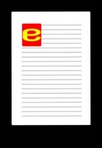
- Your local public library
- www.gutenberg.org/wiki/Christianity_(Bookshelf)
- www.haithitrust.org
- www.elm4you.org
- reflections.mndigital.org
Provided by Chris Magnusson, magnussonc@yahoo.com

p. 7


One of the missions of TCACLA is to provide a forum for church librarians to exchange information with each other. In addition to our meetings and our newsletter, we also do this via our website at www.tcacla.com.


We’re always looking for input from you. If you have an upcoming book event at your church, have had a special promotion for your library, want to recommend a new book, or have any other news that other members would be interested in, please send the information to livingoutfaith@hotmail.com.

Spring TCACLA Meeting
May 14, 2016

OFF THE SHELF
c/o Laura Dirks
333 8th St SE, Apt 206
Minneapolis, MN 55414-1246

