
Mission Statement: To energize church library ministry through education, resource sharing, spiritual encouragement and fellowship.
OFF THE SHELF

General Information

TCAC is an area chapter of the National Church Library Association, a non-profit support organization serving church librarians of all backgrounds. Membership is open to individuals or churches of all Christian denominations that desire assistance with church library development. Contact the national office or any TCAC board member if you are interested in joining or have questions.

Twin Cities Area
Chapter Board

Sandra Johnson, President
952-544-8117
sjj24@msn.com
Paula Erickson, Vice President
763-427-5128
pl.rcksn@gmail.com

Laura Dirks, Secretary
612-378-3026
Laura.Dirks@securian.com

Colleen Stieg, Treasurer
763-533-1702
cmks30@msn.com

National Office
National Church Library Association

275 South Third Street
Suite 101A
Stillwater, MN 55082
651-430-0770
info@churchlibraries.org
www.churchlibraries.org

Summer 2017
Inside This Issue
Treasurer’s Report  Election of Officers | 2
What Churches Are Reading | 3-4
Spring Meeting Highlights | 5-6
Odds & Ends | 7
www.tcacla.com | 8

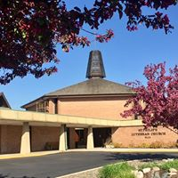

St. Philip’s Lutheran Church

St. Philip's Lutheran Church was formally or-ganized in Fridley on May 12, 1958 with 144 members. On May 6, 1965, 60 families of the congregation lost their homes to tornadoes and many others suffered severe property damage. Despite this, the congregation, now over 1,600, proceeded with plans for the current building with its unique baldachin over the chancel area. The addition of a large fellowship hall in 1991 provides space for an after-school program for Middle School youth, a shelter program for families temporarily without housing, English as a Second Language classes for new refugees, and numerous other food and helping ministries.



TCACLA Fall Meeting October 14, 2017

The next TCACLA meeting will be on the morning of Saturday, October 14, at St. Philip’s Lutheran Church in Fridley.

Although the agenda for the meeting hasn’t been finalized yet, the following activities are being planned:

- Associate Pastor Natalia Terfa, from Prince of Peace Lutheran Church, will lead us in a devotion and talk about her book, Uplift: a Little Book of God’s Promises to Give Hope and Uplift Your Soul.

- A presentation and discussion on promoting your library on your church website and other social media such as Facebook and Twitter.

- A “nuts and bolts” workshop on cataloging and classification methods, collection maintenance, library promotion and publicity, and more as time allows.

- The annual business meeting where we’ll be electing a President and Secretary for the 2018-2019 term.

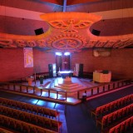
As always, there will be opportunities to exchange ideas with other church librarians, visit the church’s library, and participate in the book swap.

The Fall issue of Off the Shelf will include a complete schedule for the morning, along with a registration form.

General Information
The Twin Cities Area Church Library Association (TCACLA) is a non-profit support organization serving church librarians. Member-ship is open to individuals and churches of all denominations that desire to network with others on church library development and enrichment.
TCACLA BOARD
Ann Steen, Co-President 763-755-3388 annsteenmn@gmail.com

Jeanne Weingart, Co-President 952-942-7402 weingartjj@msn.com

Lynn Tvedt, Vice-President 763-427-6576 ltvedt@q.com

Janet Brownell, Secretary 651-765-4990 jjbewb488@comast.net

Deanna Gordon, Treasurer 952-544-5684 dgordon@iphouse.com

Historian
Jan Bolstad bolstadje@yahoo.com

Off the Shelf Editor Laura Dirks
otseditor@gmail.com

Chapter Website http://www.tcacla.com
 |  | CON
Members: | 26 churches, 1 individual
01/01/2017 | $1,415.97 |  | Beginning Balance
 | $696.00 |  | Meeting Registration
 | $340.00 |  | 2017 Membership Dues
 | $1,036.00 |  | Income
 | -$95.00 |  | Website
 | -$87.06 |  | Off the Shelf Printing & Postage
 | -$556.25 |  | Meeting Costs
 | -$738.31 |  | Expenses
06/30/2017 | $1,713.66 |  | Ending Balance

*********************************************************

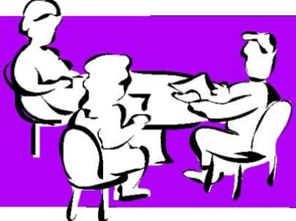

ELECTION OF OFFICERS
During the business meeting on October 14, we will be electing a President and a Secretary for the 2018-2019 term. Jeanne Schleh, St. Peder’s Evangelical Lutheran Church, and Grace Kurtz, St. Philips Lutheran Church, have agreed to run as Co-Presidents. If you, perhaps along with a friend, are interested in running for the Secre- tarial position, please contact any of the board members listed on this page.

p. 2
WHAT CHURCHES ARE READING
The following books for children and teens have recently been added to the libraries of TCACLA member churches. Your suggestions for this column are always welcome. Please e-mail the titles and authors to otseditor@gmail.com.
“There is no such thing as a child who hates to read; there are only children who haven’t found the right book.” – Frank Serafini

MAMA’S NIGHTINGALE; A Story of Immigration and Separation by Edwidge Danticat, Dial Books, 2015.
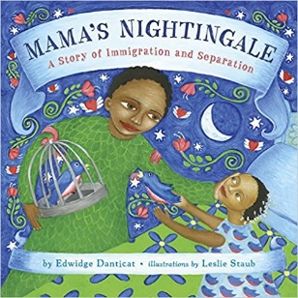

100 CUPBOARDS SERIES by N. D. Wilson, Random House, 2007-present.
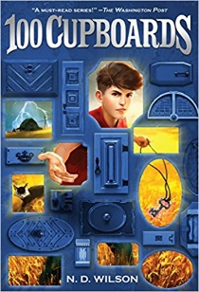

WHAT DOES IT MEAN TO BE KIND? by Rana DiOrio, Little Pickle Press, 2015.
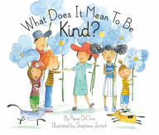

p. 3
After Saya's mother is sent to an immigration detention center, Saya finds comfort in listening to her mother's warm greeting on their answering machine. To ease the distance between them, Mama begins sending Saya bedtime stories inspired by Haitian folklore. Moved by her mother's tales and her father's attempts to reunite their family, Saya writes a story of her own—one that just might bring her mother home for good. With stirring illustrations, this tender tale shows the human side of immigration and imprisonment.

The works of children’s fantasy adventure author Wright have been compared to C. S. Lewis and J. R. R. Tolkien. In the first book of this series, 12-year-old Henry York wakes up one night and discovers cupboards of all different sizes and shapes in his attic bedroom. Through one he hears falling rain. Through another he sees a glowing room with a man pacing back and forth. Henry soon understands that these are not just cupboards, but portals to other worlds. When his cousin Henrietta boldly travels into them, it’s up to Henry to follow her.

When the girl in the red hat finds the courage to be kind to the new student in class, her kindness spreads. By kind words and by kind deeds, her whole community experiences the magical shift that happens when everyone supports and cares for one another, demonstrating patience and forgiveness. The illustrations not only feature children of different races, but children of different sizes and with different personal styles.

REMEMBER DIPPY by Shirley Reva Vernick, Cinco Puntos Press, 2013.
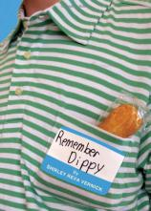

THE GREEN EMBER SERIES by S. D. Smith, Story Warren Books, 2015-present.

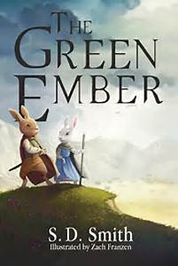

OUR FATHER by Rainer Oberthur, Eerdmans Books for Young Readers, 2016.

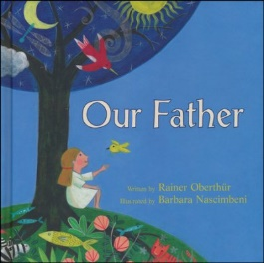

MARCH (3 volume set) by John Lewis, IDW Publishing, 2016.

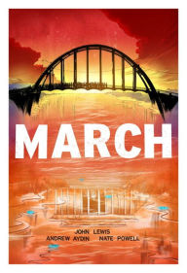

p. 4
Johnny's plans for the summer before he starts high school change when his single mother needs to leave town for a breakthrough job. He can live with Aunt Collette but only on the condition that he help with his autistic older cousin, a gawky awkward kid with some strange habits. At first, Johnny's premonitions of disaster appear to come to cringeworthy fruition, but when the two boys save a bully from drowning, salvage the pizzeria guy's romance, and share girl troubles, Johnny ends up having the summer of his life.

Adventure fantasy novels written for middle schoolers, but enjoyed by readers of all ages. Heather and Picket are extraordinary rabbits with ordinary lives until calamitous events overtake them, spilling them into a cauldron of misad-ventures. They discover that their own story is bound up in the tumult threatening to overwhelm the wider world. The books include important character lessons including loyalty, family, friendship, compassion, selflessness, and forgiveness.

The language and the ideas in the Lord’s Prayer can be daunting to children. Our Father attempts to address their questions in a way that is both clear and poetic. Each line of the prayer is explained in child-friendly language and is complemented with beautiful collage-like illustrations. The presentation is not specific to any denomination.

The life of Georgia Congressman John Lewis is portrayed in graphic novel format. The trilogy covers his youth in rural Alabama, his meeting Martin Luther King Jr., his role in organizing sit-ins to protest the segregation of lunch counters in Nashville; his joining the Freedom Riders to test the Supreme Court decision that outlawed bus segregation; and his part in the 1963 March on Washington, of which he is the sole surviving speaker. Rep. Lewis wrote the books to teach young readers about the civil rights movement and to inspire nonviolent civil disobedience. March is now being used in high school and college reading programs.

TCACLA SPRING MEETING HIGHTLIGHTS
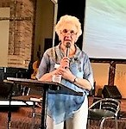
Members and friends of TCACLA gathered at St. Michael’s Lutheran Church in Bloomington on April 29, 2017. Jeanne Weingart, Co-President and member of St. Michael’s, began the meeting with a prayer, welcome, and information about the church and its library. She then made some general announcements and asked for suggestions for topics at the fall meeting and a host church. She noted that in the fall we will be electing a secretary and president, and that either or both positions could be shared by two people.

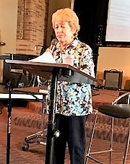

Vice President Lynn Tvedt introduced our speaker for the morning, Lindsay Hardin Freeman. During Lynn’s introduction, she mentioned a recent article by Reverend Freeman in Gather magazine, “Rediscovering Motherhood,” in which she discusses our Biblical foremothers. You can also follow Reverend Freeman’s blogs on her website at www.lindsayhardinfreeman.com/blog/.

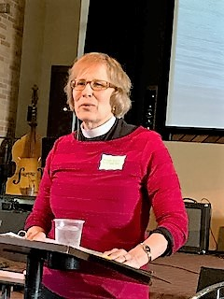
Reverend Freeman began by telling us a little bit about her background growing up in the Minnetonka area. She also talked about her books, The Spy on Noah’s Ark: Bible Stories from the Inside Out (children ages 4-9) and The Scarlet Cord: Conversations with God’s Chosen Women. She then spoke extensively about the research she did to write her most recent book, Bible Women: All their Words and Why They Matter. She presented some statistics about how many women spoke and how many words they said. She praised librarians and told us that of all the women in the Bible, she thought Hulda, a prophet in II Kings, was most like a church librarian. The Apocrypha, she pointed out, is a rich source of stories, and said, “Stories do not tell us what is true. Stories tell us what must be true.”

p. 5
After her presentation, Reverend Freeman, with the assistance of her husband, offered autographed copies of her books for sale at a discount. The meeting ended with a delicious lunch and an opportunity to share ideas with other church librarians.

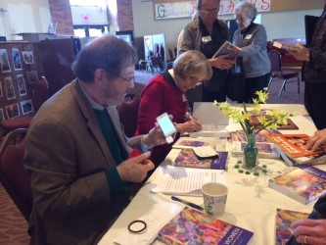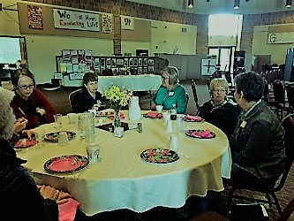

Throughout the morning, there were opportunities to explore the church library, participate in the book swap, and visit the beautiful sanctuary.

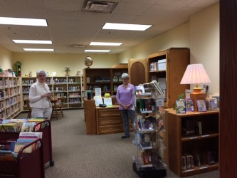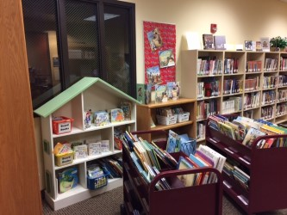

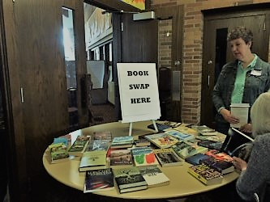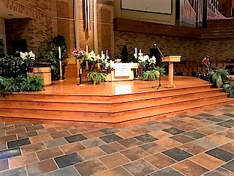

Special thanks to Jan Bolstad, Janet Brownell and Dulcie Campana for their contributions to this section.

p. 6
NEWS FROM THE LAKE SUPERIOR CHURCH LIBRARY ASSOCIATION

The members of the Lake Superior Church Library Association welcomed author Margo Hansen to their spring meeting in May. Hansen spent the first 15 years of her life in Hoyt Lakes and now lives in the north woods with her husband. She discussed her new series, Tall Timber Trilogy, and what she learned while doing research about the logging era in Minnesota. Her five volume A Newly Wed Series also takes place in Minnesota. Hansen says that her greatest desire is to share the gospel of God’s grace with others through her stories.

CHURCH-WIDE BOOK STUDIES

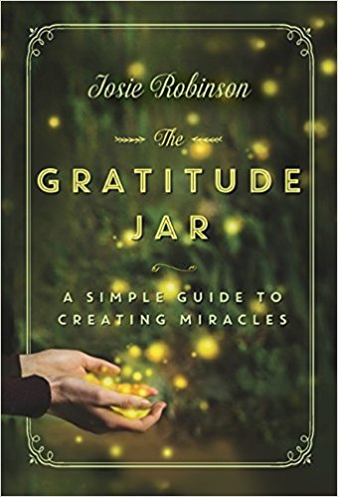
Prince of Peace Lutheran Church in Brooklyn Park recently read The Gratitude Jar: A Simple Guide to Creating Miracles by local author Josie Robinson. Before Robinson discovered the Gratitude Jar, she was a closet drinking housewife who could barely scrape up enough money to pay the grocery bill each month. In her book, she weaves her personal story with the simple act of practicing gratitude and how it has changed her outlook and influenced her life. Per Sally Onstad, it is a heartwarming and inspirational tale of spiritual transformation and self-discovery, but also a guidebook to direct one with new energy onto the path of joy and personal freedom. It will nourish your soul and restore your faith in the goodness of the world as you begin to use its simple truths within your daily life. Many church members have begun keeping a Gratitude Jar as suggested in the book.

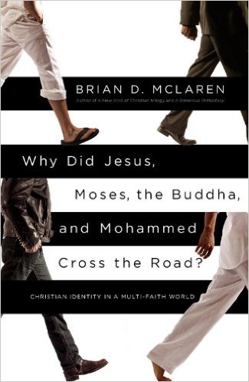
Woodlake Lutheran Church has used Why Did Jesus, Moses, the Buddha, and Mohammed Cross the Road?: Christian Identity in a Multi-Faith World by Brian McLaren for a life lesson book and group discussions. McLaren argues that Christians can respect other faiths while not diluting their own Christianity. He proposes a new faith alternative, one built on "benevolence and solidarity rather than rivalry and hostility." This way of being Christian is strong but doesn't strong-arm anyone, going beyond mere tolerance to vigorous hospitality toward, interest in, and collaboration with the other. While challenging readers to stop creating barriers in the name of God and learn how affirming other religions can strengthen their commitment to their own, McLaren invites Christians to become more Christ-like than ever before.

TCACLA ON FACEBOOK

If you’re not following the Twin Cities Area Church Library Association on Facebook, you’ve missed an amazing video of China’s surreal infinite library. Check it out!

p. 7


One of the missions of TCACLA is to provide a forum for church librarians to exchange information with each other. In addition to our meetings and our newsletter, we also do this via our website at www.tcacla.com.


We’re always looking for input from you. If you have an upcoming book event at your church, have had a special promotion for your library, want to recommend a new book, or have any other news that other members would be interested in, please send the information to livingoutfaith@hotmail.com.

Fall TCACLA Meeting
October 14, 2017

